1. Parts of a Beef Animal

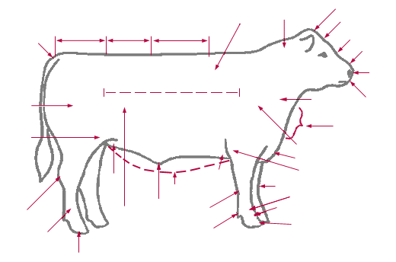

Label the parts from the words listed below:

Throat Brisket Pastern Hook

Stifle Joint Heart Girth Cannon Bone Rear Flank

Dewlap Rib Hock Loin

Dew Claw Pin Muzzle Sheath (steer) or

Navel (heifer)

2. Draw a line from the term to the current definition.

Sire Female kept to produce calves

Dam The father of a calf (bull)

Brood Cow The mother of a calf (cow)

Dehorn To remove the testes from a bull so that

it cannot reproduce

Castrate To remove the horns

Bloat Abnormal condition in ruminants due to an

accumulation of gases

# KNOW YOUR BEEF BREEDS

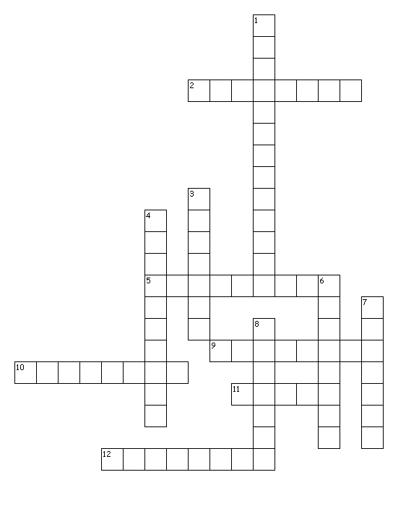

Across

2. Developed in Italy, this breed can be very large in size.

5. Imported from Switzerland, France & Germany. Colored to dark red, spotted bodies

with white to light straw faces.

9. Red and white breed from England, popular for its superior foraging ability, vigor, and

hardiness.

10. Originated in Germany. This breed is solid cream to reddish yellow in color.

11. Black polled breed that originated in Scotland and is known for its mothering and

carcass quality.

12. Originated in British Isles and the red color dates back to 1805.

Down

1. These animals have long horns and several different colors.

3. Breed developed in U.S. by crossing Zebu cattle from India with British breeds.

4. A mix of at least two different breeds.

6. Originated in west central France. Solid to golden red in color with lighter circles

around the eyes and muzzle.

7. Originated in the counties of Suffolk and Norfolk, England. They are polled and red in

color.

8. Developed in Louisiana by crossing Brahman and Angus.