1. Parts of a Beef Animal
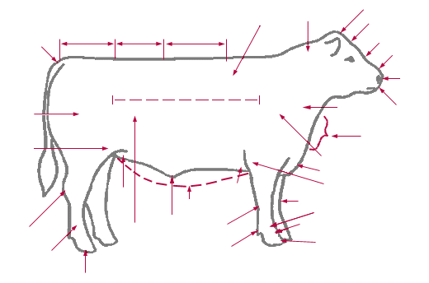
Label the parts from the words listed below:

Poll Brisket Pastern Hook
Stifle Joint Heart Girth Cannon Bone Rump
Dewlap Belly Hock Loin
Dew Claw Pin Back Sheath (steer) or
Navel (heifer)

2. Draw a line from the term to the current definition.
Sire Female kept to produce calves

Dam The father of a calf (bull)

Brood Cow The mother of a calf (cow)

Dehorn To remove the testes from a bull so that
it cannot reproduce

Castrate To remove the horns

Ration A daily mixture of feed ingredients given to
cattle

KNOW YOUR BEEF BREEDS

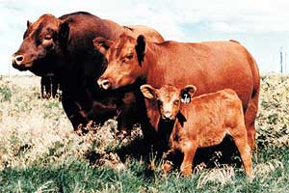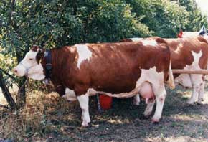

Red Angus _____ Simmental _____

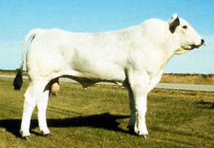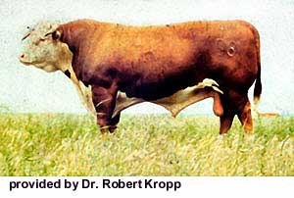

Chianina _____ Hereford _____

Match the sentence with the breed. (Place the letter on the line.)

A. This breed is from England and is popular for its superior foraging ability,
vigor and hardiness.

B. Originated in British Isles and the color dates back to 1805.

C. Developed in Italy, this breed can be very large in size.

D. Imported from Switzerland, France & Germany. Colored to dark red, spotted
bodies with white to lite straw faces.

