1. Parts of a Beef Animal
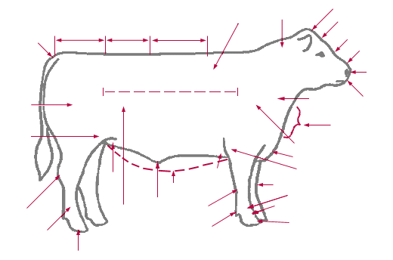
Label the parts from the words listed below.

Pin Loin Hook Back
Hoof Tail Head Rib Rump

2. Draw a line from the term to the correct definition:

Heifer An intact (non-castrated) male

Steer A young female beef or dairy animal that
has not calved (had a calf)

Bull A castrated male calf

Breeds Groups of cattle with similar traits such as
color, horns, or body and head shape that are
passed from generation to generation (parents
to calves)

3. The ideal mature market steer weighs ______________________ to
________________________ pounds.

4. Water is a very important part of an animal’s diet. Cattle will drink up to
_______________ gallons or more of water in one day, depending on their
weight and the environmental temperatures.

BEEF BREED WORD SCRAMBLE

Word Bank

Angus Chianina
Polled Hereford Limousin
Maine-Anjou Shorthorn
Simmental Red Poll
Salers

DLOLOEP EFRORHED ________________________________

IOULMINS ________________________________

THROHNORS ________________________________

USNGA ________________________________

ANCHANII ________________________________

NAJUO EAMIN ________________________________

METNAILSM ________________________________

DER LOLP ________________________________

LARSES ________________________________

