**BEEF SKELETAL PARTS**

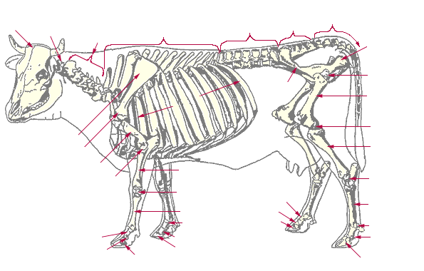

Locate these Beef Skeletal Parts

A. Scapula F. Cervical Vertebrae

B. Lumbar Vertebrae G. Cranial Bones

C. Thoracic Vertebrae H. Sacral Vertebrae

D. Femur I. Ribs

E. Tibia J. Radius

1. Beef carcass evaluation is accomplished through two grading systems:

____________________ grading and ____________________ grading.

2. The average dressing percentage for steers and heifers is ________%, but can

vary greatly with changes in the type of cattle.

3. Marbling is the small flecks of fat that are in meat. In cattle, marbling degrees (the

amount of fat) help to determine the Carcass Quality Grade (i.e. prime, choice, etc.).

List the degrees of marbling found on the Quality Grade Chart.

highest Abundant_____________________________

_______________________________________

_________________ ______________________

_______________________________________

___Modest______________________________

_______________________________________

_______________________________________

_______________________________________

lowest ___Practically Devoid______________________

4. Match these Retail Beef Cuts with the Wholesale Cut (where they come from).

Word Bank (can use these more than once) (See Retail Meat Chart in Book.)

Round Chuck Rib Sirloin

Shank Flank Short Loin Brisket Plate

Retail Cut Wholesale Cut

Beef Rib Roast ___Rib____________________________

Beef Brisket Roast __________________________________

Beef Top Round Steak __________________________________

Beef Sirloin Steak __________________________________

Beef Rib Eye Steak __________________________________

Beef Porterhouse Steak __________________________________

Beef Boneless Shoulder Pot Roast __________________________________

Beef Flank Steak __________________________________

Beef T-Bone Steak __________________________________

Beef 7-Bone Pot Roast __________________________________

Beef Blade Roast __________________________________