CATTLE STRUCTURAL DIFFERENCES

Fill in the term used to describe the following structural conditions.

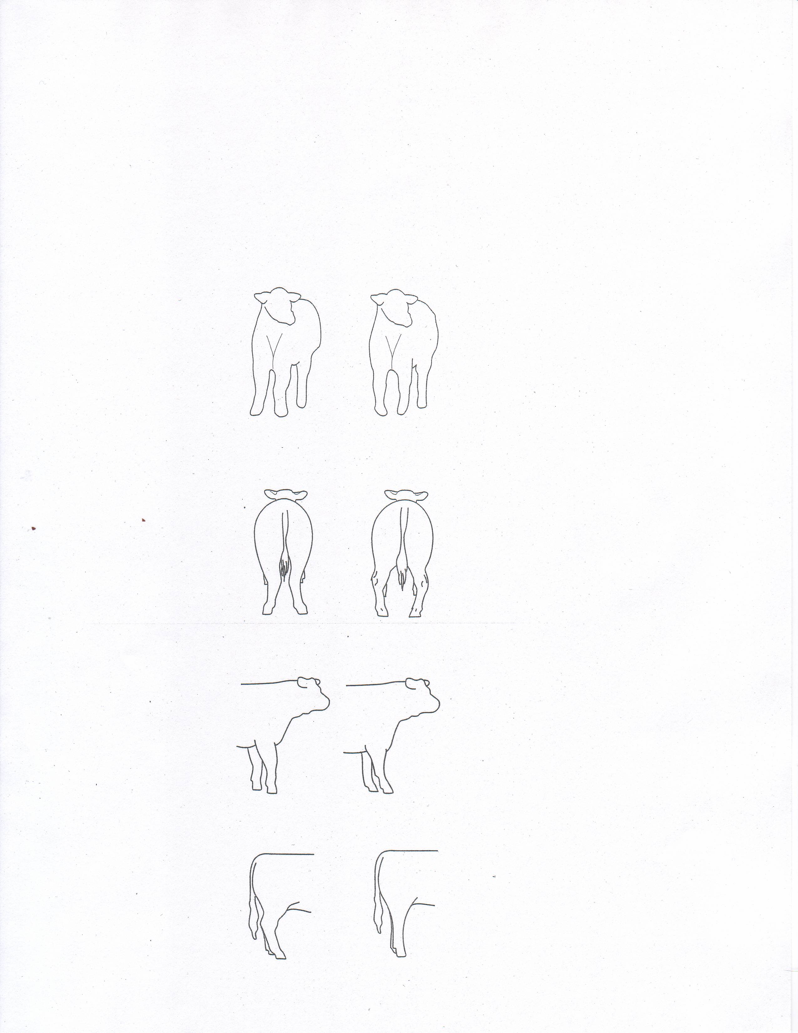

**Word Bank** <EMPTY>

________________ ______________

________________ ______________

______________________ _____________________

______________________ _____________________

knock kneed or splayfooted

cow hocked

sickle hocked

postlegged

pigeon toed or bowlegged

buck kneed

calf kneed

1. What does the grade of L2 mean in the USDA Feeder Calf System?

____________________________________________________________________

____________________________________________________________________

____________________________________________________________________

2. Frame scores are a way of estimating what size cattle will be when they are fully

grown. It is based on the height of an animal at the hips, at different ages. (Note: See

Frame Charts page 2-17 in Beef Resources Handbook 4-H 117R). Find these Frame

Scores:

Frame Score

Heifer, Age 12 Months, 47.0” Hip Height = __________

Bull, Age 13 Months, 47.8” Hip Height = __________

Heifer, Age 20 Months, 58.9” Hip Height = __________

3. Disposition of an animal refers to how calm or relaxed an animal may be around people.

Check the characteristics of an animal that has a poor (wild) disposition.

_____ easy to halter break and taught to lead

_____ may have low rate of gain

_____ may end up being a “dark cutter” carcass

_____ likes to be brushed

_____ seems very nervous when around people

4. After a calf is born, you can help it to start breathing by following these steps.

1. ______________________________________________________________

2. ______________________________________________________________

3. ______________________________________________________________

4. ______________________________________________________________

5. The general procedure for Artificial Insemination breeding is to follow the ___________

rule. If the cow shows signs of standing heat at night, breed her in the morning. If she

shows signs of heat in the morning, breed her at night.

6. After a heifer or cow calves, she needs approximately ________% more energy, 50%

more ________________, 50% more calcium and _________% more phosphorus in

her diet. In addition Vitamin A requirement increases about ________%.

7. Muscling traits that are found in an ideal market steer include: (check the traits that apply)

_____ wide through the center of the quarter

_____ muscular loin

_____ long neck and smooth shoulders

_____ natural thickness down the top

_____ clean and balanced underline

8. Milk production in beef cows is the most important factor of maternal (mothering) ability.

The most accurate reflection of a cow’s maternal or mothering ability is the

___________________________ of the calf at weaning.