CATTLE STRUCTURAL DIFFERENCES

Fill in the term used to describe the following structural conditions.

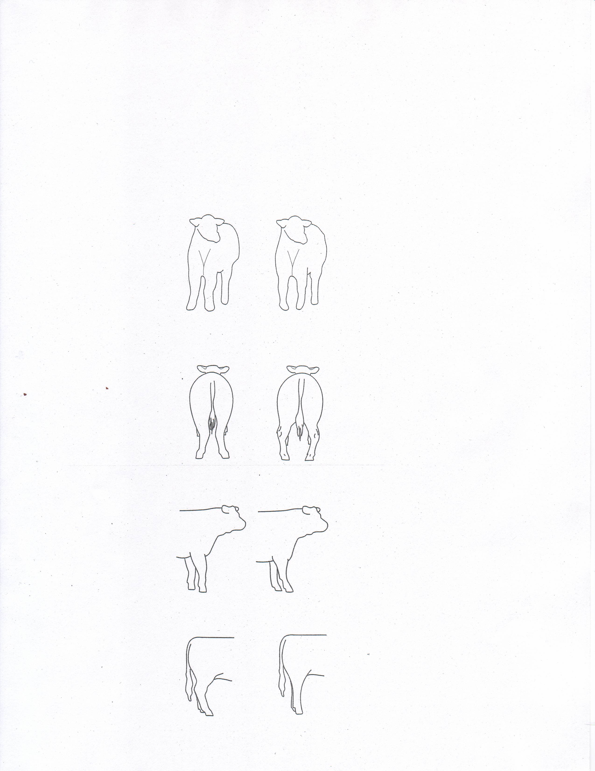

**Word Bank** <EMPTY><EMPTY>

________________ ______________

________________ ______________

______________________ _____________________

______________________ _____________________

knock kneed or splayfooted

cow hocked

sickle hocked

postlegged

pigeon toed or bowlegged

buck kneed

calf kneed

______________________ _____________________

1. When evaluation breeding cattle, several important characteristics must be

examined. These characteristics include:

A. ______________________________________________________________

B. ______________________________________________________________

C. ______________________________________________________________

D. ______________________________________________________________

E. ______________________________________________________________

2. What does the grade of L2 mean in the USDA Feeder Calf System?

____________________________________________________________________

____________________________________________________________________

____________________________________________________________________

3. When evaluating feeder calves, finish or fat cover is not a priority. In fact, excessively fat

Feeder calves can be an indication of ____________________or very early__________.

4. Frame scores are a way of estimating what size cattle will be when they are fully

grown. It is based on the height of an animal at the hips, at different ages. (Note: See

Frame Charts page 2-17 in Beef Resources Handbook 4-H 117R). Find these Frame

Scores:

Frame Score

Heifer, Age 12 Months, 47.0” Hip Height = __________

Bull, Age 20 Months, 56.9” Hip Height = __________

Heifer, Age 17 Months, 51.1” Hip Height = __________

5. What traits would contribute to volume and capacity in breeding stock evaluation?

_____ level rump

_____ spring of rib

_____ depth of rib

_____ smooth and uniform fat cover over ribs

_____ width and depth of stifle

6. List four of the seven signs of heat.

_____________________________________________________________________

_____________________________________________________________________

_____________________________________________________________________

_____________________________________________________________________

7. The general procedure for Artificial Insemination breeding is to follow the ___________

rule. If the cow shows signs of standing heat at night, breed her in the morning. If she

shows signs of heat in the morning, breed her at night.

8. After a heifer or cow calves, she needs approximately ________% more energy, 50%

more ________________, 50% more calcium and _________% more phosphorus in

her diet. In additional Vitamin A requirement increases about ________%.

9. Structural correctness in breeding cattle is important. Check the characteristics that could

Refer to structural correctness.

_____ level from hooks to pins

_____ thickness of quarter

_____ move with a long, reaching stride

_____ proper slope to the shoulder

_____ width of chest