

Enrolling in 4-H Online as a NEW Youth Member

Creating a New 4-H Online Account
- Go to http://v2.4honline.com.  - Click “Don’t have an account?” if you have never enrolled in 4-H before using 4-H Online.  NOTE: If you had an account in 4-H Online 1.0, enter the login information for your existing account and skip to Member Enrollment. | 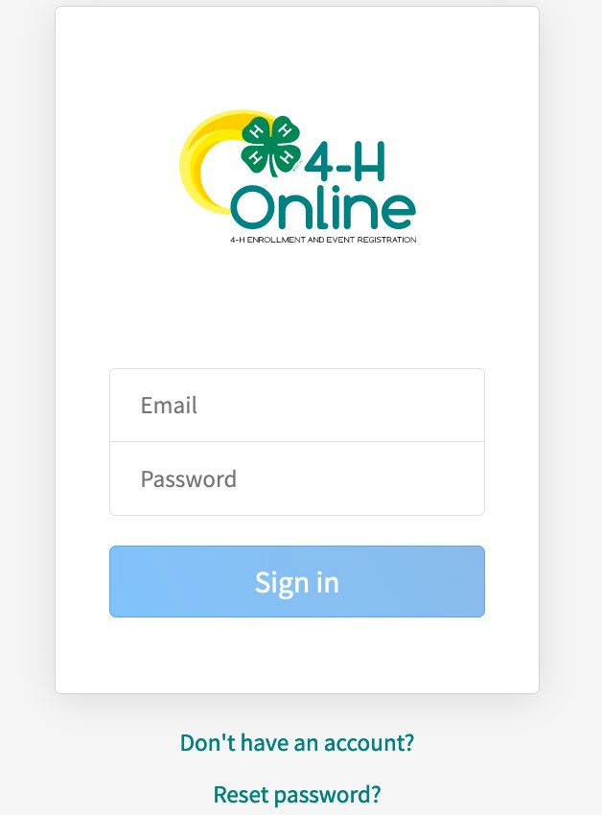
3. Select Indiana from the drop-down menu. | 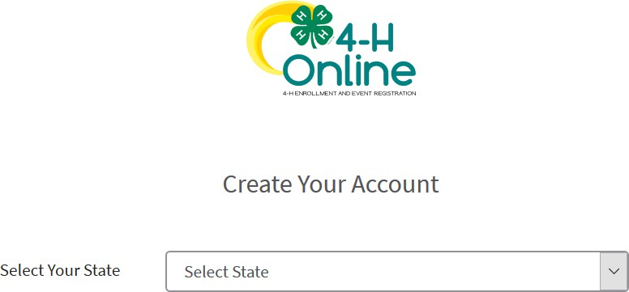
4. Choose your county from the drop-down menu. | 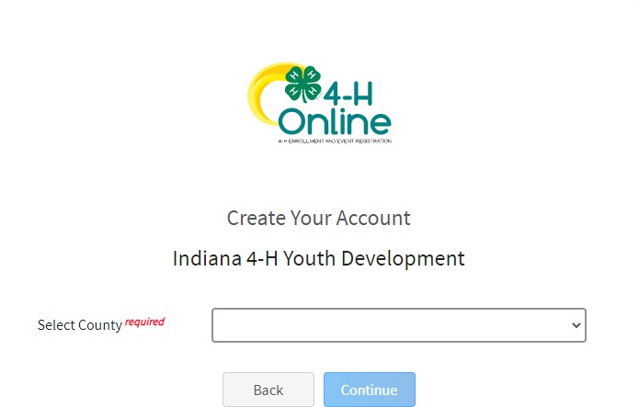

- Complete your family’s information.  - Click the Create Account button. | 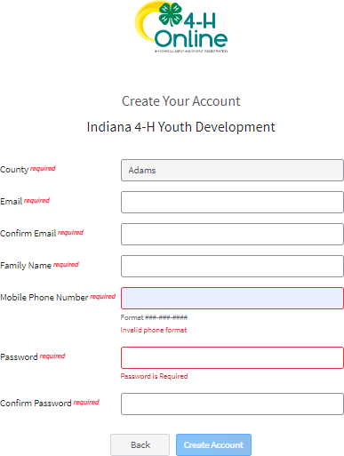
- Enter your family’s address information.  - Click the Verify button.  NOTE: The verification process may require you to select an appropriate USPS format. | 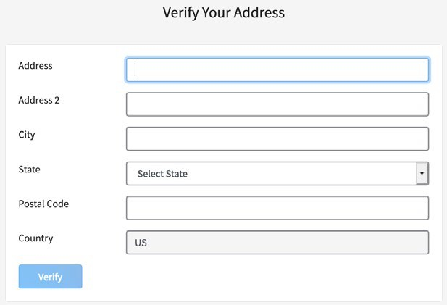
9. If you create a new account and an existing account is found, click the Confirm button and continue to Logging in with  an Existing 4-H Online Account. |  |  | 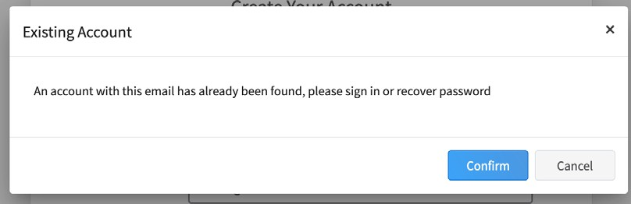
Adding a New Member to the Family
- Enter the member’s information.  - Click the Next button.  NOTE: fields marked with a red asterisk ( * ) are required fields and must be completed. |  | 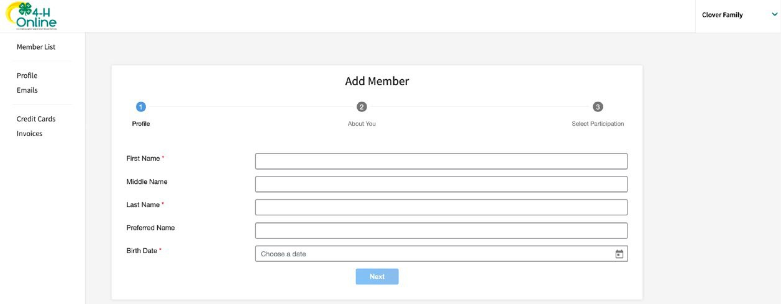

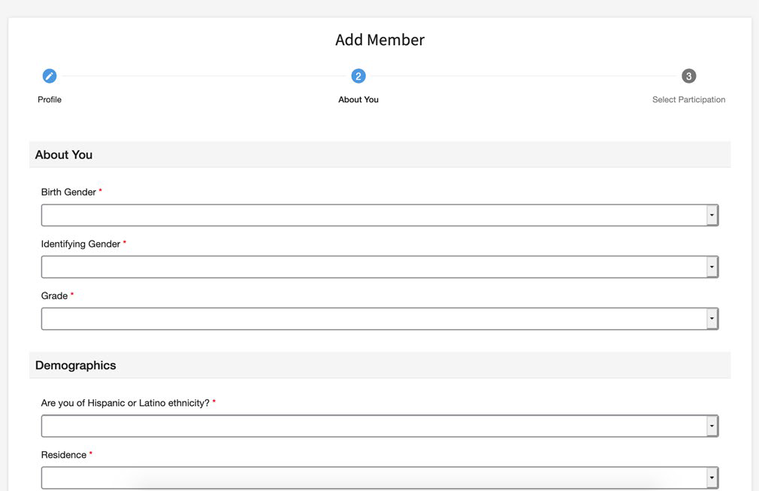
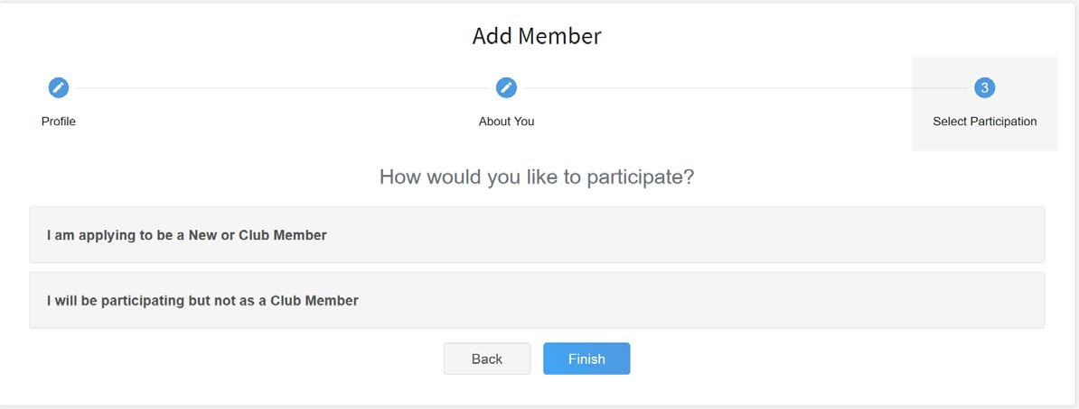
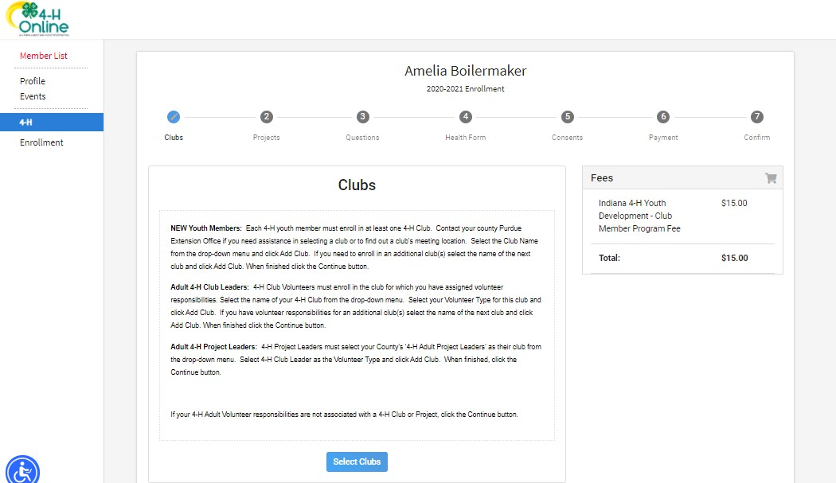

- Complete the “About You” form with the requested information.
- Click the Next button.

- Select your method of participation.
- Click the Finish button.

Continue to Youth and Mini 4-H Member Enrollment.

Youth and Mini Member Enrollment

- Click the Select Clubs button.

- Select the County in which your Club is located.  - Click Add next to the Club you would like to join.  - Repeat steps 1-3 to add all of the Clubs in which you would like to participate.  *Note if you do not know what club to elect at this time, choose Contact Me to Learn About Clubs and someone from your county will contact you to choose a club.** | 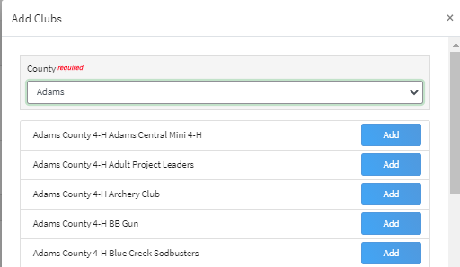
- If you have enrolled in more than one club, be sure the Primary club is marked correctly. If not, click the Change to Primary button to mark a different Club as your Primary Club.  - Click the trash can icon to remove a Club from the list.  - Once all of your Clubs are added, click Next at the bottom of the screen. | 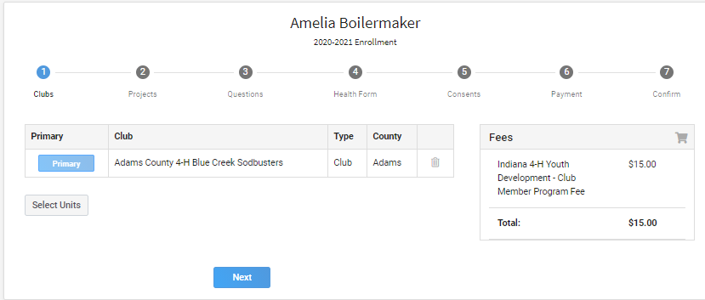
7. Click Select Projects | 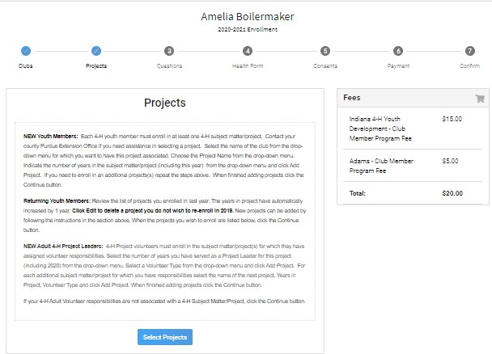

- Select the Club with which you want your project to be associated.  - Click the Add button next to the project you want to add to the member’s enrollment.  - Repeat steps 7-9 for each project in which you would like to participate. |  | 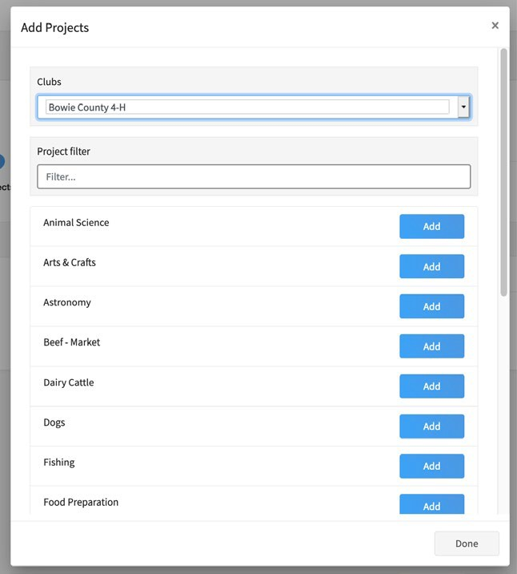
- Click the trash can icon to remove any projects.  - Click the Next button once all the member’s projects have been added. | 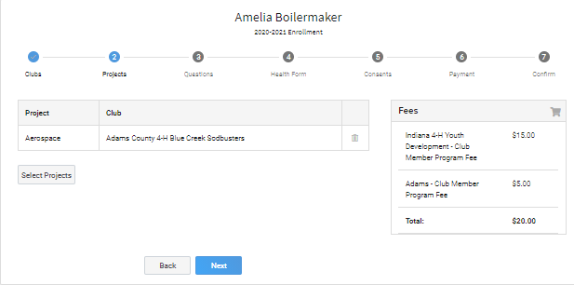
- Click “Show Questions”  - Complete the enrollment questions. Some of the questions will be completed for you based on what you entered when you created your record.  NOTE: Any questions with a red asterisk (*) are required. Questions may vary by Institution. | 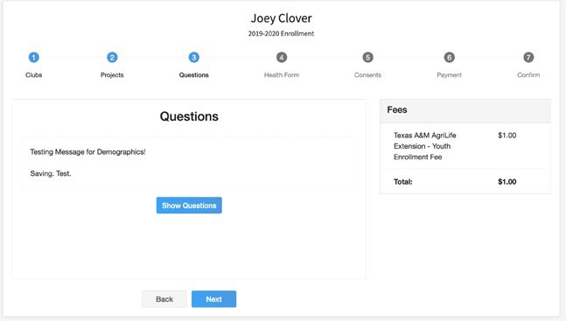

- Complete the Health form fields and Consents.  - Click the Next button at the bottom of the screen when you are done. | 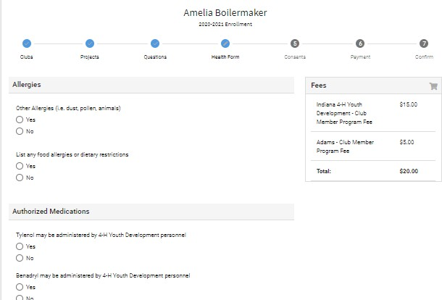
- Complete the Consents  - Click the Next button at the bottom of the page when you are finished. | 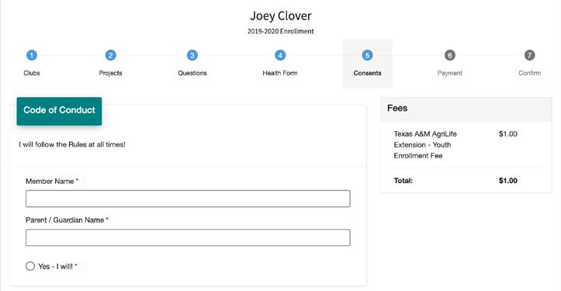
If no fees are due, click the Next button and skip to step 23. | 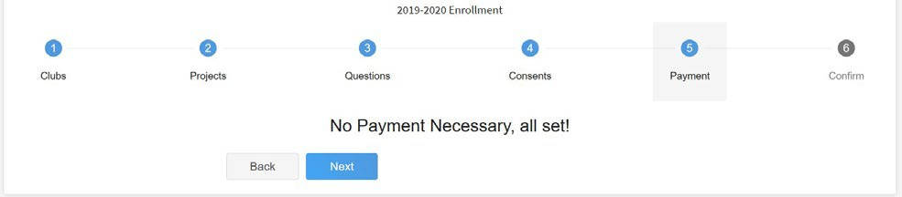
- If applicable, review the fees for the member.  - If you are choosing to pay with credit card, you will need to Add New Card. This will redirect you to a new site. This site is not mobile friendly so you will need to be on a computer for this step using either Mozilla Firefox, Google Chrome, or Safari web browsers (skip to step 22) | 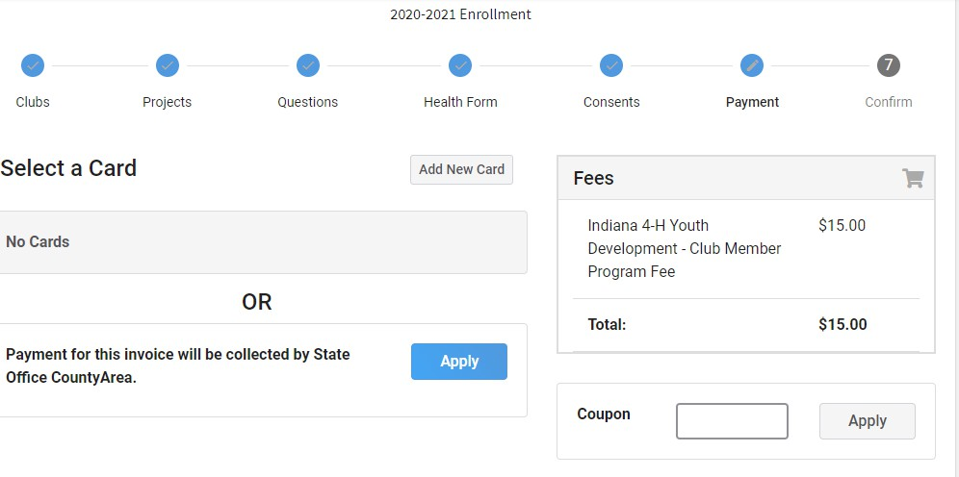

21. If choosing to pay with check to your County Extension Office, select Payment for this invoice will be collected *YOUR COUNTY* County. (skip to
step 23)
22. If you selected to pay with credit card you will be redirected to enter that information. Fill out all the required fields noted with an * and then click Continue. Upon completion you will be returned to 4-H Online. | 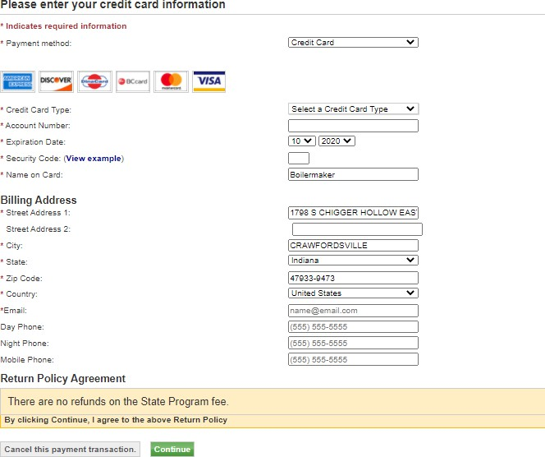
- Review the enrollment information.  - Once you have verified that the clubs and projects are listed correctly, click the Submit button.  Congratulations, your enrollment is complete! | 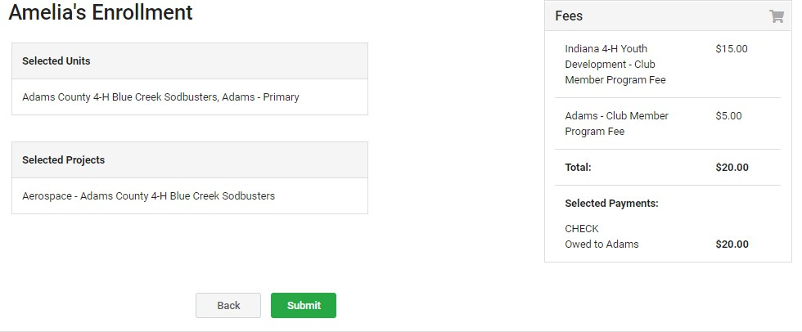
You will receive an email to let you know your enrollment has been submitted. You will receive another email when your County Extension office has approved your enrollment. You may view the enrollment status on the Member List. Any enrollments that have fees to be paid by credit card will process when the County Extension Office approves the enrollment. Should the transaction be declined, you will receive an email notification. It will include a link to login
so that you may add another card or change your payment method.

