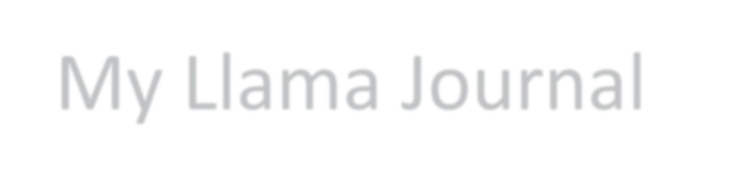

My Llama Journal

Name

Grade in school Years in project
To be used by Allen County 4-H Llama Project members who plan to show a llama at the county fair.

Goals for this year | Ways to accomplish  your goals | Accomplishments and  Outcomes
Participation in club activities Date completed
Presentation
Public service activity
Journal
Farm day
Additional activities:

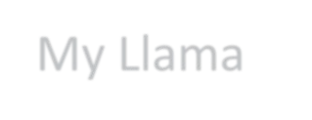
My Llama
Name of Llama DOB Color(s): Height at withers Name of sire: Name of Dam: Known siblings (full or half)

Date acquired: Own or lease: Identification or registration number: Owner of Lama: Farm:

Llama Health Record
Vaccinations and deworming
Date given | Medication | Route of  administration
Other treatment
or comments

Leader’s signature: Date:

