2023 Small Farms Conference – Vendor Marketing Toolkit

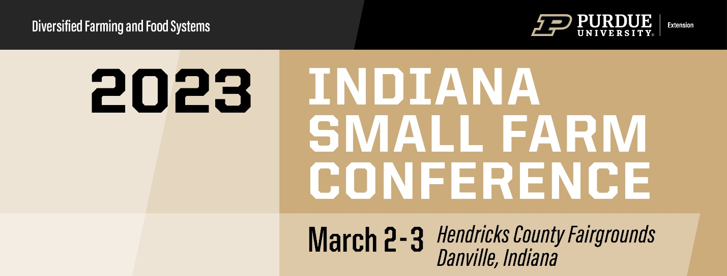

Newsletter Copy:
Don’t miss Purdue Extension’s 2022 Indiana Small Farm Conference, the annual educational networking event for the Indiana small and diversified farming community. This year’s conference will be in-person at the Hendricks County Fairgrounds in Danville, Indiana. To get full access to this fun, instructive and growing experience, check out the four levels of registration below:
Commercial Exhibitor booth fee -$300
Non-profit Exhibitor booth fee - $175
Tabletop display fee - $100
For more information and registration, visit https://purdue.ag/sfc.

Calendar text:
Title: 11th Annual Indiana Small Farm Conference
Dates: Thursday, March 2 – Friday, March 3, 2023
Location: Hendricks County Fairgrounds, Danville, Indiana
Contact: Amy Thompson, (765) 496-1930, afthompson@purdue.edu
Information/Registration: https://purdue.ag/sfc

Description:
Don’t miss Purdue Extension’s 2023 Indiana Small Farm Conference, the annual educational networking event for the Indiana small and diversified farming community. This year’s conference will be in-person at the Hendricks County Fairgrounds in Danville, Indiana. To get full access to this fun, instructive and growing experience, check out the four levels of registration below:
Commercial Exhibitor booth fee -$300
Non-profit Exhibitor booth fee - $175
Tabletop display fee - $100
For more information and registration, visit https://purdue.ag/sfc.

Facebook Post:
Join us at the @PurdueExtensionSmallFarms conference — coming March 2-3, 2023, at the Hendricks County Fairgrounds in Danville, Indiana. Learn more and register today at https://purdue.ag/sfc. #PurdueSmallFarms #IndianaSFC @PurdueAg

Twitter Post:
Proud to partner with #PurdueSmallFarms! 2023 @SmallFarmPurdue conference on 3/2-3/3! #IndianaSFC https://purdue.ag/sfc
**Include photo at the top of this page**

Instagram Post:
Visit us at the upcoming Purdue Small Farm Conference! We are excited to be a part of the 11th annual event, which draws more than 500 attendees and will be held in-person at the Hendricks County Fairgrounds in Danville, IN. Learn more at https://purdue.ag/sfc. @PurdueDFFS #PurdueSmallFarms #IndianaSFC
**Include photo at the top of this page**

