Dry Bean Research Summary 2022 – Exploring Large Grains on the Small Farm
By Ashley Adair, Extension Organic Agriculture Specialist

Introduction
Many farmers, especially beginning farmers, plan their farms around producing a variety of perishable products that sell well, like tomatoes, peppers, and leafy greens. As farmers gain more experience and build their markets, they may begin to wonder what other crops they can add to their crop rotation. Storage crops can be part of that plan, allowing them to extend their sale season and provide additional value to their customers. Storage crops might include winter squash, onions, and pumpkins. Another storage crop to consider is grain: flint corn, popcorn, wheat, or even dry edible beans, which are the focus of this project.
Stepping into the world of grain might seem daunting at first. The farmer might assume they need a lot of land, a combine harvester, large tractors, and complex planting equipment to ensure success. This project aims to dispel preconceived notions about grain production on a smaller scale and explore ways to make small scale grain production viable for the small scale grower. This project also seeks to discover which heirloom dry bean varieties are suitable for production in Indiana.

What are dry edible beans? Dry edible beans, or simply dry beans, are a food grade storage grain crop. Dry edible beans come from the same type of plant that many fresh edible beans (i.e. green beans, or fresh shell beans) come from, Phaseolus vulgaris. There are many varieties of beans available, and some varieties can be grown either for fresh or dry. They are most commonly grown as a food grade crop, and provide many nutritional benefits to those who consume them. That being said, they can also be incorporated into animal feed, but are more lucrative in the food grade market, selling for as much as $60 per hundredweight (cwt) in the certified organic marketplace. Compare this to certified organic soybeans, which have sold for $35-40 per bushel in 2022, and require a growing season as many as 20 days longer to mature.
Dry beans are a shorter-season crop, usually taking 80-90 days from planting to harvest. They prefer well-drained soil and are generally poor competitors with weeds. In organic management, dry beans require vigilance and much attention focused on mechanical weed control. Foxtails and other grasses are public enemy number one for this crop, but any weed will be problematic for growing these successfully. On the other hand, dry beans are a legume and can provide for much of their own nitrogen needs, even in soils that have relatively low organic matter, like the sandy soils where they prefer to grow. Dry beans are most commonly grown in the north-central states of the US, as well as Ontario, Canada. The number one producer of dry beans in the US is North Dakota, followed by Michigan, Nebraska, and Idaho. While these states are different from each other in terms of climate and weather patterns, they share some combination of suitable soil types, rainfall amounts, grain handling infrastructure, and shortened growing seasons that make growing dry beans (versus soybeans) a viable option for the commercial grain grower.
Many of the commercially available dry beans at the grocery store are limited to a handful of specific varieties. Commonly available to consumers are pinto beans, black beans, great northern beans, and kidney beans. But there are a huge number of dry bean varieties available to the small scale grower and market gardener that can’t readily be found at the grocery store. These varieties often are locally adapted to where they were bred, rather than bred for adaptability to a large geographic area or mechanized harvest. In addition to local adaptability, each dry bean has specific flavor, culinary characteristics, and cultural history that can help enrich the farmer’s and consumer’s kitchens while providing essential nutrients, such as fiber, protein, and several minerals, to the human diet.

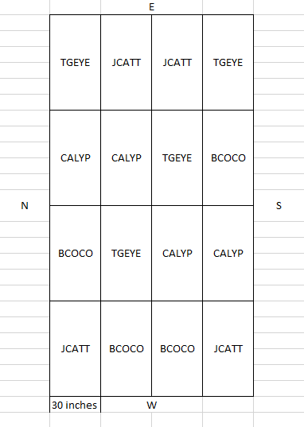
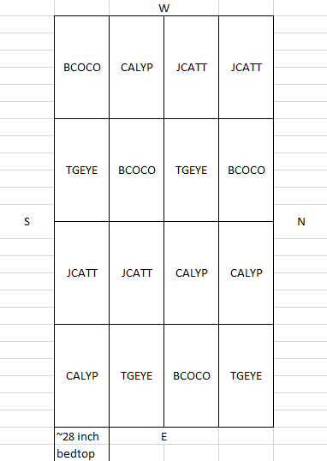
Project description and design: A dry edible bean variety trial was installed at the Purdue Student Farm (West Lafayette, IN) and Pinney Purdue Agricultural Center (Wanatah, IN). Each site was planted in a randomized complete block design (RCBD) (see figs 1 and 2).
Figure 2. RCBD at Pinney PAC.
Figure 1. RCBD at PSF.

One of the largest differences between the two sites is soil type. The PSF features a silty clay loam, and Pinney PAC features a sandy loam. Other differences include cropping history and weather conditions. The PSF has been an organically managed (not certified), diversified vegetable farm since 2016, whereas the research plot used at Pinney PAC has been left unused and untreated for several years prior to the installation of this trial – which means a large weed seed bank. The trial was designed as a randomized complete block trial, meaning each “column” of the trial will feature all four varieties, randomly arranged. This type of design is common in agricultural research and helps to account for variability in the field where the trial is planted. Varieties used in this trial include the following:
- Black Coco – a type of black bean (determinate bush-type)
- Calypso – a type of black bean (determinate bush-type)
- Jacob’s Cattle – a type of kidney bean (determinate bush-type)
- Tiger’s Eye – a type of cranberry bean (indeterminate upright-type)

Varieties were selected based on several characteristics, including time to maturity, cultural relevance to the Midwest, common cooking preparations, and growth habit.

Materials and Methods
Each variety was planted using an Earthway seeder fitted with a pea plate in a double row at each site, each with about 18 inches of spacing between rows. Each block was 12.5 feet in length resulting in about 25 plants per block. Both sites were irrigated as needed using plastic drip tape, to the equivalent of about 1 inch of rain per week. At PSF, beans were grown on shaped beds about 4 inches high. Hand labor was used to weed the beds. Each trial was side-dressed when bean plants had fully unfurled their second set of true leaves using an OMRI-listed pelletized poultry manure to the equivalent of 40 lbs. N per acre using an Earthway seeder fitted with a pea plate.
At PSF, the trial was planted on 6-3-22. Pinney was planted on 6-10-22, and due to inadequate irrigation, had to be replanted on 6-24-22. PSF was harvested over the course of several days beginning 9-6-22. Pinney was harvested on 9-20-22 and 9-22-22. Harvest can take place as soon as dry bean pods are about 85% yellow and 15% brown, or when beans split in two when smashed with a hammer.
Dry beans must be threshed and winnowed in order to prepare them for weighing and sale. For the purposes of developing recommendations and materials for demonstration, two threshing methods were used. Manual threshing was completed by flailing bean plants against the inside of a 55-gallon food grade plastic drum. Mechanical threshing was done using a Swanson Machine Co. portable gas powered plot thresher (see figs. 3 and 4).
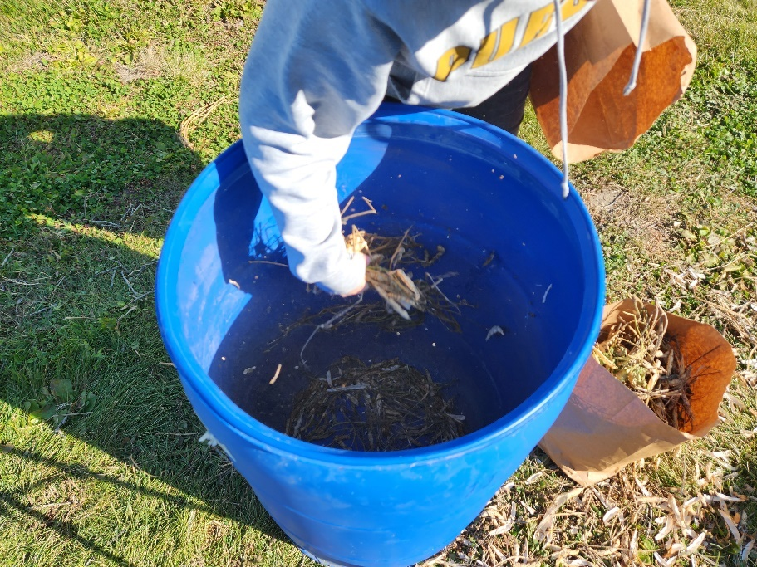
Figure 3. Manually threshing whole dry bean biomass using a 55-gallon drum.
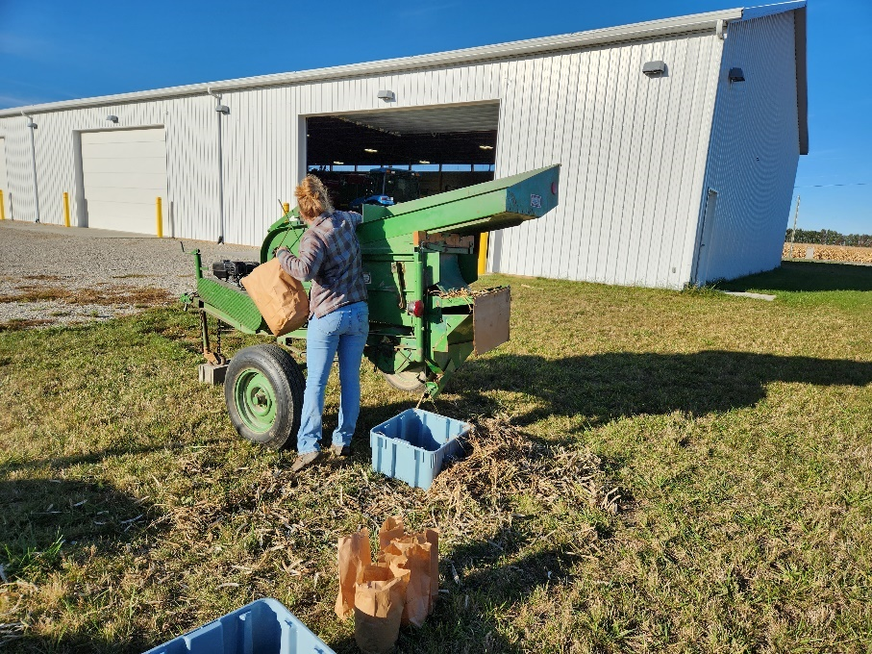
Figure 4. Swanson Machine Co. portable plot thresher being fed whole dry bean biomass.
Each method presented advantages and disadvantages, namely time commitment (hand threshing took as much as 10 times longer) and expense devoted to purchasing and maintaining a machine (threshing machines can cost upwards of a few thousand dollars).
Whether threshed mechanically or manually, all dry beans still needed to be winnowed. Winnowing takes place by either using mesh screens or moving air to separate dry biomass from the beans themselves. In this case, moving air was the method used, to help simulate conditions and equipment available to a small-scale grower. A garage fan and solid-bottomed harvest bins were used. Video footage was procured from this process in order to instruct prospective growers further (available upon request). Fig. 5 shows part of this process.
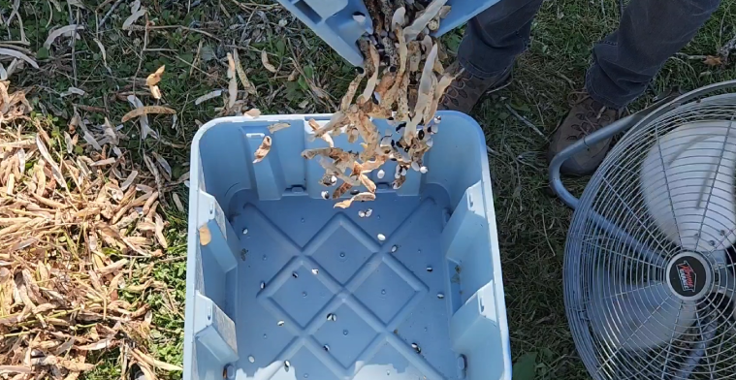
Figure 5. Winnowing Calypso variety using a garage fan and harvest bins. Chaff is separated from beans while pouring biomass material from one bin into the other. Process is repeated until beans are reasonably free of chaff.
After harvest, the Purdue Student Farm site was flail mowed and power harrowed using a BCS walk-behind tractor and corresponding attachments. A cover crop mix including cereal rye and hairy vetch was seeded at the Purdue Student Farm. The Pinney PAC site was disced under. Cover crops are planned for the area beginning in March 2023.

Preliminary Results
Dry beans were weighed by replicate in grams after threshing and winnowing was complete. Preliminary results are shown below. Variances were not pooled across sites.
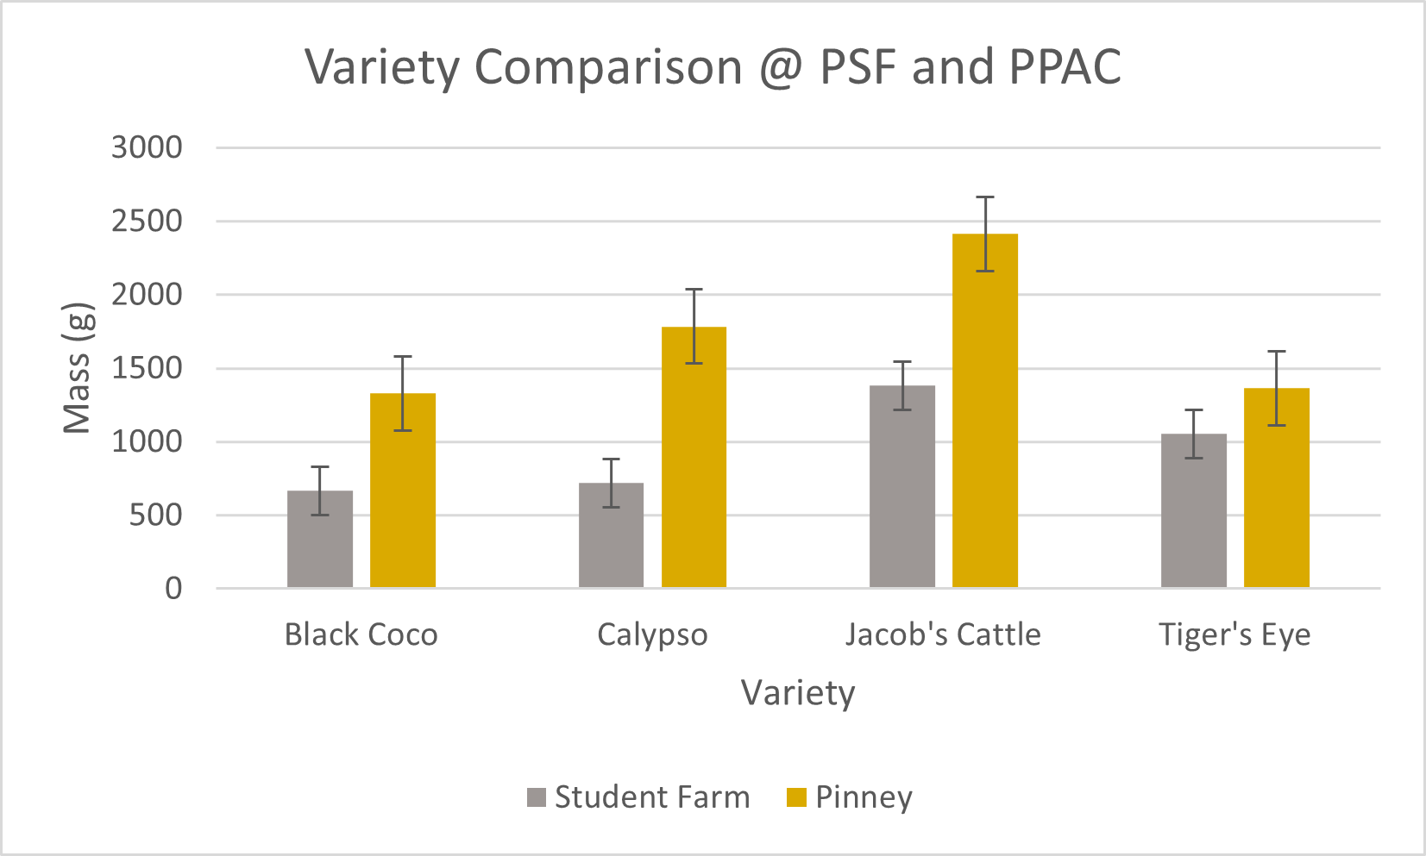
Figure 6. Comparison of average mass (g) produced by each variety in each replicate at PSF (gray) and PPAC (gold).
It is unwise to draw conclusions from a single year of data, but data combined with anecdotal experience in the field can yield some insight for future years. One of the major differences in performance between the two field sites was the performance of Calypso. Calypso performed poorly at the Purdue Student Farm and performed much better at Pinney. This may signal a strong response to well-drained soil conditions at Pinney versus poorly drained conditions and weed pressure at the Purdue Student Farm. The only other insight worth discussing is the apparently strong performance of Jacob’s Cattle at both sites.

2022 Deliverables
In 2022, the dry edible bean trial was involved in the following:
- Featured as a field stop at the Pinney Purdue Vegetable Field Day on 8/9/2022
- Utilized as a teaching opportunity in the lab section of the Small Farms Experience course (SFS 210), taking place at the Purdue Student Farm, in September 2022
- Purdue Vegetable Season Pass (community supported agriculture) participants (86 families) received about 1 pound of dry edible beans in their final share for the 2022 season. Feedback on the use of the beans will be collected in the Student Farm’s annual survey of CSA participants.

Future Plans
This trial will be repeated at both PSF and Pinney PAC in 2023. This will be the second and final year of the project, yielding 2 site years of data for analysis.
Future deliverables include, but are not limited to, the following:
- “Dry Beans – A Large Grain for the Small Farm?” presentation at the Indiana Small Farm Conference, 3/2/2023
- “Dry edible beans for the small scale producer” factsheet
- “Calibrating and using a push seeder to side dress crops on the small farm” extension publication
- Presentation during the Small Farm Education Field Day at the Purdue Student Farm in 2023
- Equipment demonstration videos
  - BCS power harrow
  - BCS flail mower
  - Swanson plot thresher
  - Manual threshing and winnowing of dry beans
  - Using a push seeder to side dress crops

Acknowledgements
First, I want to thank NC-SARE for providing the funding needed to conduct this variety trial and allow for exploration of a crop not traditionally grown in Indiana.
Secondly, I want to think Dr. Liz Maynard, Clinical Engagement Professor of Horticulture, for her advice and collaboration. Her experience growing dry beans during her graduate studies and her willingness to share in the labor needs of this project were indispensable.
Others I would like to thank include the Purdue Student Farm, including Chris Adair, Farm Manager, and Alfonso Rosselli, former student production intern, for their assistance in installing and maintaining this project. Alfonso assisted in planting and installing irrigation at both field sites, as well as field maintenance. Chris and his farm crew made sure that the crop was protected from wildlife using a deer fence and helped weed and schedule irrigation for the beds. I would also like to thank Dr. Petrus Langenhoven, Horticulture and Hydroponics Crops Specialist at Purdue, for his advice and the use of his field equipment during the growing season.
Lastly, I would like to thank Dr. Steve Hallett, Professor of Horticulture, for inviting me to teach his Small Farms Experience course about dry edible beans and variety trials, and instruct students during lab time about harvesting, threshing, and winnowing dry beans.

What follows is several more photos from the project and its deliverables.

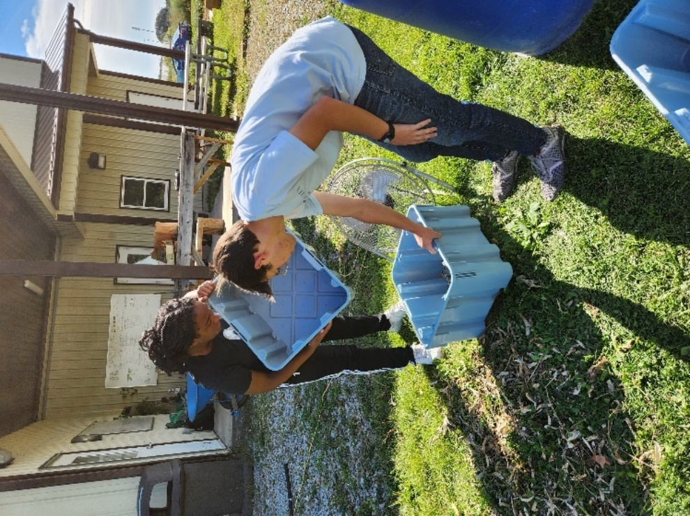
Figure 7. Students in the Small Farms Experience course learn to winnow during lab.

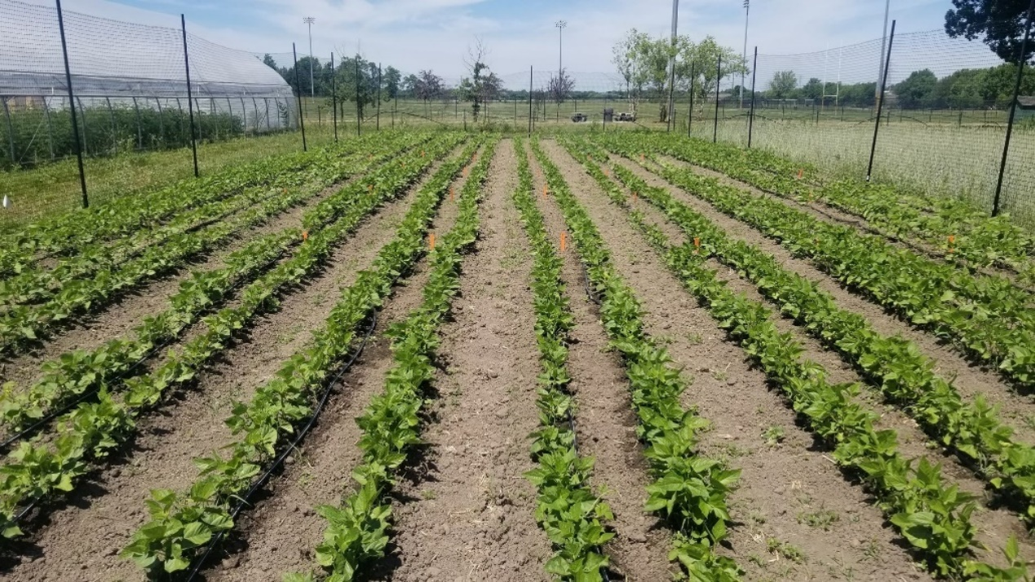
Figure 8. Dry edible beans 21d after planting at PSF.

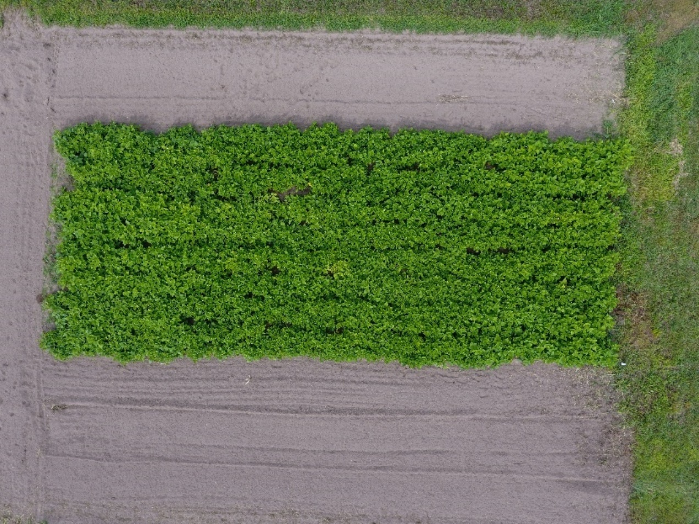
Figure 9. Aerial imagery sourced from Pinney PAC site on 8/2/2022. Crop progress was documented aerially at both field sites throughout 2022.

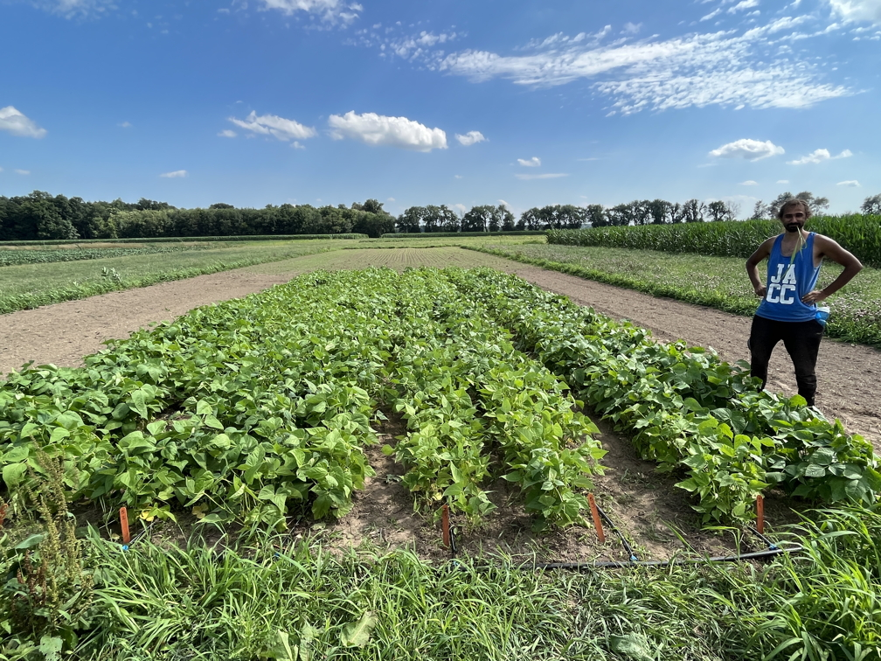
Figure 10. Momin Mirza, summer worker at Pinney PAC, stands at the dry bean plot after a long day weeding the bean plot. Photo provided by Liz Maynard.
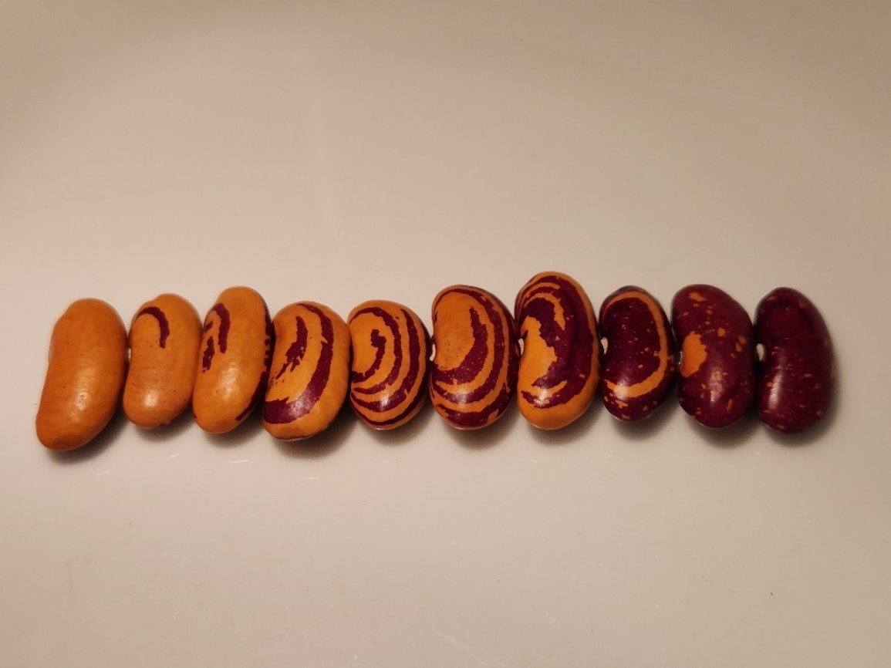
Figure 11. Variation in appearance of Tiger’s Eye bean from several individual plants and pods from the 2022 season.

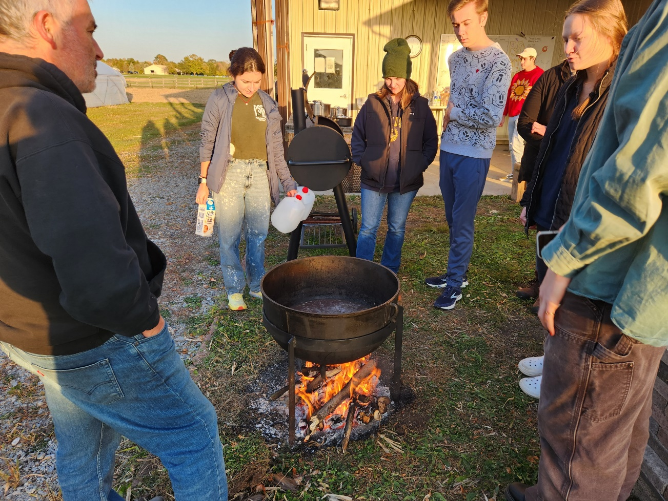
Figure 12. Dry beans from the 2022 trial were tested in a squash curry recipe at the annual Purdue Student Farm Organization banquet held October 20th, 2022.

