**Facilitator Guide: Sustainable Communities Spark Club**

Pressing environmental challenges, such as climate change and declining biodiversity, necessitate the development of an environmentally literate workforce. Youth are also increasingly concerned about these environmental challenges. This facilitator guide includes multiple learning activities that introduce youth to challenges and solutions related to environmental sustainability in their communities. Youth explore sustainability through designing sustainable cities. These activities provide opportunities for youth to recognize the interdependencies of ecological, social, and economic systems and to consider sustainability-related educational and career pathways. These activities will also challenge youth to apply systems thinking to design solutions that meet the needs of communities while minimizing negative impacts on ecosystems. These activities can be used as grab-and-go lessons or organized into a project-based series on sustainability, such as for a Spark Club or in-school programs.

This series of activities builds upon the first activity (i.e., core activity), *Build a City*. In each of the following activities, youth explore new content related to sustainability and then have opportunities to apply this understanding to modify the design to make their city more sustainable. The series concludes with a city showcase during which teams can share the final designs of their cities and rationale behind these designs.

**Program Overview:**

1. Build a City (Core Activity)
2. Urban Heat Island (Scientific Inquiry & Data Science)
3. Impervious Surface Area (Scientific Inquiry)
4. Stormwater Management & Green Infrastructure (Engineering Design)
5. Waste Management (Engineering Design)
6. Habitat Fragmentation & Wildlife Corridors (Modeling, Engineering Design)
7. Renewable Energy (Technology)
8. Zoning & Stakeholder Needs with iPlan (Modeling, Engineering Design)
9. City Showcase (Technical Communication)

**Module 1: Build A City**

**Background:** Introduce learners to the characteristics of sustainable communities and how to design communities to limit urban sprawl and improve quality of life. Learners are challenged to design and build a model of their city with LEGOs. Design constraints include fitting the city within a fixed footprint, designing buildings and houses to meet or exceed minimum footprints, and maintaining a minimum amount of space between buildings for roads. Design criteria include incorporating buildings providing critical services (e.g., school, grocery store, and library) and placing the courthouse/town center at the city's center. This exercise also encourages learners to think about what makes communities a better place to live, work, and play. The lesson plan also stresses the importance of thorough design before the building process.

**Related Careers:** City Planners, Landscape Architects, Civil Engineers, Architects, Environmental Assessment Specialists, Environmental Engineers, GIS Technicians, Land Developers, and Surveyors.

**Materials:**

* Printed copies of [City Planner workbook from Rose-Hulman Institute of Technology](https://nam04.safelinks.protection.outlook.com/?url=https%3A%2F%2Fwww.rose-hulman.edu%2Facademics%2Feducational-outreach%2F_assets%2Fpdfs%2FGrand%2520Challenges%2520K-12%2520Unit%2520PDFs%2FBuildLegoCity-Workbook.pdf&data=05%7C02%7Cwinter35%40purdue.edu%7Cd586be8a57e547ead68b08dc78ffddcd%7C4130bd397c53419cb1e58758d6d63f21%7C0%7C0%7C638518287544359744%7CUnknown%7CTWFpbGZsb3d8eyJWIjoiMC4wLjAwMDAiLCJQIjoiV2luMzIiLCJBTiI6Ik1haWwiLCJXVCI6Mn0%3D%7C0%7C%7C%7C&sdata=z21SHUivTQrb8UZPuLB%2Ba9NTgBbzblgwP47gETBXz9E%3D&reserved=0)
* Writing utensils
* Sticky notes
* LEGO baseplates for each city (10”x10” baseplate is recommended).
* Assorted LEGOs to build city features

**Procedure:**

1. Introduce how the engineering design process is applied to urban planning via the [Let’s Build A City: Crash Course Kids video](https://nam04.safelinks.protection.outlook.com/?url=https%3A%2F%2Fwww.youtube.com%2Fwatch%3Fv%3DgnnUid8Hof0&data=05%7C02%7Cwinter35%40purdue.edu%7Cd586be8a57e547ead68b08dc78ffddcd%7C4130bd397c53419cb1e58758d6d63f21%7C0%7C0%7C638518287544332291%7CUnknown%7CTWFpbGZsb3d8eyJWIjoiMC4wLjAwMDAiLCJQIjoiV2luMzIiLCJBTiI6Ik1haWwiLCJXVCI6Mn0%3D%7C0%7C%7C%7C&sdata=YBMtrmAgDpzepmblzW%2F%2BTFWzSJy4dxyda8RiXwXp7Fg%3D&reserved=0).
2. Form teams of 2-4 learners that will be maintained throughout the series of activities.
3. Facilitate Rose-Hulman Institute of Technology’s [Build-A-City lesson activity](https://nam04.safelinks.protection.outlook.com/?url=https%3A%2F%2Fwww.rose-hulman.edu%2Facademics%2Feducational-outreach%2F_assets%2Fpdfs%2FGrand%2520Challenges%2520K-12%2520Unit%2520PDFs%2FBuildLegoCity-Guide.pdf&data=05%7C02%7Cwinter35%40purdue.edu%7Cd586be8a57e547ead68b08dc78ffddcd%7C4130bd397c53419cb1e58758d6d63f21%7C0%7C0%7C638518287544318074%7CUnknown%7CTWFpbGZsb3d8eyJWIjoiMC4wLjAwMDAiLCJQIjoiV2luMzIiLCJBTiI6Ik1haWwiLCJXVCI6Mn0%3D%7C0%7C%7C%7C&sdata=XOxmvii4qEiZIB9NdAT2ybNwA47JGpi2d1JfBccqF4M%3D&reserved=0).

To modify for younger age groups, remove some of the design constraints and criteria presented in the lesson plan (e.g., each building must have so many dots as the base; ensure that there are two dots between buildings).

**Module 2: Urban Heat Island Effect**

**Background:** Urban heat island is the phenomenon by which urban areas tend to have warmer temperatures than less developed areas under the same weather and climatic conditions. The urban heat island effect is partly driven by differences in how land covers and surfaces that are common in developed areas, such as concrete and asphalt, absorb and reflect incoming solar radiation differently than land covers and surfaces that are more common in less developed areas. In this activity, learners will 1.) test differences between air temperature and surface temperatures for different materials, 2.) explore relationships between land cover and surface temperature and between population density and urban heat islands, and 3.) modify their cities (Module 1) to mitigate urban heat island effects. Read more about [Urban Heat Islands](https://mynasadata.larc.nasa.gov/basic-page/urban-heat-islands).

**Related Careers:** City Planners, Landscape Architects, Civil Engineers, Architects, Land Developers

**Indiana 4-H Project Connections:** Weather and Climate Science

**Materials:**

* Infrared thermometers ([Example 1](https://www.amazon.com/Etekcity-Thermometer-774-Temperature-Accessories/dp/B0B71HFH9K/ref=sr_1_3?crid=1UBXSRXS8A72A&dib=eyJ2IjoiMSJ9.KL92lMkFVf2n6vA63IOtELEvlBrMCPq7tHt6y4cd-jJj6u3v8ELjn-0W-_lsbfxjl9svptfTwEEmPgZj7yOHZowJmHFPj2HWEb3JPPNJAYS0E3BRxMRmRjNDj_CM6p-qmMFeiuSm8vJNsqlUf3ULOa99HIHm3w7MiW03AvKQfGKXtR16-1Idvp-kmhffaMDnyUiG0qr7GBFAn1pwufopI2ivP2Jd6v00DIZpmuK88WE.mK4tKAE_fEhj0p83nTIUAoa4ITctnJtYLbZ_M96qs7c&dib_tag=se&keywords=infrared+thermometer+gun&qid=1729002963&sprefix=infrared%2Caps%2C101&sr=8-3), [Example 2](https://www.amazon.com/Thermometer-Backlight-58%E2%84%89-932%E2%84%89-50%E2%84%83-500%E2%84%83-Temperature/dp/B0BN317X6Z/ref=sr_1_5?crid=1UBXSRXS8A72A&dib=eyJ2IjoiMSJ9.KL92lMkFVf2n6vA63IOtELEvlBrMCPq7tHt6y4cd-jJj6u3v8ELjn-0W-_lsbfxjl9svptfTwEEmPgZj7yOHZowJmHFPj2HWEb3JPPNJAYS0E3BRxMRmRjNDj_CM6p-qmMFeiuSm8vJNsqlUf3ULOa99HIHm3w7MiW03AvKQfGKXtR16-1Idvp-kmhffaMDnyUiG0qr7GBFAn1pwufopI2ivP2Jd6v00DIZpmuK88WE.mK4tKAE_fEhj0p83nTIUAoa4ITctnJtYLbZ_M96qs7c&dib_tag=se&keywords=infrared+thermometer+gun&qid=1729002963&sprefix=infrared%2Caps%2C101&sr=8-5)) or paper thermometer strips ([Example 1](https://www.amazon.com/dp/B0BZRW6WWD/ref=twister_B0CKXGZHFM?_encoding=UTF8&psc=1), [Example 2](https://www.amazon.com/Temperature-Adhesive-Thermometer-Aquarium-Fahrenheit/dp/B086PXY5BZ/ref=sr_1_6?crid=11X2Q3HTPDH8R&dib=eyJ2IjoiMSJ9.OR-DslAi3cRg4Ps7tggBptktD6JHvu-d1k9LOj7LjbEhVt0-dS5GocHmfpy4JRFnyc1LEByIYuIYSEYARFop26NxxAyOeiupuccx_6ZZ7Ad7y2BEBvyVRStAX1-XJwhJ-oTyWpLdWAuE4KxacgjGqg.tMGtAdLdtD5TNsJpxRTPBjIb87-M8qZx-Uyl-TYEW9E&dib_tag=se&keywords=liquid+crystal+paper+thermometer+strips&qid=1729006031&refinements=p_72%3A1248921011&rnid=1248919011&s=industrial&sprefix=liquid+crystal+paper+thermometer+strips%2Caps%2C72&sr=1-6)) to measure surface temperatures. Temperatures may exceed the temperature range of paper thermometers on warm days, and limited sensitivity of the paper thermometer strips may make it difficult to detect differences in temperature between materials.
* Liquid-in-glass or digital thermometer to measure air temperature
* Variety of materials to represent different building materials and land cover, such as aluminum foil, sand, black construction paper, white construction paper, soil, green sponges (wet and dry), moss, and grass/sod.
* Writing utensils
* [Printed Student Data Sheets](https://mynasadata.larc.nasa.gov/sites/default/files/2021-11/Student%20Sheets_What%20makes%20cities%20hot_%20An%20urban%20heat%20island%20activity_508.pdf) – adapt as needed based on available materials
* Access to outdoor space for sun or a heat lamp
* Devices with access to the Internet

**Procedure:**

1. Facilitate the[***What makes cities hot? An urban heat island activity***](https://mynasadata.larc.nasa.gov/lesson-plans/what-makes-cities-hot-urban-heat-island-activity). Learners will test differences in air temperature and surface temperatures of different materials that represent different building materials and land covers.
2. After increasing their understanding of how different building materials and land covers reflect and absorb light, learners can explore relationships between land cover and surface temperature and between population density and heat islands with [NASA’s Human Impact and the Creation of Urban Heat Islands StoryMap](https://mynasadata.larc.nasa.gov/interactive-models/human-impact-and-creation-urban-heat-islands).
3. Encourage teams to modify their cities based on what they learned about urban heat islands. Teams might represent different building materials with varying LEGOs of color and an accompanying legend. Teams might also represent these different building materials in sketches of their cities. Facilitators could also provide additional supplies, such as colored construction or tissue paper, for youth to represent different building materials or vegetation in their city models to abate the urban heat island effect. Prompt teams to create a legend to communicate what different colors and/or materials in the LEGO city represent.

**Follow-Up Activities:**

* Engage youth in citizen science by collecting and contributing [surface temperature data through the GLOBE Program](https://www.globe.gov/web/atmosphere/protocols/surface-temperature).
* Explore how surface temperature and land cover vary over space and time with My [NASA Data’s Earth System Data Explorer](https://larc-mynasadata-2df7cce0.projects.earthengine.app/view/earth-system-data-explorer).

**Module 3: Impervious Surface Area**

**Background:** Negligible or no water infiltrates into impervious surfaces, such as asphalt or roofs. When rain falls onto impervious surfaces or soils that are already saturated with water, this water becomes runoff, (i.e., water that flows across land surfaces toward bodies of water). Developed areas tend to have considerable amounts of impervious surface areas, and these high levels of impervious surface areas can lead to excess runoff (Figure 1). High discharges from excessive runoff in urban stream channels can lead to streambank erosion (Figure 2). Runoff also transports pollutants from the landscape to bodies of water, especially excess sediment. This excess runoff can also lead to nuisance flooding (i.e., anywhere it rains, it can flood). Stormwater control measures (SCMs) reduce these environmental impacts by 1). decreasing runoff, 2.) capturing runoff and delaying discharge into water bodies, and/or 3.) capturing runoff and promoting infiltration. Learn more about [Surface Runoff and the Water Cycle](https://www.usgs.gov/special-topics/water-science-school/science/surface-runoff-and-water-cycle#overview) in the USGS Water Science School.

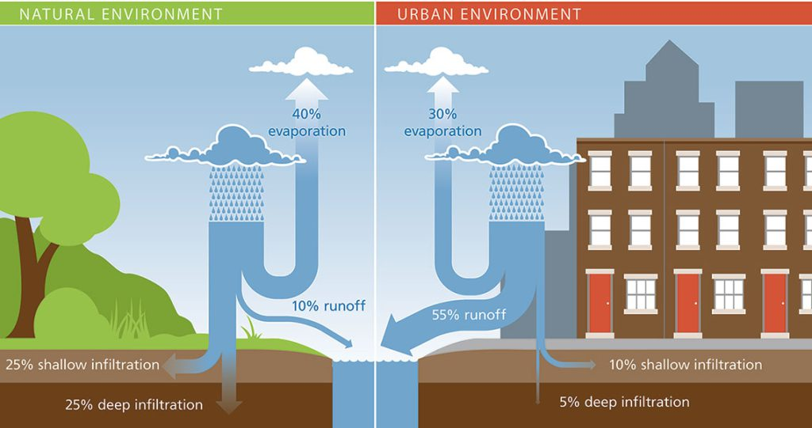

Figure 1: Contrast water budgets between minimally disturbed ecosystems and highly developed urban ecosystems (Image Source: Lara Milligan, University of Florida Institute of Food and Agricultural Solutions)

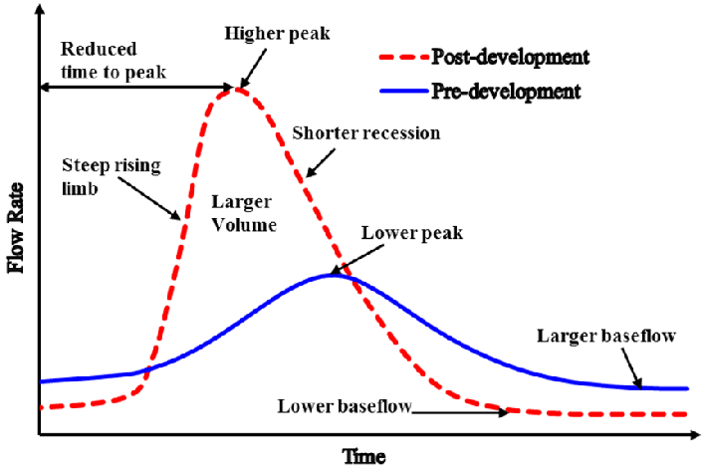

Figure 2: Hydrographs to compare peak discharge, lag to peak discharge, rising and falling limbs, and baseflow between (Image Source: Rezaei et al. (2019). *Desalination and Water Treatment*, 164, 276–292)

**RelatedCareers:** Stormwater Engineer, Landscape Architect, Civil Engineer, Environmental Engineer, Ecological Engineer

**Indiana 4-H Project Connections:** Soil and Water Sciences

**Materials:**

For the entire group:

* Sponge (i.e., an example of a pervious surface)
* Large rock or concrete paver (i.e., an example of an impervious surface)
* Water
* Container to catch water during the demonstration

For each team:

* Writing utensils
* Clipboard with paper or field notebook for outdoor observations
* Materials to represent different surfaces for testing (i.e., sand, clay, tile, concrete pavers, potting soil, sod, etc.)
* Droppers/transfer pipets (measure a set water volume with the number of drops) or a graduated cylinder (measure a set water volume directly)
* Water
* Stopwatch
* Clear beakers or other tall containers to hold surface materials being tested
* 50mL graduated cylinder to measure material volume
* Printed or digital copies of the [results table](https://ecosystems.psu.edu/outreach/youth/sftrc/lesson-plan-pdfs/groundtable.pdf)

**Procedure:**

1. Introduce runoff and the environmental impacts of runoff.
2. Define impervious (impermeable) and pervious (permeable) surfaces. Demonstrate the difference between pervious and impervious surfaces by pouring water onto the class example of a pervious surface (i.e., sponge) and impervious surface (i.e., large rock or concrete paver).
3. Follow the *Observation*, *Experimentation*, and *Analysis* procedures outlined in the [*Ground Surfaces and Infiltration* activity](https://ecosystems.psu.edu/outreach/youth/sftrc/lesson-plans/water/6-8/surfaces) from the Penn State Department of Ecosystem Science and Management. As an alternative to running the *Experimentation* section in the classroom, run the experiment outside to limit the materials that you will need and stress the importance of controlling for other environmental factors that might impact runoff through the selection of test sites, such as differences in slope.
4. Prompt teams to identify impervious surface area in their model cities (Module 1). In the next module, learners will be introduced to solutions for managing stormwater.

**Follow-Up Activities:**

* Use Google Earth or other mapping software to measure the impervious surface area at the school, fairgrounds, or community center. Teams could also estimate surface area through pacing. Calculate the percentage of surface area that is impermeable.

**Module 4: Green Infrastructure & Stormwater**

**Background:** Traditional stormwater management often involves diverting untreated stormwater directly to waterbodies with hard infrastructure, such as curbs and pipes. Stormwater picks up pollution on the land surface (e.g., heavy metals, bacteria, and road salt) and transports this pollution to water bodies. Inspired by natural hydrologic and water treatment processes, ***green infrastructure*** consists of stormwater practices that use infiltration, and evapotranspiration to capture stormwater and filtration and other natural processes to treat pollutants in stormwater. Capturing stormwater volume increases the time to peak discharge and reduces peak discharge in urban streams, moving toward hydrologic regimes more characteristic of less developed watersheds. Green infrastructure may also reduce nuisance flooding and the resulting property damage. Green infrastructure also improves aesthetics and creates better habitat in urban areas. In this activity, learners will explore green infrastructure practices, apply knowledge of these practices to select appropriate green infrastructure practices for different scenarios, and design

**Related Careers:** stormwater engineer, landscape architect, ecological engineer

**Indiana 4-H Project Connections:** Soil and Water Sciences

**Materials:**

* Printed copies of Slide 2 in [this presentation from Teach Engineering](https://www.teachengineering.org/content/usf_/lessons/usf_stormwater/usf_stormwater_lesson02_presentation_v2_tedl_dwc.pptx) for teams to reference
* Two-liter bottles or plastic water bottles with the bases removed
* Large beakers or other containers to hold bioretention cell models (i.e., two-liter bottles or water bottles) and capture the filtrate
* Materials to represent media in bioretention cells, such as sand, pea gravel, gravel, mulch, activated charcoal, and potting soil. Media options should represent a range of textures and organic matter contents.
* Coffee filters or landscape fabric
* Rubber bands
* Water quality testing kits or sensors to test water before and after flowing through the bioretention cell model. You can purchase low-cost multi-parameter sensors, build sensing systems with Arduino or micro:bit, or borrow sensors from local or regional environmental agencies or non-profits. Parameters of interest may include turbidity, total suspended solids, phosphate, nitrate, and conductivity.
* Stormwater or surface water for testing. Alternatively, make your “stormwater” by mixing soil (turbidity) and table salt (conductivity) into tap water.

**Procedure:**

***Introduction to Green Infrastructure***

1. Introduce different green infrastructure solutions for managing stormwater with [this presentation from Teach Engineering](https://www.teachengineering.org/content/usf_/lessons/usf_stormwater/usf_stormwater_lesson02_presentation_v2_tedl_dwc.pptx). If time permits, create a slide deck with examples of green infrastructure in your community. See [the slide narration](https://www.teachengineering.org/lessons/view/usf_stormwater_lesson02) associated with this lesson.
2. After introducing these green infrastructure practices, prompt students to form design teams.
3. These design teams should select an appropriate green infrastructure practice for each scenario in [this presentation](https://app.box.com/s/3bzspctq7j4wewttnnongcgykxk163m0). After selecting a specific green infrastructure practice, students should sketch a site plan with this green infrastructure practice, particularly the location and size of the practice*.

*This activity is modified from the TeachEngineering [*Green Infrastructure and Low-Impact Development Technologies*](https://www.teachengineering.org/lessons/view/usf_stormwater_lesson02)activity. The examples in the presentation that is referenced above are designed to allow the design teams to select an appropriate practice for each site, rather than assigning a specific practice. The aforementioned presentation also uses sites within Indiana.

***Design, Build, and Test Bioretention Cell Media (Build a Filter)***

One of the key design choices for bioretention cells are media layers. These media layers should support plant growth and the filtration, sorption, and microbial processing of pollutants. Students will design, build, and test models of bioretention cells to make recommendations about bioretention media, particularly the type of media included and order and thickness of media layers.

1. Prepare the bioretention cell models for the teams: 1.) Cover the mouths of the plastic bottles (i.e., bioretention cell) with coffee filters or landscape fabric to hold in the media materials that will be added. 2.) Fasten the coffee filters or landscape fabric to the necks of the plastic bottles with rubber bands. 3.) The mouths of the plastic bottles represent underdrains in bioretention cells. Place the bottles into larger containers that will hold these bottles upright and capture any filtrate from the model.
2. Present students with the following scenario: You are a team of stormwater engineers designing a bioretention cell for the parking lot of a new community center. This bioretention cell should treat pollutants in stormwater. The final component that your team needs for this design is the media (i.e., soil) layers in the bioretention. Your team will need to decide on which materials should be included, how layers of materials should be ordered, and how thick each layer should be.
3. Challenge teams to use the engineering design process below to make recommendations for media layers in their bioretention cells.
   * 1. **Understand the problem**: Research common pollutants in stormwater and media used in bioretention cells.
     2. **Brainstorm**: Develop a list of potential solutions and select the best solution.
     3. **Design**: Draft a design on blank paper, including which materials that will be used, order of these materials, and thickness of each layer.
     4. **Build**: Build the model of the bioretention cells.
     5. **Test & Refine**: Test the solution, identify what needs to or can be improved, and refine the design and prototype. Repeat the process of designing, building, testing, and refining as time permits. [Design teams can test the effectiveness of their model bioretention cell by comparing source water to water that has passed through the model with the water quality testing kits or sensors].
     6. **Communicate**: Share your results by creating a diagram of the final design. This diagram should include labels for the materials used and thickness of each layer.

***Modifying Their Sustainable Community***

Prompt students to revise their city (Module 1) to apply their knowledge of green infrastructure to effectively manage stormwater through reducing impervious area and/or capturing and treating stormwater.

**Module 5: Sustainable Waste Management**

**Background:** Excessive waste production can pose significant environmental and public health challenges for communities. Both reduction of waste production and effective waste management are needed to maintain healthy, sustainable communities. In this exercise, learners will apply the engineering design process to design, refine, and pitch a solution for reducing waste production, managing waste streams, or reducing the impacts of excess waste on the environment.

**Related Careers:** Industrial engineer, industrial designer, sustainability manager or consultant, recycling specialist, waste management specialist

**Materials:**

* Printed waste management scenario cards (see below)
* Writing utensils
* Printed project logbook
* Assorted materials and tools for teams to build prototypes of their designs or access to laptops/tablets/computers to build digital prototypes

**Procedure:**

***Engineering Design Challenge***

1. Divide learners into teams of 2-4.
2. Distribute 2-3 scenario cards to each team.
3. Prompt teams to pick one scenario to address.
4. Teams should brainstorm solutions to address their scenario and develop a preliminary design. If time and resources permit, teams could build a physical or digital prototype of their design, test the prototype, and revise the design, repeating the process to move toward an optimal solution. Build a physical prototype with various supplies and tools that you might have on hand, or build a digital prototype with design software, such as Tinkercad. The printed project logbook will guide teams through this process and encourage proper documentation of their design and process.
5. Each team should pitch their solution to the larger group.
6. Teams can revise their solutions based on feedback from peers.

***Modifying Their Sustainable Community***

Encourage teams to develop an outline of a sustainable waste management plan for their city (Module 1).

**Waste Management Scenario Cards**

|  |
| --- |
| **Concrete Clean-Up:** A busy downtown shopping district with lots of concrete and asphalt surfaces is experiencing litter problems, especially after festivals and other events. Devise a waste management system that prevents litter from entering stormwater drains and keeps the shopping district clean. |
| **Apartment Action:** A high-rise apartment building does not provide a method for residents to recycle or compost to divert waste from landfills. Develop a space-efficient recycling and composting systems for the building’s residents. |
| **School Supplies Savers:** Classes at the local elementary school frequently create projects, leading to leftover supplies, such as paper scraps, dried-up markers, empty glue sticks, and crayon nubs. Develop a solution to reuse or recycle some of these materials to divert waste from landfills. |
| **Restaurant Responsibility:** Restaurants, bakeries, and coffee shops in a neighborhood often have leftover food and drinks at closing that cannot be sold the following day. Develop a solution for reducing the amounts of food and drink that are thrown in the trash. |
| **Wildlife Watchers:** Wildlife are getting into trash cans throughout the neighborhood. The trash is getting scattered across the neighborhood and poses a health hazard to wildlife. Design a retrofit for residents’ lidded trash cans to keep wildlife safe. |
| **Cafeteria Care:** An elementary school wants to improve recycling rates in the cafeteria, but younger students often contaminate recycling streams by incorrectly disposing of items. Design a system to limit the number of items that are disposed of incorrectly. |
| **Textiles Transformation:** A local clothing manufacturer produces significant fabric waste during the production process. Design a system to repurpose or recycle textile scraps. |

**Follow-Up Activities:**

* Expand on this waste reduction or management solution to develop an Invention Convention project.

**Module 6: Habitat Fragmentation & Wildlife Corridors**

**Background:** Urban wildlife must have habitats with sufficient cover, food, water, and space. Fragmentation is a natural process, whereby habitats are separated into smaller, discontinuous patches by natural disturbances, such as fire, landslides, and extreme weather events, or landscape features, such as mountains and rivers. Human activities, such as developing land and growing crops, accelerate and exacerbate habitat fragmentation, leading to small, disconnected patches. A population refers to organisms belonging to the same species in a patch, while the metapopulation includes organisms belonging to the same species spread across different patches. Carrying capacity is the maximum number of individuals of a population that can be sustained in a given area without degrading the environment. Smaller patches from anthropogenic fragmentation sustain smaller populations due to limited space and resources, which decreases the carrying capacity of the larger fragmented area. Two key drivers of species' survival in highly fragmented urban and suburban ecosystems are 1) the size of each population (i.e., the number of individuals of a species in a patch) and 2) the connectivity across patches of different populations. Wildlife corridors can increase connectivity between patches in urban and suburban ecosystems. In this activity, youth will learn about the impacts of small patches due to fragmentation of wildlife populations and apply the engineering design process to develop wildlife corridors to connect passages.

**Indiana 4-H Project Connections:** Wildlife

**Related Careers:** Wildlife Biologist, Natural Resources Manager, Civil Engineer, Environmental Engineer

**Materials:**

* Roll of yarn/string
* Scissors
* Wildlife profile cards (1 per group)
* Sticky notes
* Paper
* Writing utensils
* Assorted prototyping (i.e., craft) supplies and tools (e.g., cardboard)
* Ruler or tape measure
* Small weight

**Procedure:**

1. **Introduce habitat fragmentation:** Facilitate a demonstration of the impacts of habitat fragmentation on wildlife with Activities 8.1 (Accessing prior knowledge) and 8.2 (Testing ideas related to population size) from Loyola Marymount University’s Center for Urban Resilience.
2. **Increase connectivity between patches with wildlife corridors**
   1. Ask the larger group what pedestrians need to safely cross busy intersections or highways. Prompt the group to think about the structures that help humans cross roads and highways safely. Introduce how highways and roads separate patches of wildlife habitat and how crossing highways puts the safety of wildlife and drivers at risk. Just like certain structures and systems help pedestrians cross busy highways and roads, dedicated wildlife crossings (i.e., man-made wildlife corridors).
   2. Screen the following video for the group:[***How wildlife crossings protect both animals and people***](https://youtu.be/pzUIbvYMSDI?si=s6AYV83vU-wOSh9h)
   3. Divide the class into small design teams of 2-4 learners and assign each team a wildlife profile card. The information on the wildlife profile cards will help teams adapt their design for their target species.
   4. Challenge students to use the engineering design process below to develop a highway crossing for their species and build a prototype with available materials. Present design teams with the following design criteria and constraints. Encourage teams to test the minimum width and the load-bearing capacity.
      1. **Understand the problem**: Learn about the target species from the *Wildlife Profile Card.*
      2. **Brainstorm**: Develop a list of potential solutions and select the best solution to satisfy design criteria and constraints.
      3. **Design**: Draft a design on blank paper, including dimensions and materials that will be used.
      4. **Build**: Build a prototype from available materials. Indicate what materials or components in the final build are represented by different
      5. **Test & Refine**: Test the solution, identify what needs to or can be improved, and refine the design and prototype. Repeat the process of designing, building, testing, and refining as time permits.
      6. **Communicate**: Prepare an elevator pitch to share your results with community members. Use the prototype to convey your message during the pitch.

**Design criteria:**

1. ***Safety***: The crossing should prevent vehicle collisions with wildlife.
2. ***Accessibility***: The crossing should be easily used by the target species. Consider what might attract the target species to the crossing.
3. ***Connectivity***: The crossing must connect habitat patches on either side of the highway, spanning the minimum combined widths of the shoulder and lanes. Model this width as a minimum of 12 inches when testing your prototype.
4. ***Load-Carrying Capacity:*** The crossing must meet state standards for load-carrying capacity. When testing your prototype, model this load capacity as 3 pounds (substitute in the weight/object you are using). For above-ground crossings, place directly on the crossing during the test. For underground crossing, place the weight directly on the highway. Visually monitor for signs that the structure may collapse.

**Design constraints:**

1. ***Sustainable materials:*** The crossing must only be built from environmentally friendly materials that are available locally.
2. ***Optional - Budget***: The construction materials must only cost X. [Facilitator: Set prices for the prototyping materials. Then, set a maximum material budget for the crossing].
3. **Modify cities:** Prompt teams to consider the size and connectivity of patches of wildlife habitat in their sustainable city (Module 1) impacts wildlife, especially biodiversity. Teams should consider redesigning their city with consideration for patch size (i.e., a larger wildlife refuge, rather than numerous, small refuges) and path connectivity (i.e., adding wildlife crossings and corridors).

**Wildlife Profile Cards**

|  |  |
| --- | --- |
| **White-tailed Deer**  DNR: Fish & Wildlife: White-tailed Deer Biology  Image Source: Indiana DNR  ***Physical characteristics:*** Large mammal with reddish-brown fur during summer, grayish fur during winter, and a distinctive white tail  ***Habitat:***  *Cover:* Prefer mixed and deciduous forests  *Food:* Herbivore: forbs, browse (leave, soft shoots, and buds of woody plants), nuts, soft fruits (mast), and crops  *Space: R*equire large areas for foraging and mating  ***Movement:*** Can travel several miles daily, reach speeds up to 35 mph  ***Activity***: Primarily crepuscular (active at dawn and dusk), active year-round with increased movement during the fall mating season | **Bobcat**    Image Source: Indiana DNR  ***Physical characteristics:*** Medium-sized wild cat (15-30 pounds) with a spotted coat and short bobbed tail  ***Habitat:***  *Cover:*  Forests with brushy areas, rocky areas, wetlands  *Food:* Carnivore: small mammals and birds  *Space: R*equire large territories with diverse habitats, home range of 3800-7600 acres for females and 19200-48000 acres for males  ***Movement:*** Solitary, can travel several miles daily  ***Activity***: primarily nocturnal (active at night) and crepuscular (active at dawn and dusk), active year-round |
| **Eastern Box Turtle**    Image Source: Indiana DNR  ***Physical characteristics:*** Small- to medium-sized turtle with a high, domed shell; shell typically has yellow to orange streaks and patches  ***Habitat:***  *Cover:* terrestrial turtle that prefers forests but may be found in grasslands and wetlands  *Food:* Omnivore: insects, herbaceous vegetation, fruit, and mushrooms  *Space*: small range, typically less than 2 acres  ***Movement:*** slow-moving, small range  ***Activity***: Diurnal (active during the day), active spring through fall, hibernates during the winter  ***Conservation Status:*** State Special Concern (Indiana) | **Gray Fox**    Image Source: Indiana DNR  ***Physical characteristics:*** Medium-sized canid (8-15 pounds) with gray fur on most of their bodies, reddish fur on their legs and neck, and a tail with a black stripe and tip  ***Habitat:***  *Cover:* Forests, forests with brushy areas  *Food:* Omnivore: small mammals, birds, fish, insects, fruit, and vegetation  *Space*: Territorial, solitary, home range of 190-1600 acres  ***Movement:*** can travel several miles daily, can climb trees (semi-arboreal), avoid humans  ***Activity***: Crepuscular (active at dawn and dusk) and nocturnal (active at night), active year-round |
| **Coyote**    Image Source: Indiana DNR  ***Physical characteristics:*** Medium-sized candid (20-50 pounds) with grizzled gray or buff fur with a bushy tail  ***Habitat:***  *Cover:* Historically prairies but have adapted to a variety of habitats  *Food:* Omnivore/opportunistic feeders: small mammals, fruits, insects, birds, carrion  *Space*: Large home ranges (2500-9600 acres)  ***Movement:*** Can travel long distances, often follow the edges of habitats  ***Activity***: Nocturnal (active at night) and crepuscular (active at dawn and dusk), active year-round | **Raccoon**    Image Source: Indiana DNR  ***Physical characteristics:*** Medium-sized mammal with black mask and ringed tail  ***Habitat:***  *Cover:* Forests; nearby streams, ponds, and wetlands  *Food:* Omnivore/opportunistic feeders: nuts, fruits, insects, small animals  *Space: H*ome ranges span from 7.5 acres to 12,000 acres,depending on habitat type; typically not territorial with overlap in home ranges  ***Movement:*** strong climbers, can travel several miles daily  ***Activity***: nocturnal (active at night) and crepuscular (active at dawn and dusk), active year-round |
| **Wild Turkey**    Image Source: Indiana DNR  ***Physical characteristics:*** Large ground bird with dark brown and black feathers  ***Habitat:***  *Cover:* Forests and open areas (forest edge and grassland)  *Food:* Omnivores: insects, seeds, fruit, herbaceous vegetation, crops  *Space*: Large territories: 400-2000 acres  ***Movement:*** Can walk or fly short distances  ***Activity***: Diurnal (active during day) | **Northern Bobwhite**    Image Source: Indiana Audubon  ***Physical characteristics:*** Small ground-dwelling game bird; males have a white throat and chin with a white stripe above the eyes, while females have brown throats and chins  ***Habitat:***  *Cover:* grassland, prairie, edges of agricultural land, shrubby woodlands  *Food:* Omnivores: seeds, insects, fruits  *Space*: Not considered territorial, coveys (groups) have overlapping ranges, optimal home range of 20-40 acres  ***Movement:*** Short flights, ground foraging  ***Activity***: Diurnal (active during day)  ***Conservation Status:*** State Special Concern (Indiana) |

**Follow-Up Activities:**

* Become a citizen scientist by helping the Indiana DNR monitor wild turkeys with the [*Wild Turkey Brood Reporting* program](https://www.in.gov/dnr/fish-and-wildlife/wildlife-resources/animals/wild-turkey/turkey-brood-reporting/), which takes place from July 1 to August 31 each year. Outside of the reporting period, build data science skills by reviewing and summarizing [turkey brood reports from previous years](https://www.in.gov/dnr/fish-and-wildlife/wildlife-resources/animals/wild-turkey/turkey-brood-reporting/).

**Module 7: Renewable Energy**

**Background:** By adopting renewable energy technologies, such as solar, wind, and hydroelectric power, communities can become more sustainable by reducing their carbon footprint. Renewable energy can also support local energy independence and foster economic growth through job creation. In this activity, learners will explore renewable energy sources and the role of batteries in storing energy through hands-on activities with Snap Circuits Green Energy kits.

**Related Careers:** Electrical Engineer, Mechanical Engineer, Materials Engineer, Renewable Energy Service Technician, Urban Planner

**Indiana 4-H Project Connections:** Weather and Climate Science, Electric

**Materials:**

* Snap Circuits Green Energy kit
* Devices with access to the Internet (for Optional Step 2)
* Soda or juice (optional)

**Procedure:**

1. Introduces connections between climate change and energy sources with this video: [Climate Change Series – 7. Renewable Energy and Climate Change](https://www.youtube.com/watch?v=H1jVz5uxQ8o).
2. Optional: Incorporate place-based education by having students use the EPA’s Power Profiler Tool to research energy sources for electricity generation in their community. The steps are outlined below for students. Alternatively, do this exercise as a larger group.
   * Navigate to the [Power Profiler tool](https://www.epa.gov/egrid/power-profiler#/).
   * Enter your zip code on the left side of the page
   * Review the fuel mix, which summarizes the proportion of electricity generation that can be attributed to different renewable and non-renewable energy sources.
   * Contrast local carbon dioxide (CO2), sulfur dioxide (SO2), and nitrogen oxides (NO and NO2) emissions from electricity generation to national averages. How do emissions from your community compare?

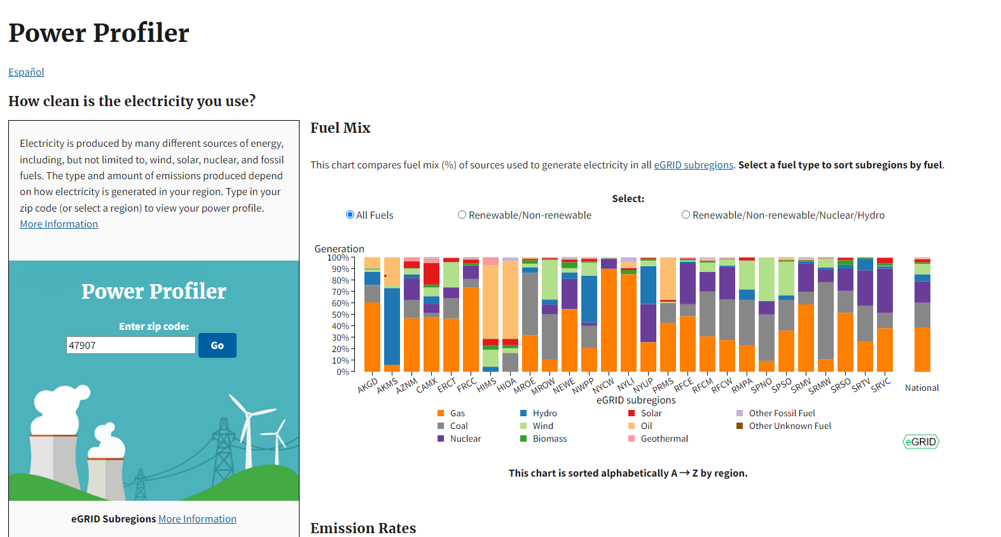

1. Small groups should explore energy by constructing circuits that are powered with renewable energy sources using the Snap Circuits Green Energy Kits. The following projects in the Snap Circuits Green booklet introduce how renewable energy sources can generate electrical power. Set these activities as stations. Have groups construct 1-2 of these circuits and then facilitate a gallery walk where each group will explain their circuit and related concepts to other groups.
   * + Energy Conversions
       - 1 (using magnetism to convert mechanical energy to electricity and electricity powers different devices)
     + Solar Energy
       - 4 (introduction to solar energy)
       - 7 or 14 (battery charging with solar)
       - 38 (solar car)
     + Wind Energy
       - 9 (introduction to wind energy)
       - 10 (wind speed versus electricity yield)
       - 7 (battery charging with wind)
       - Contrast 26 and 27 (aerodynamics of wind turbines)
       - 39 (wind-powered car)
     + Hydroelectric Energy
       - 81 (introduction to hydroelectric power – flowing water)
       - 84 versus 85 (role of dams in hydroelectric power – conversion of potential to kinetic energy and then to electricity)
2. Teams should explore batteries as energy storage solutions for renewable energy sources by constructing circuits with the Snap Circuits Green Energy Kits. The following projects in the Snap Circuits Green booklet focus on the role of batteries in storing energy for later use. Set these activities as stations. Have groups construct 1-2 of these circuits and then facilitate a gallery walk where each group will explain their circuit and related concepts to other groups.
   * + 2 (mechanical energy converted to electricity to charge a battery)
     + 3 (assess best configuration for charging)
     + 12 (batteries can provide reliable power when electricity from the green energy source cannot be presently generated)
     + 41 (battery load)
     + 59 versus 60 or 61 versus 62 (contrast configurations of batteries and green energy sources)
     + 71 and 72 (use soda or juice to explore transformations between chemical and electrical energy in batteries)
3. Prompt teams to make their cities (Module 1) more sustainable by applying knowledge gained from this activity to incorporate sources of renewable energy into their cities.

**Module 8: Zoning and Land Use with *iPlan***

**Background:** Developed by researchers at the University of Wisconsin-Madison and Mass Audobon, iPlan is an online game that helps users explore intertwined social, economic, and environmental systems and how zoning and land use changes impact these systems. Socio-economic and environmental indicators in the game include population, jobs, greenhouse gas emissions, impervious surface area, and biodiversity. Land uses include commercial, cropland, industrial, limited use, conservation, pasture, recreation, high-density residential, low-density residential, timber, and wetlands. Read more about[**iPlan.**](https://education.wisc.edu/news/iplan-lets-game-players-reimagine-land-use-based-on-real-science/)

**Related Careers:** Urban Planner

**Materials:**

* Devices with access to Internet to use *iPlan*
* Accounts on *iPlan*

**Procedure:**

1. Have students work through the iPlan Tutorial, which uses Wilkesboro, NC as an example scenario for modifying zoning to meet the goals of diverse stakeholders. Through the tutorial, students will develop a zoning plan for Wilkesboro, North Carolina in the tutorial and then submit the zoning proposal to stakeholders for feedback. The goal is to develop a zoning plan that meets the requests of as many stakeholders as possible.
2. Encourage students to explore their community in the main map after completing the tutorial. In the main map, users can select up to five environmental or socio-economic indicators. The availability of certain indicators may differ based on the selected region.
3. Encourage students to modify their model cities from Module 1 based on what they learned about zoning and land use.

**City Showcase**

Provide an opportunity for teams to showcase their cities and modifications to these cities based on what they learned about sustainability. Teams should prepare their LEGO city model and maps of their cities with key features labelled. The teams may need to create multiple maps to convey their modifications (i.e., stormwater management map and land use map). These maps could be handwritten or be computer-aided designs.

Teams should also be prepared to give a short talk about their cities, the changes that they have made to make their cities more sustainable, and why they made these changes.