4-H Online Event Registration Instructions: State Shooting Sports Events
All Disciplines May 13th: Air Pistol, Air Rifle, Archery, Pistol, Rifle, Muzzleloading
Shotgun May 20th
Before you Begin:
- If you are registering as an individual, you must be in Approved status in 4-H Online to register. You must also provide the contact info of the parent who will be attending with you to the event during the registration process.
- If you are a coach registering a team, you must have an Approved Volunteer profile in 4-H Online to register.
- Team Registration:
  - Before you begin you must have the following information to complete registration
    - What division are you signing up under?
      - Junior: Grades 3-7 (as of Oct 1, 2022)
      - Senior: Grades 8-12 (as of Oct 1, 2022)
      - General: team members are a mix of grades (as of Oct 1, 2022)
    - Name of Coach and contact information
    - Which contest you are participating in (for May 13th registration)
    - Names of team members
    - Grades of team members
  - You can submit multiple registrations after you complete the first one if you have more than one team. You will also need to complete the event registration for each event if you are competing in both weekends.
- Costs:
  - All Disciplines May 13th: $30/person or team member
  - Shotgun May 20th $50/person or team member

Instructions for completing the Registration Teams and Individuals:
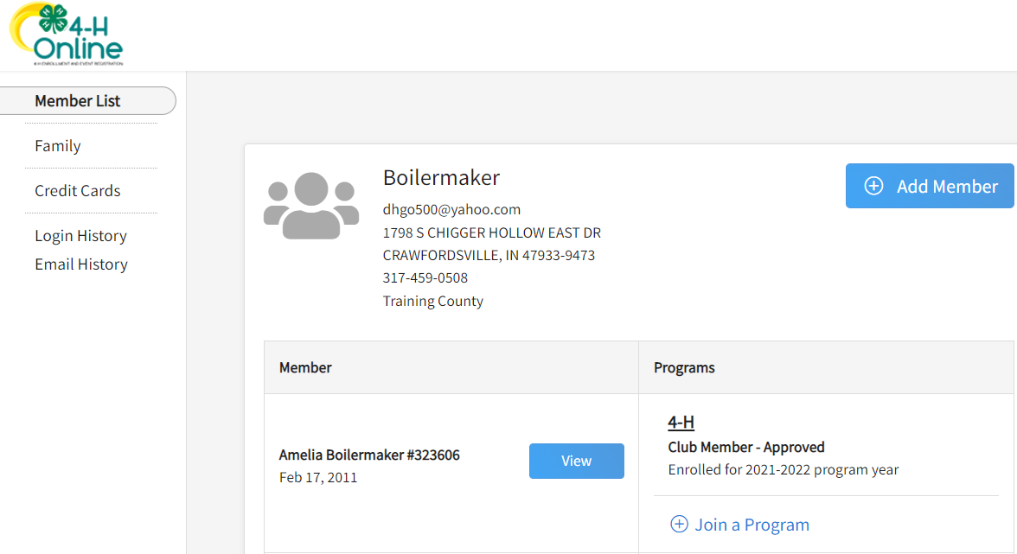
- Login to your 4-H Online account and click View next to your name.

- Click on Events and then on Register
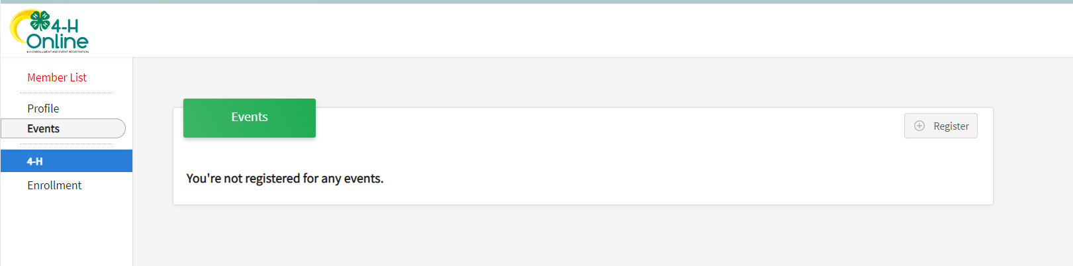
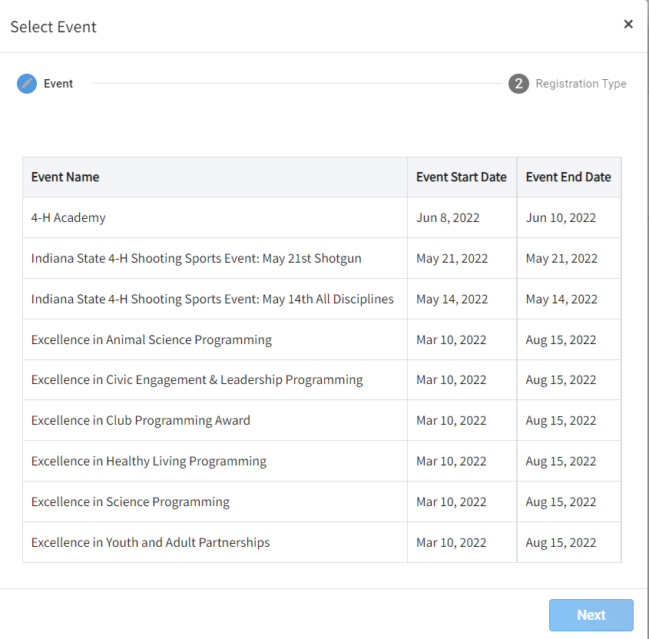
- Locate either the “Indiana State 4-H Shooting Sports Event: May 13th All Disciplines” or “Indiana State 4-H Shooting Sports Event: May 20th Shotgun” event and select it, then click Next. If you are competing in both, once you completed this first registration, you can do the next one upon submitting the first
one.

- Select the registration type name followed by Start Registration. Pay attention to what Registration Type you are selecting. The Team Registrations are by Division. Junior (3-8 grade as of Oct 1, 2022) or Senior (9-12th grade as of Oct 1, 2022) or General (if you have a mix of ages on a team). Individuals will see just 1 type to select.

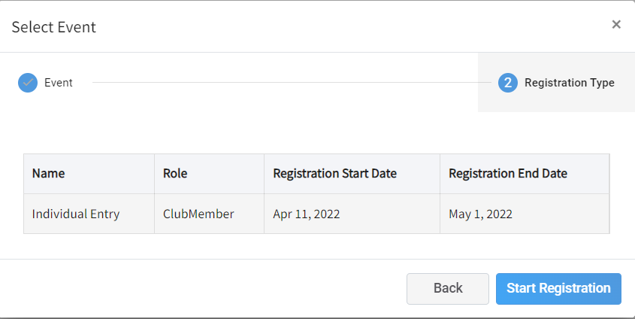
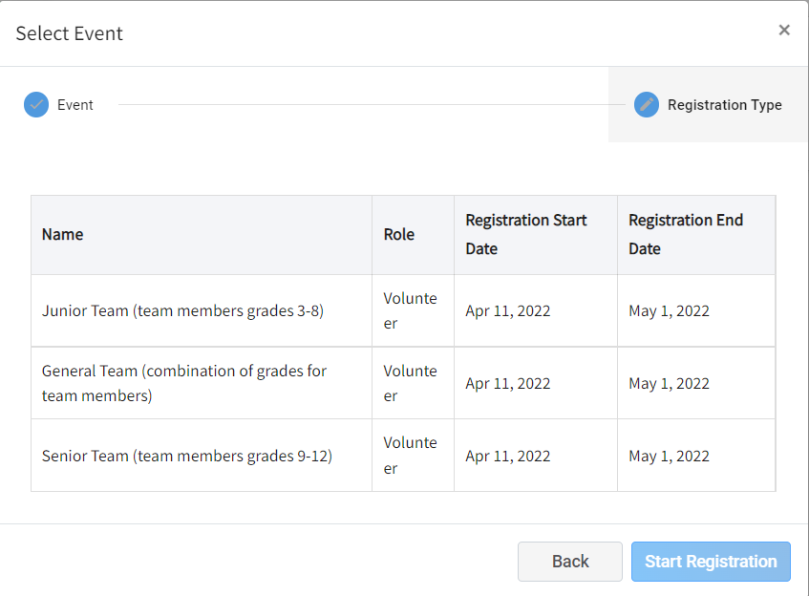
Team Individual

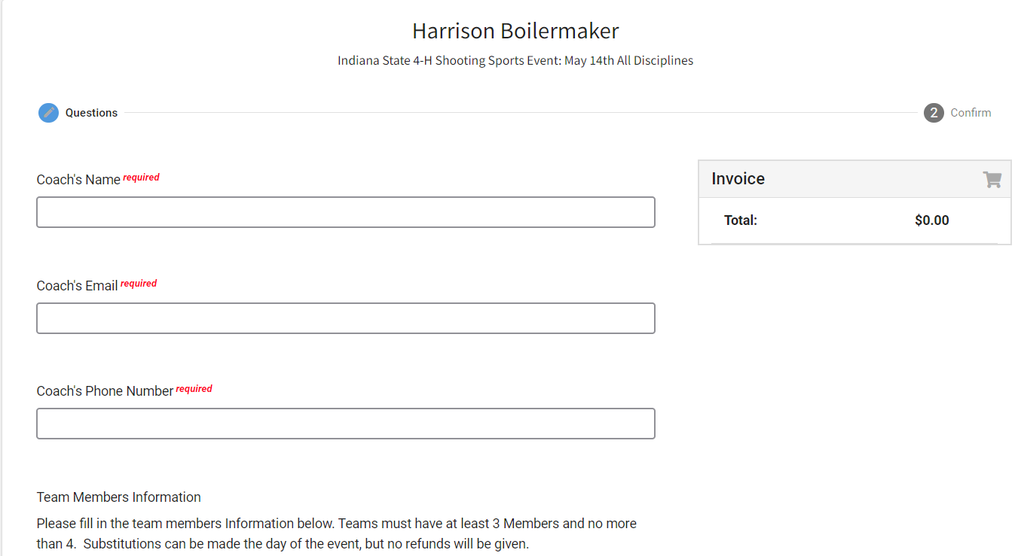
- Fill out the information you gathered before you began (reference the “Before you begin” above). Then click Next.

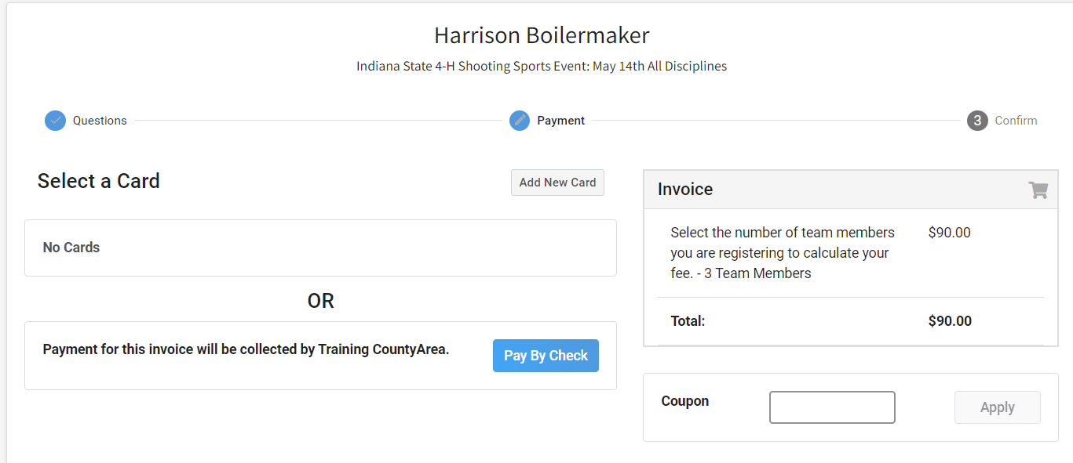
- Select method of payment and then confirm the registration to procced to submit.

- A list of event registrations that have been submitted will appear. To add more teams for either the same event or another repeat steps 2-7.
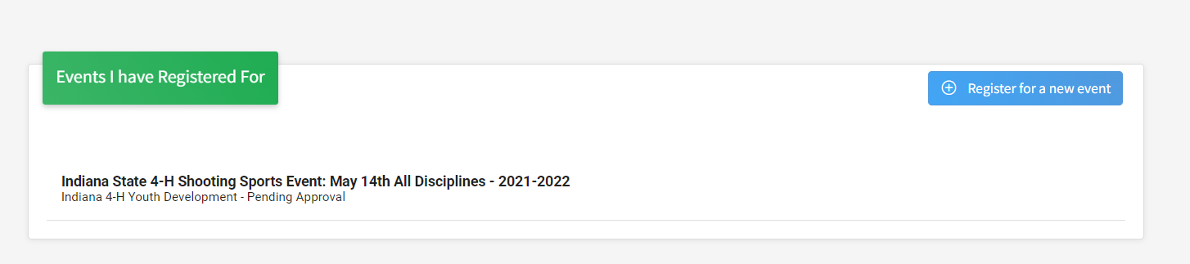

Additional Notes:
- If paying by check, please send payment to your local County Purdue Extension Office. Checks can be made payable to ____ (your county) ___County Purdue CES Fund.
- If paying with credit card, your payment will be processed shortly after your registration has been submitted.

