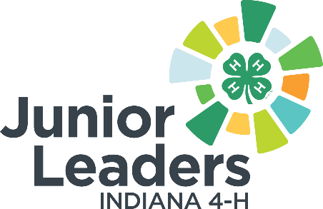
Medicine 101 Vocabulary

Acetaminophen: common OTC relieves pain and fever, but does not reduce inflammation.

Active Ingredient: ingredient in a pharmaceutical drug that is biologically active.
Analgesics: From two Greek words “an” (without) and “algos” (pain), this group of drugs relieves pain

Antacid: preventing or correcting acidity, especially in the stomach.
Antiperspirant: Used to reduce or eliminate “underarm wetness”

Aspirin: a synthetic compound used medicinally to relieve mild or chronic pain and to reduce fever and inflammation
Brand Name Drug: Patented drug sold exclusively by the company that controls the patent
Diuretic: type of medicine that functions to help the body eliminate excess water

Dextromethorphan (DXM): An oral cough suppressant available without a prescription, but which is sometimes abused and results in “skittling”
Dose: a quantity of a medicine or drug taken or recommended to be taken at a particular time
Driving Under the Influence of Drugs (DUID): Driving unsafely because you have prescription or OTC drugs in your system, which can result in being arrested and charged with this violation

Excipient: an inactive substance that serves as the vehicle or medium for a drug or other active substance
Food and Drug Administration (FDA): This federal agency regulates the Drug Facts Label. Responsible to make sure drug manufacturing processes and the drugs themselves are safe and effective.

Generic Drug: Contains the same active ingredient, the same amount of active ingredient, and the same dose as the Brand name.
Hepatotoxicity: the medical term for liver poisoning
Inactive Ingredients: components of a drug product that do not increase or affect the therapeutic action of the active ingredient

NSAID: This abbreviation stands for non-steroidal anti-inflammatory drugs

Over-the-Counter (OTC): medicine you buy off-the-shelf without a doctor’s order
Pharmacist: A health care professional; this person is licensed to dispense prescription drugs

Poison Control Center: A toll-free telephone service, which provides emergency advice and response to poisoning

Prescription: medicine you purchase from a pharmacy with a health care professional’s order
Pseudoephedrine: An ingredients used to make “meth;” the sale of drugs containing this OTC substance is sometimes restricted.

Rx: These two letters indicate a prescription drug
Side Effects: a secondary, typically undesirable effect of a drug or medical treatment
Skittling: taking cold remedies in small pills that look like Skittles candy in order to get high

New May, 2020

