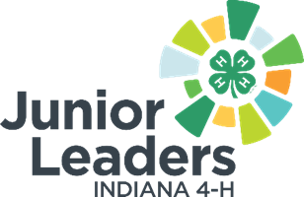

TEMPLATE for County 4-H Junior Leader Officer Role Descriptions
Qualifications:

Skills:

Responsibilities:

What you will gain from this:

