 Animal Identification

Animal Identification
4-H members (Grades 3 – 12) must identify all Beef and Dairy Cattle, Goats, Horses, Llamas, Sheep and Swine in the 4-H Online system by the species deadline or earlier county deadline if applicable to be eligible for exhibition.
• Beef and Dairy Beef Steers, Beef Heifers, Beef/Dairy Feeder Calves, Dairy Cattle, Goats, Horses, Llamas, Sheep, and Swine must be entered into 4-H Online no later than May 15, 2026.

Animal Identification in 4-H Online
Please complete the following steps to identify your livestock in the 4-H Online system.
1. Login to your family profile at: https://v2.4honline.com using your family email address and password associated with your 4-H enrollment record.
- If you have forgotten your password, please use the ‘Reset password’ option on the 4-H Online login page, and you will be sent a new temporary password.
- If you have forgotten your family email address or turned in a paper 4-H enrollment form, please contact your local Purdue Extension Office for assistance. 2. Click View next to the Member’s record for whom you would like to add an animal
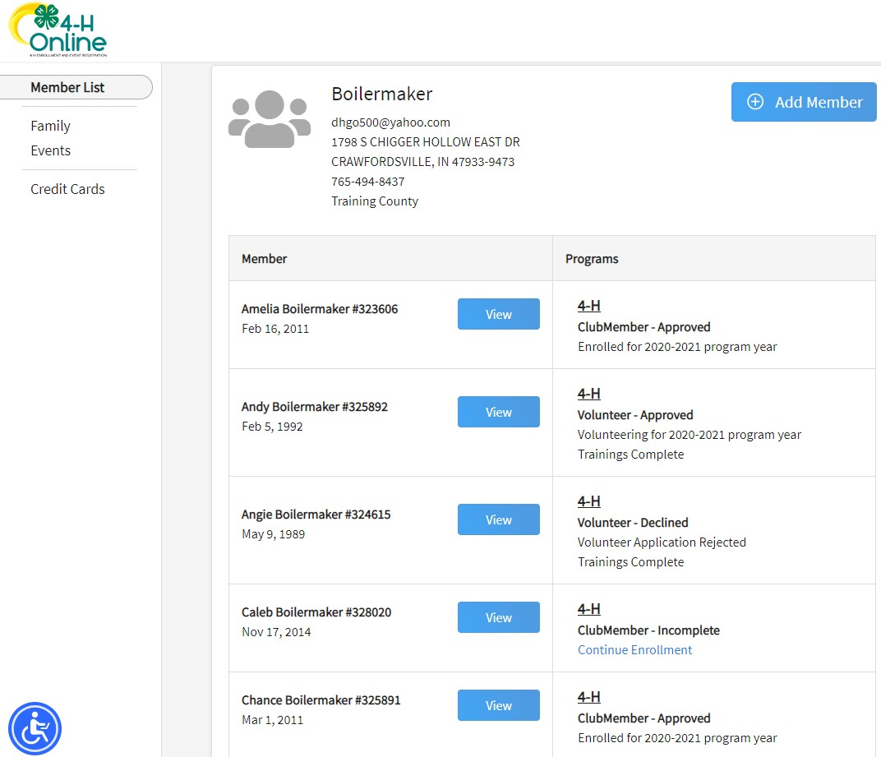
- Click Animals in the navigation pane.
- Click the blue "Add an Animal" button. (even if you have previous year animals that can be registered again, click "Add an Animal")
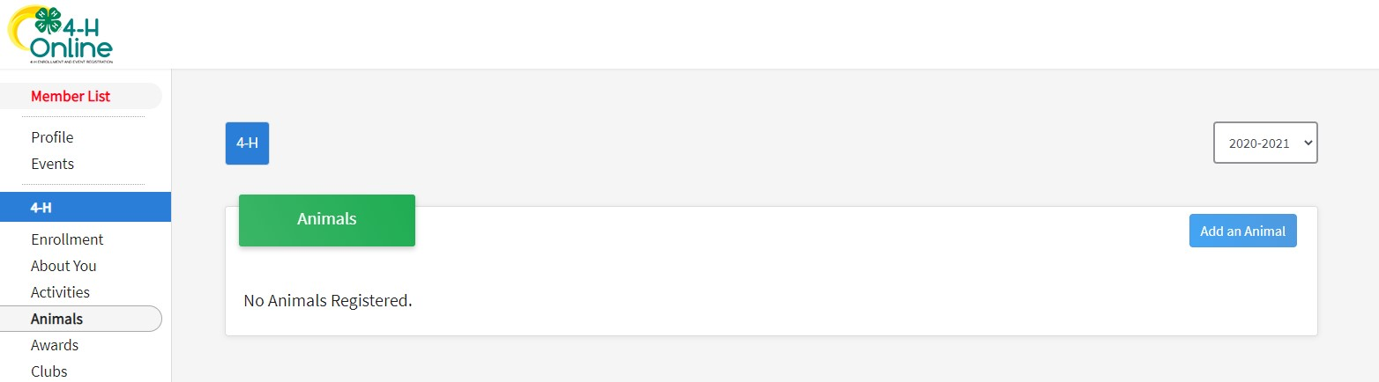
1

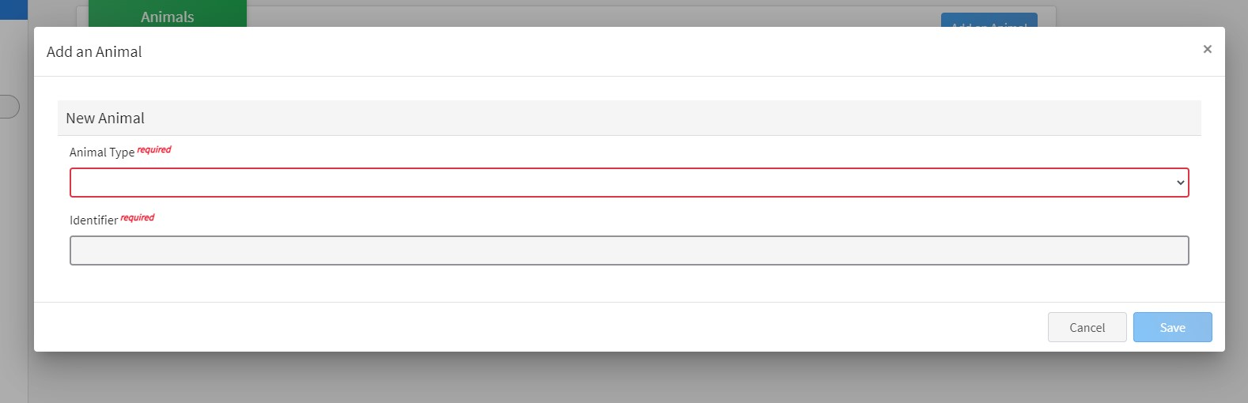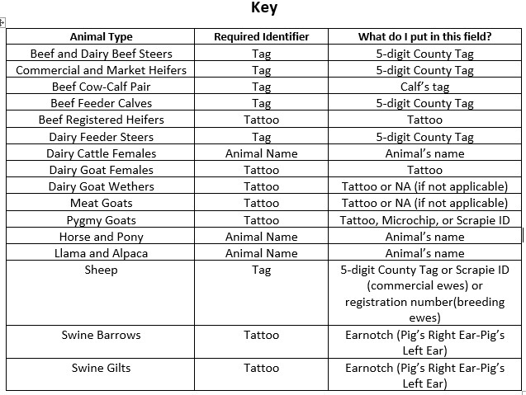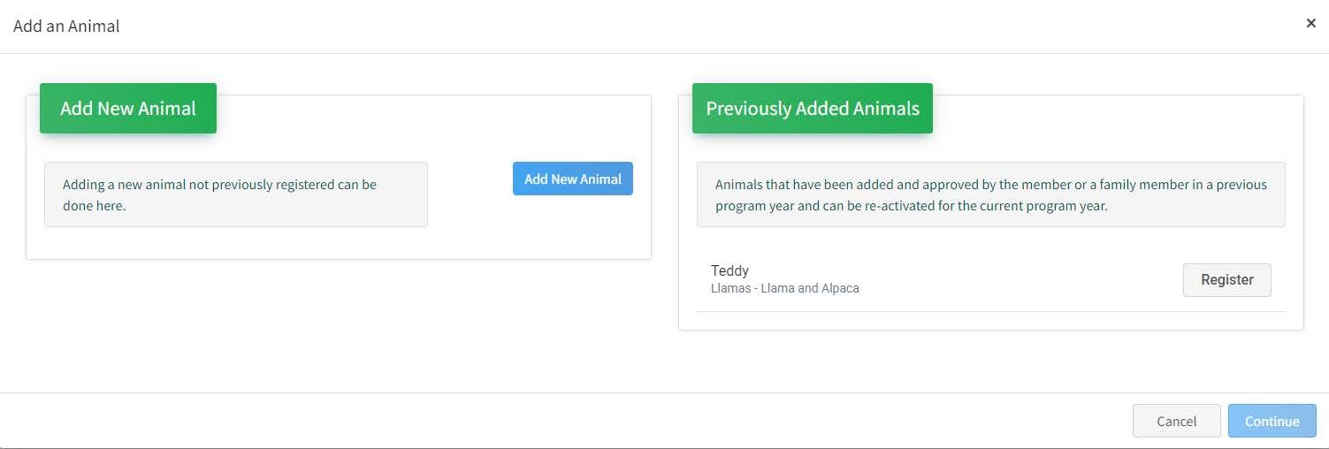
Animal Identification
5.
Click on
"
Add New Animal
"
to start adding a new animal

or
if
you have animals that carry over from the previous year you
"
Register"
those
. Animals that can be registered from
previous years
must be

REGISTERED
every year by
complet
ing
this step. You cannot select a previous year and
assume they are there.
Animals
that carry over

are Dairy
Cattle Females, Horse&Pony, Llama&Alpaca, Dairy

Goat
Females, and Pygmy Goats
(move onto step 9 if registering
previous animal).
6.
Select the appropriate animal type from the drop-down menu.
7.
Enter the required Tag, Tattoo, or Animal Name as directed
for the first step that will then allow you to proceed to the
remaining identification process.

(
see

Key)
8.
Click Save.
- Read the on-screen instructions for Animal ID requirements for County Fair and Indiana State Fair Exhibition.
- Click on the button "Show Questions" after reading the instructions.
- Required fields are indicated, but be sure to complete all other visible fields as applicable.
- Click next once completed. If animals have been carried over, the ID information will already be there.
- Upload any files if required or necessary for the particular Animal type. For animals that are carried over, new photos and files must be uploaded each year.
- Click next once completed.
- Review the entered information. Use the Back button at the bottom of the page to return to the previous screen to make corrections if needed.
- Once the entered information is correct and reviewed, click the Submit button.
- The animal information will display on the screen with the status, created, modified, and submitted date and time stamp (local time). You will also receive a confirmation email upon submission.
- To add more animals for the same member repeat steps 3-17. To add animals for another member return to the Member List and View another member.
**Note** Members are able to edit Animal ID information until the species specific Animal ID deadline of May 15, 2026.
Click on the Animals tab from your account at any time to view the status for all of the animals for a member in the family.

Family Enrollment of Animals
Animals are automatically co-enrolled within the same family (Siblings and step-siblings). The animals
may be identified under a single 4-H member in 4-H Online and be exhibited by a different sibling listed in the same family profile. With this capability in 4-H Online, animals do not need to be entered 2 under each 4-H member in the family. The exhibit management program will allow a member to select to exhibit any animal identified by the family in 4-H Online. It is suggested that at least 1 animal be identified by each member enrolled in the project.

