4-H Robotics State Competition
The date of the Indiana 4-H Robotics Competition will be March 14th and will be held at the Indiana State Museum Get your teams together now. Registration information will be announced shortly.

Competition Specifics
Events using this game format will use the known challenges outlined below, as well as additional unknown challenges that will be released on the day of the contest. Successful teams should pre-build and pre-program their robot prior to the competition for the known challenges. On the contest day, time will be given to account for additional building and programming for the unknown challenges. Expect 1 ½ to 2 hours.
Teams will be allowed shared access to the game tables during this time.

Divisions
  - Junior - Grades 3-8
  - Senior Grades 9-12 – Seniors have a separate challenge which is detailed below.
  - Seniors will have additional unknown challenges released on the day of the contest.
- Teams will consist of 2-4 (four) youths.
- Each team must be made up of current 4-H members. To sign your team members up for 4-H, contact your local Extension Office and go to 4-H Online
Other headings identify and highlight other main ideas within a document

Game Table Design
4’X8’ board surrounded by 2X4's The size of the actual board will be 45”x 93”
All assets that do not have a defined starting point on the field will be outside the game board. i.e., the trough will be in the designated feed trough area, but the “feed” will be stacked outside the game board and can be put onto the robot manually.
While not required if you would like a game board it can be purchased at
https://shop.frecklesgraphics.com/purdue_4h_extension_robotics_pl/shop/home

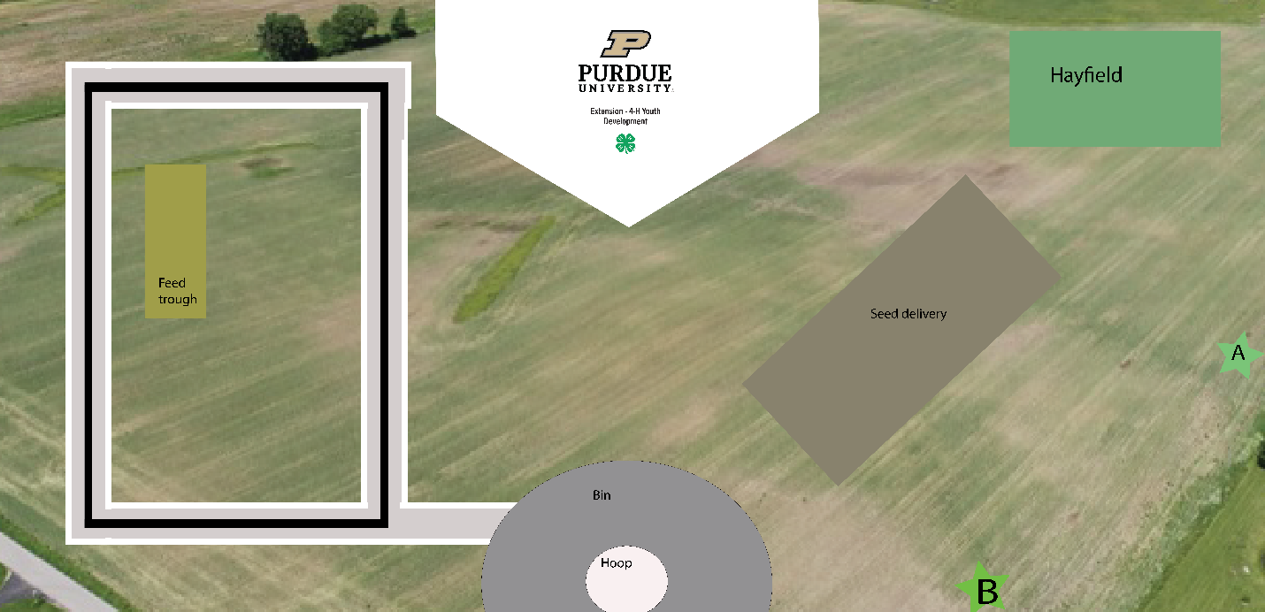

Objectives and Rules

 | Objective | Description | Point Value
1 | Deliver packages to the houses. There will be 4 houses placed on the outside perimeter of the black road. One foam square in the corresponding color will be delivered to each home.  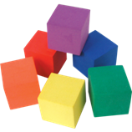 | Houses will be 3-D printed and no larger than 12.7 cm sq. (approx. 5 inches)  If a color or light sensor is used for the duration of the trek, bonus points will be awarded. The team captain must notify the judge before starting the challenge that the sensor will be used.  The black line is exactly 6 1/2 inches from the board's edge. | 75 points per package delivered at the matching house.  If the wrong color is delivered, team will earn no more than 25 points.  If package is delivered in the road, team will lose 15 points.  A 100-point bonus for incorporating the color/light sensor  300 points maximum
2 | “Swing the baby”  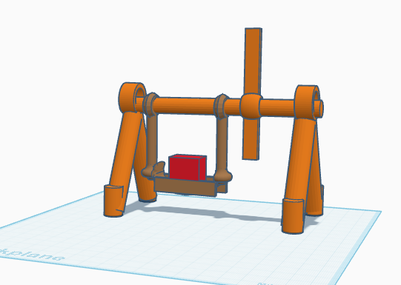 | The swing will be located in the “Hay Delivery” section of the board. Swing will be swung forward and back three times by the robot without the “baby” falling out. | 200 points for successfully completing the challenge.  200 points maximum
3 | Sandbox Sort – There will be two boxes. One with 3 ping pong balls and 3 boxes, and one empty. All ping pong balls need to be moved to the second box.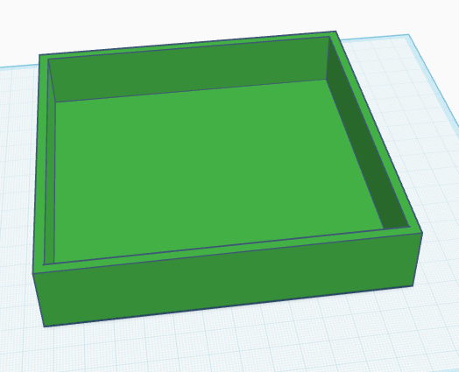   https://www.thingiverse.com/thing:7217611 | The green box will contain three ping-pong balls and three foam boxes. The three ping pong balls need to be moved to the orange box.  The sandbox will be located near point A and the empty box near point B | The score will be tabulated at the end of the match. – 25 points per ball. – 75 points maximum
4 | See Saw Balance - Balance two provided foam squares so that the seesaw is balanced and not touching the ground.  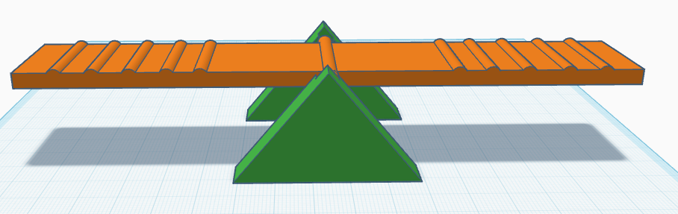  https://www.thingiverse.com/thing:7217638 | The seesaw will be located in the Hayfield area and the foam squares will be outside of the field.  Foam squares must be touching the last marker on the seesaw to receive points. The board must be approximately balanced and not touching the ground on either side. | 50 points tabulated at the end of the match.
5 | Terrain obstacle – Each of the 8-10 hex blocks will be fastened to the table with Velcro closely together.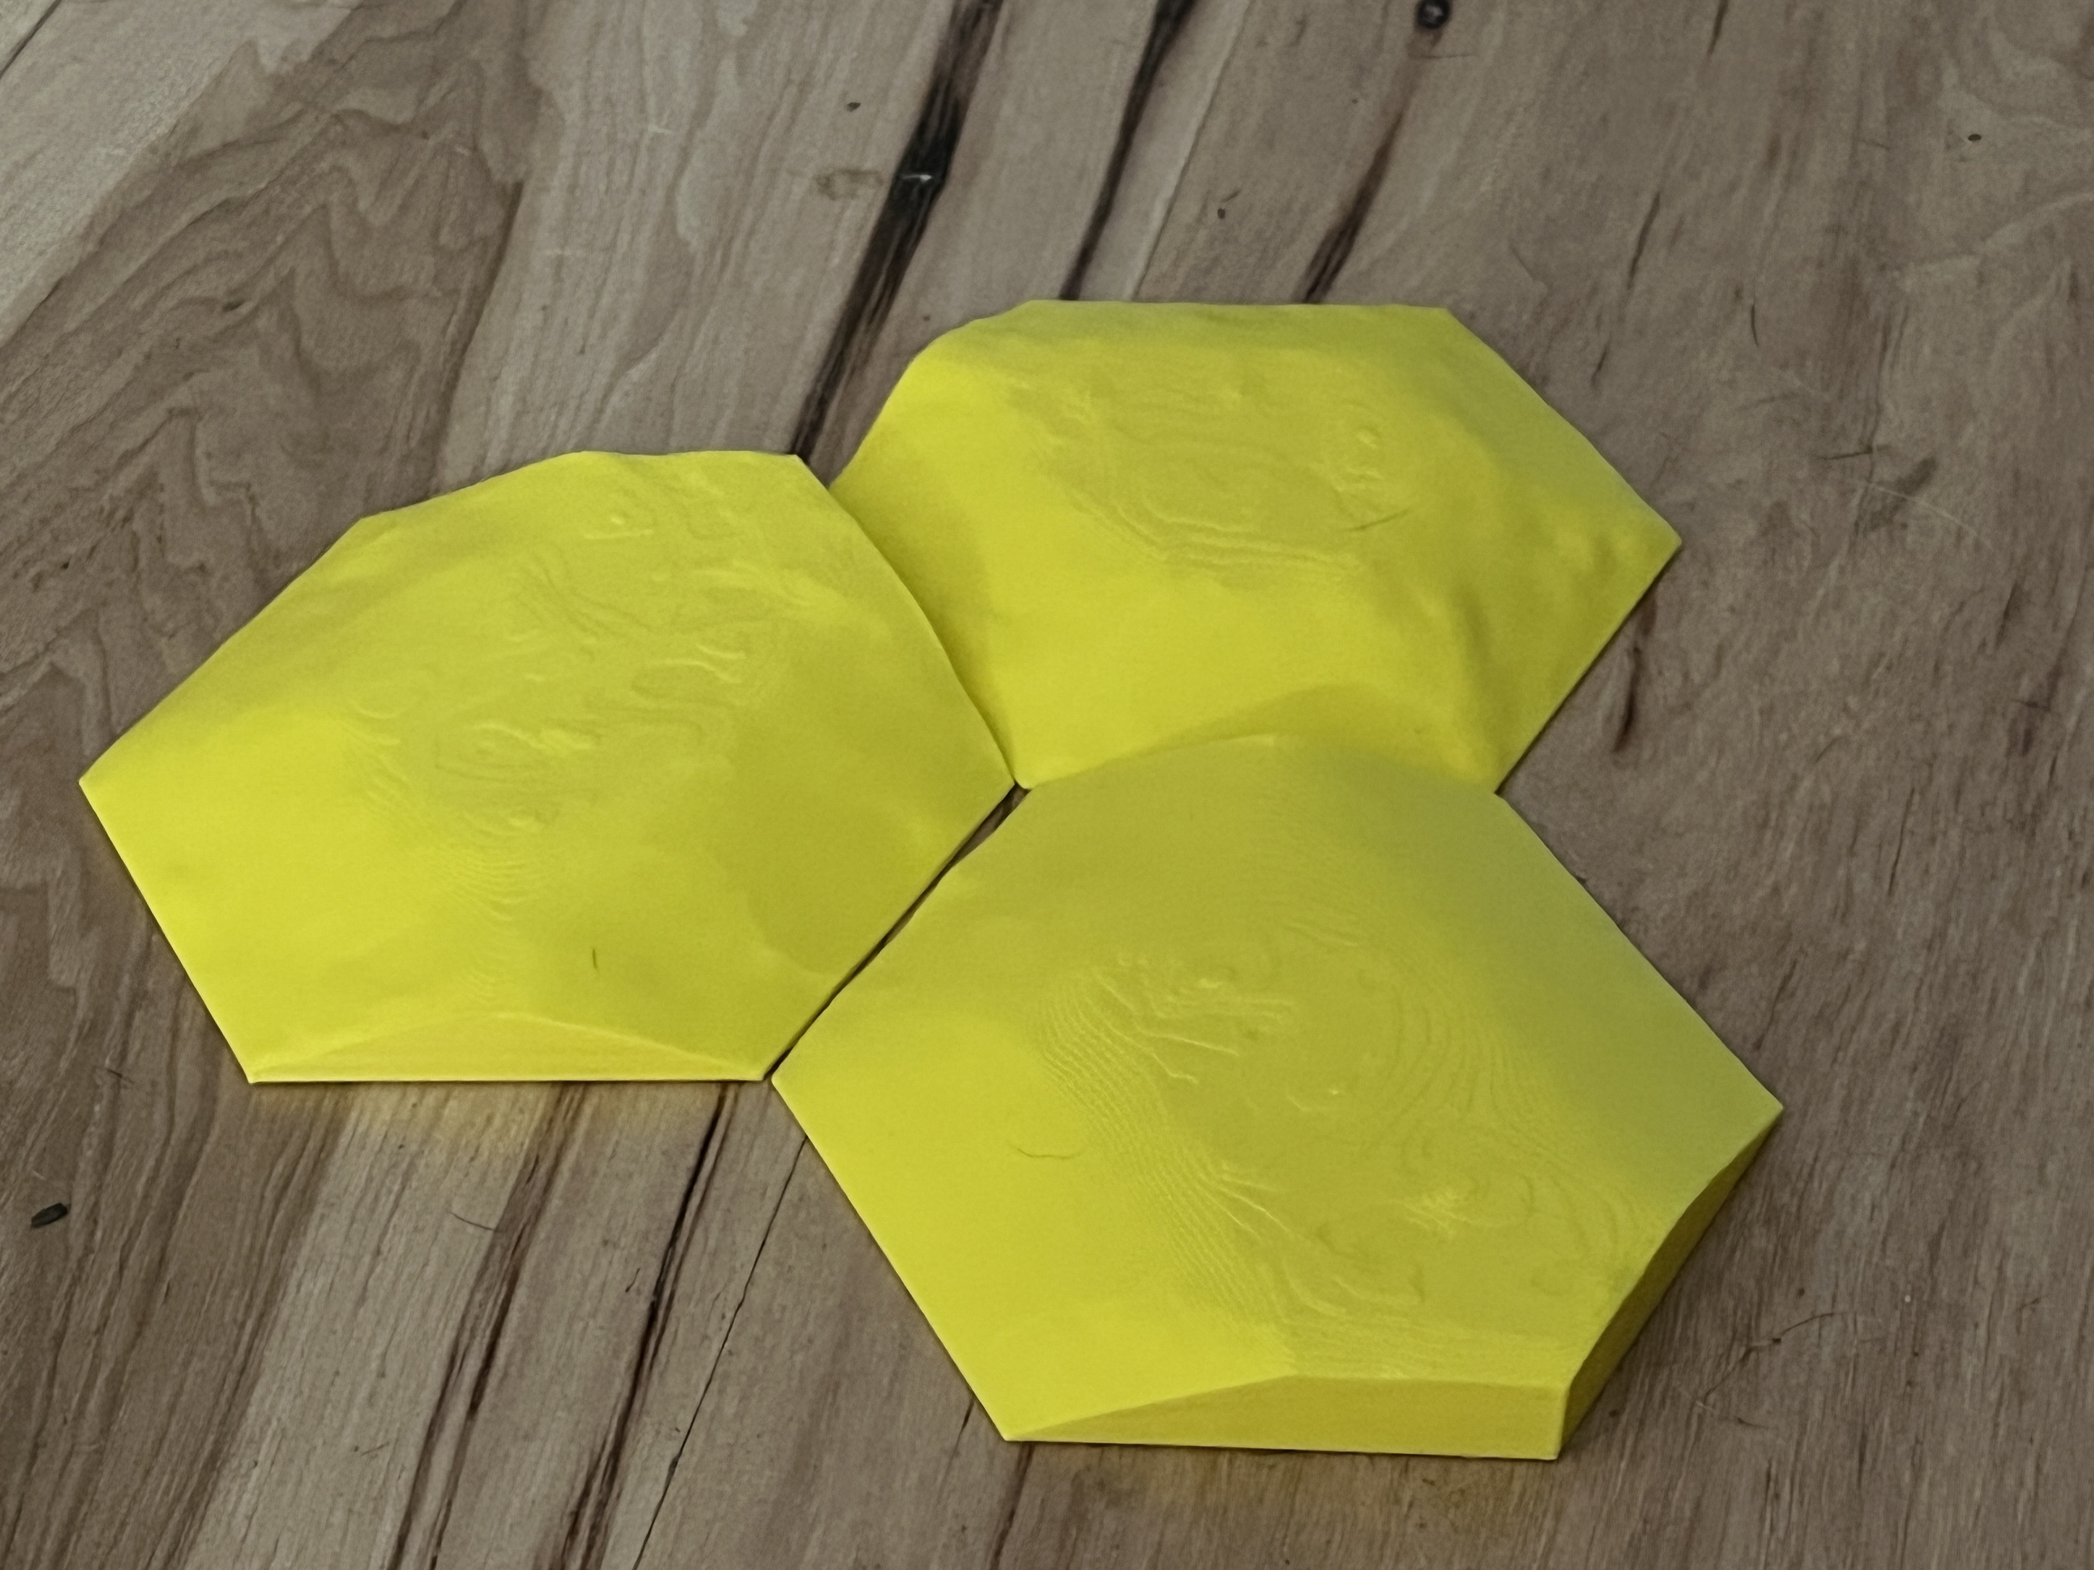  https://www.thingiverse.com/thing:6377673 | Up to 10 terrain blocks will be placed between the landing site and the bins. There will be room to move around it, but you will receive a bonus of 150 points if you are able to navigate over it at least one time.  all 4 wheels touch as passing, not necessarily at the same time. | 50 points total  While you can navigate the terrain as many times as you’d like, you will only receive points once.
 |  | All known challenges | 675 points max

Rules of Play
- At the beginning of the match, your team’s robot must start in the BARN (the white hexagon). At least one wheel of the robot must be touching inside the BARN boundary.
- The GAME ZONE is the area outside of the BARN.
- The RESOURCE TRAY is a plastic tray that will be placed on the outside of the game table and will hold game pieces for known and/or unknown challenge(s).
- Robots must be launched from the BARN throughout the Before being launched, at least one wheel of the robot must be touching inside the BARN boundary. The wheel must be attached to the robot at the time of launch and must be within the 13 inch cube of the robot.
- Each match will be 3 minutes.
- Time begins when the announcer says “BEGIN” and continues until the announcer says, “TIME.”
- Any structures built by the team cannot be placed onto the GAME ZONE by human players but are permitted to be placed by the robot so long as it is done autonomously and is permitted by challenge rules.
- No containers used by game officials to store game pieces can be used by the team/robot.
- Players may retrieve their robot at any time during the match without penalty. When retrieved, the robot must return to THE BARN. Judges will not assist in retrieval.
- If a player interrupts the robot, the robot must return to THE BARN.
- Possession is defined as a piece that is not touching the playing surface and is under the control of the robot.
- Items in possession of a robot may be retrieved once any part/piece of the robot has broken the plane of the BARN boundary.
- If the robot is in possession of a game piece in the GAME ZONE, and the robot is retrieved by the player, the game official will return the game piece(s) to its original location/state.
- A player is not allowed to touch any game piece except when the piece is completely inside the BARN boundary OR if the robot is deemed in The BARN AND in full possession of a game piece(s). Once the piece is deemed inside The BARN, contestants may remove the game piece from the game table/robot and store it in the RESOURCE TRAY.
- If a contestant intentionally touches a game piece in the GAME ZONE, the team will be given a 50-point penalty per occurrence. Judges will issue one warning for the first offense. In such cases, the piece will be returned to its original starting position by contest officials as quickly as possible.
- All competing team members are allowed around the game table during the competition, and any member may touch the robot if necessary. Once a robot is “touched,” it must be moved back to THE BARN
- Teams not competing must remain at their tables or staging
- Good sportsmanship is always crucial during practice times. Practice time on the game table may be restricted as build time progresses.
- Practice time will be approximately 1 ½ - 2 hours between check-in and the start of matches. You will be assigned a match table and will share practice time with other teams.
- At the conclusion of the match, it is the responsibility of the team captain to review the score sheet with the judge and then initial at the bottom, signifying agreement of the final match score. Scores are final after this point and cannot be contested.

Equipment Rules
- Robots must fit in a 13-inch cube at the start of play. They can expand another 5 inches in any direction after being placed on the field, making the robot a maximum of 18 inches long.
- You can have a maximum of one controller active in a match
- You can use any sensors necessary to complete your challenges
- At the start of the match, your equipment may be stored off the table or in the launch area. It may not be in the play area until the timer has started.

Scoring Rules and Rubric
- After 3 minutes, the match will end. Do not touch your robot until scoring is finalized.
- Unless otherwise specified, scoring will take place at the end of the match. For instance, when you get the ball through the hoop, it will be scored immediately.
- If a team cannot run their robot, they can still gain points with their engineering notebook.
- The referee will document the results of the match with the team captain. The captain will initial the results, and it will become final at that point.
- Each team will have two attempts per round. Only the high score will be recorded. In the case of a tie, the second score will be used to make the final decision.
Table 1 - Game Rubric
Objective | Description | Point Value | Points awarded
Package Delivery - Deliver packages to the houses. There will be 4 houses placed on the outside perimeter of the black road. One foam square in the corresponding color will be delivered to each home. | Houses will be 3-D printed and no larger than 12.7 cm sq. (approx. 5 inches)  If a color or light sensor is used for the duration of the trek, bonus points will be awarded. The team captain must notify the judge before starting the challenge that the sensor will be used.  The black line is exactly 6 1/2 inches from the board's edge. | 75 points per package delivered at the matching house.  If the wrong color is delivered, team will earn no more than 25 points.  If package is delivered in the road, team will lose 15 points.  A 100-point bonus for incorporating the color/light sensor  300 points maximum
Swing the Baby | The swing will be located in the “Hay Delivery” section of the board. Swing will be swung forward and back three times by the robot without the “baby” falling out. | 200 points for successfully completing the challenge.  200 points maximum
Sandbox Sort – There will be two boxes. One with 3 ping pong balls and 3 boxes, and one empty. All ping pong balls need to be moved to the second box | The green box will contain three ping-pong balls and three foam boxes. The three ping pong balls need to be moved to the orange box.  The sandbox will be located near point A and the empty box near point B | The score will be tabulated at the end of the match. – 25 points per ball. – 75 points maximum
See Saw Balance - Balance two provided foam squares so that the seesaw is balanced and not touching the ground. | The seesaw will be located in the Hayfield area, and the foam squares will be outside of the field.  Foam squares must be touching the last marker on the seesaw to receive points. The board must be approximately balanced and not touching the ground on either side. | 50 points total tabulated at the end of the match.
Terrain Challenge | Up to 10 terrain blocks will be placed between the landing site and the bins. There will be room to move around it, but you will receive a bonus of 150 points if you are able to navigate over it at least one time.  all 4 wheels touch as passing, not necessarily at the same time. | 50 points total  While you can navigate the terrain as many times as you’d like, you will only receive points once.
 | All known challenges | 675 points max

Engineering Notebook

Adapted from University of Idaho Extension “All about the FTC Engineering Notebook”.

Why an Engineering Notebook?
An engineering notebook is a working document. It is where ideas, sketches, and team thoughts are recorded in addition to the final production information about your team and robot. It is a journal your whole team will use to help everyone know what’s going on, where you record your testing data, and it is a record of your abandoned ideas and prototypes.
- Engineering notebooks show the thought behind your strategy, designs, innovations, and organization. They show how each team member contributes and how your team overcomes obstacles. These things are hard to see at an event when you are there with a finished product.
- Your engineering notebook is the primary reference for your team. It records all thoughts at meetings and events, all ideas for robot design, all changes to the code (although the actual code does not need to be included), and game strategy. The notebook is a tool for the entire team to communicate together. It should be used as a reference for the team as well as for the judges.
- Engineering notebook is a tool you can use to show how your team works, what you do, and the concepts you are exploring with your sponsors and potential sponsors.

Should I follow this formatting guideline?
The short answer is yes, some of the guidelines are presented as optional, but by closely following the guidelines you make your engineering notebook easier for the judges to understand and eligible for the Think and Inspire awards.
If you plan to use a handwritten notebook it is a good idea to divide the sections before you start writing, or decide if you want to use multiple small notebooks to document your season. Keep in mind that your meeting discussions are as important as your engineering, game strategy, and programming thoughts when considering the awards. Showing how your team uses all of its strengths to overcome engineering challenges is critical – and that includes all aspects of the team. You also have the option of using an electronic notebook. These can be easier to use if you are meeting in different places, as long as you have access to it, no one will have forgotten to bring the notebook. While the judges do not differentiate between a handwritten notebook and a printed one, there are pros and cons to each your team should consider.

Table 2 – Dos and Don'ts for Your Engineering Notebook
Handwritten Engineering Notebook | Electronic Engineering Notebook
Pros:  Easy to use – everyone can write on paper  - Already printed and bound, what you see is what you have  - Easy to show how the whole team contributed with different writing styles, ink, and signatures  - Easy to reference during the build season  - Shows it’s use with stains, cross outs, and worn pages  - Easy to add tabs and make ready for competition (the pages your team referenced the most will be the ones the judges want to see.) | Pros:  - Available anywhere (if in the cloud)  - Spell Check, and legible  - Easy to add images and summaries, and they won’t fall out  - No worries about running out of pages in a section and running into the next section  - If you forget it at home, it can be reprinted anywhere.  - Can print a new copy to mark for each competition. – although not necessarily advised
Cons:  - Each section needs to be decided at the beginning of the season, it’s not possible to change mid-way through. If you don’t have enough pages you have to use pages in the back or a second notebook.  - Not everyone has really legible handwriting, or spelling, but everyone does need to contribute.  - Must be remembered everywhere you go, especially tournaments. | Cons:  - Not easy to tell that everyone has contributed to the notebook.  - Need to remember to print and get it in an appropriate binder for each tournament.  - Sometimes needs reformatting to print nicely.  - Adding hand drawings, pictures, PTC renderings takes more effort.

Now that you have decided on your notebook/notebooks, get out a sharpie and put your TEAM NAME, and COUNTY on the notebook. This is one of the most important things you can do! It not only helps the judges find your notebook in the mountain of engineering notebooks at a tournament, but it lets those same judges know you care about your notebook and can follow basic instructions. No matter how nice your cover is, if a judge has to hunt to find your team name and county, it does not leave them with a good impression – even before they look inside. Remember the judge is your advocate to being considered for awards, you want them to have a positive impression of the team in every way possible.

Requirements of Your Engineering Portfolio/Notebook:
- Portfolio should be organized in a logical manner.
- Engineering portfolio must have engineering content. The engineering content could include entries describing examples of the underlying science, mathematics, and game strategies in a summary fashion.
- The engineering portfolio must provide examples that show the Team has a clear understanding of the engineering design process including an example of lessons learned.
- The portfolio should inspire the judges to ask about specific, detailed engineering information.
- Portfolio format is less important but enables the judges to understand the Team’s design maturity, organizational capabilities, and overall Team structure.
- Portfolio could reference specific experiences and lessons learned but should capture the summary of the status of the Team and their Robot design.
- Portfolio could summarize experiences and lessons learned from outreach with concise tables of outcomes.
- Portfolio could summarize how they acquired new mentors and/or acquired new knowledge and expertise from their mentors.
- Portfolio could contain a summary of overall Team plan.
- Portfolio could contain information about the plans to develop skills for Team members.

Getting Started
Everything is going in this notebook, but right now it’s a blank page or screen. So how do you get going?
- Make sure your Team Name and County is on the cover – both are required
- The next thing you need to do is set aside the first page for your team summary. You will want to do a draft of this page. It is the first impression you give to the judges! They will see your team summary before they even meet your team! Alternatively, you can fix your team summary to the backside of the front cover.
- Label the next page table of contents. As you set the sections you will start filling this in! This will help keep your notebook organized and where you will highlight key pages you want the judges to look at.
- Divide the sections. You are welcome to organize the engineering notebook into more categories if you like, but remember, the chronology and connectedness between everything you do is important to the judges, especially strategy, design, build, and programming all work together to make your season.
  - You want a Team Profile section where each team member is introduced, preferably with pictures.
  - Your Engineering Section will be the bulk of your notebook. It will include all your team meeting notes, designs, programming thoughts, strategy ideas, and reflections. Each meeting will need its own page and you will want additional pages for your engineering notes.
- Add your first meeting to the table of contents, and create an entry in the Engineering section. On your tasks column include setting up your engineering notebook and your contribution policy; remember EVERY team member should contribute to the notebook! Don’t forget the team reflections on the meeting – this is a good place to get contribution, by having each team member present take the pen (never use pencil!)
Stick with your notebook policy for every meeting! Everything needs to be in the notebook.

What do You Mean When You Say Everything Goes in the Notebook?
Every meeting, add the meeting to the entry to the table of contents, and then write your tasks and reflections. Every credible idea discussed needs to be included in the notebook – even the ideas that don’t work out. Do not self-censor your notebook! If you use a whiteboard to draw out ideas, take pictures, or have a team member sketch the ideas into the notebook. Make sure you leave space on meeting pages for photographs of what was happening – OUTLINE THEM IN INK and follow the picture inserting guidelines, pictures do occasionally fall out.
If you find yourself wondering if you should include something in the engineering notebook, do! Judges love the little bits of information that make your journey real like; ideas you discard because they are out of budget, when you sacrifice strategy because of a programming limitation, drawings sketched on napkins, the inconsequential details of a meeting – like celebrating a team member or coach’s birthday, although honestly, judges don’t need to know if the cake was good.

Tournament Time
You’ve done good, you’ve brought your engineering notebook to all team meetings and it’s been a great resource for your team over the season. You’ve saved it from near fatal disasters. Your team has poured their heart and designs into it. Maybe you’ve even shown it to a few potential sponsors? But it is tournament time, and that’s when the engineering notebook transforms from a working document for the team to keep their thoughts, ideas, and designs, into the written transcription of what makes your team special.
Now is the time to go back and flag pages for the judges. What entries really tell your team’s story and show their strength? Where are your PTC or other design sketches? Where are the best pages to learn about the team’s innovative idea? What about the Control Award? Great! You have your flags, you’ve highlighted your table of contents for the judges.
- Look at the front cover, is your TEAM NAME and COUNTY there and easy to read? Make it bolder if you need to – if you can put it on the binding too.
- Is your team summary on the first page or fixed securely to the inside of the front cover?
- Is your table of contents completely filled in with key entries highlighted for the judges?
- Every team member has a bio and their photo in the Team Section?
- Your Engineering section has all of your meetings, your designs, your notes and reflections?
Have the key entries been flagged for the judges?
- Your Bill of Materials is fixed into your notebook and added to the table of contents so the judges can find it quickly. Did you print a second copy for inspection?
- Page-by-page:
  - All pictures have ink borders with the page number on the back of the photo should it fall out?
  - All white space is removed?
  - Every page has a page number. It’s okay, if the numbers restart for each section.
  - All corrections are crossed out a single time and dated?
  - Everything fixed to the pages is secure and not coming loose?
Review this document again. Remember to turn in your notebook when you check in at the tournament. The longer the judges have with your notebook, the more they can get from it. The judges should receive your notebook shortly after they arrive. You can still feel free to point out key passages in the judging room, just don’t use all your time flipping pages – your flags can help you here.
After the tournament, remember to pick up your engineering notebook!

