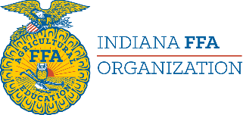

2026 4-H/FFA Milk Quality & Products CDE Saturday, February 14, 2026

Milk Quality and Products CDE
Register no later than 5:00 p.m. on Friday, January 30, 2026. Registration fee $15.00 per contestant.
4-H Registration: https://milkqualitycde2026.4honline.com
FFA: https://www.inffa.org/
This is a non-qualifying contest.
Contest rules and information can be found on the Milk Quality and Products CDE web page.
An individual contestant may compete in only one contest on this day.
There is no limit on the number of team/individual entries per school/club. If more contestants are registered than facility space can accommodate the contest coordinator will adjust the schedule to create two judging groups.
8:15-9:00 am Registration- LILY 1-105
9:00-9:15 am Orientation- LILY 1-105
9:15 am Contest begins
11:30 am (tentative) Contest concludes
Lunch on your own
1:30 pm (tentative) Milk Quality Awards Ceremony, LILY 1-105

Contact Amanda Mullins (amullins1@isda.in.gov) or Cara Harbison (charbi@purdue.edu) with questions regarding the Milk Quality and Products CDE.

***Locations are subject to change. We will share all information with registered coaches prior to the contest.

