

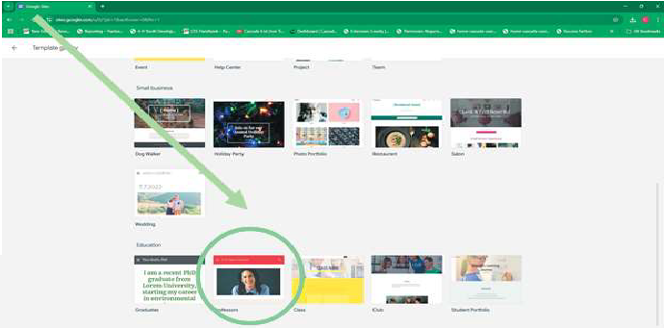
i
TheTem
te
- Open Template Gallery
- View Existing Templates.
- Open 11Professors11

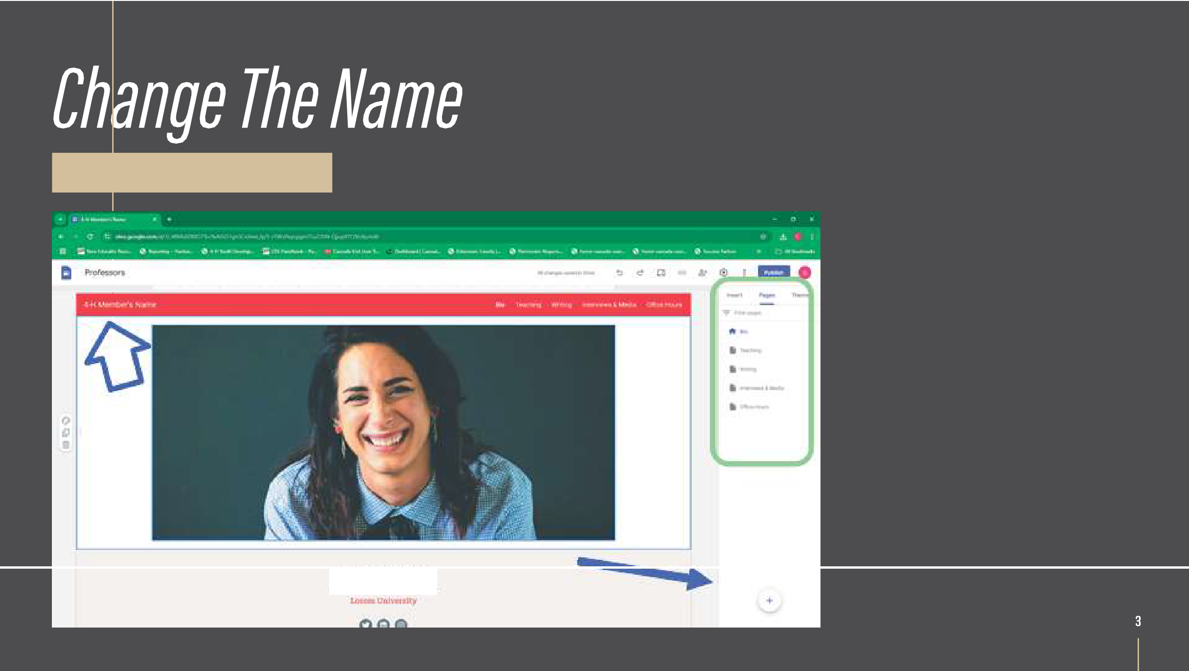
Sam 00oclwell
l'fO/( l'o,-1,1�



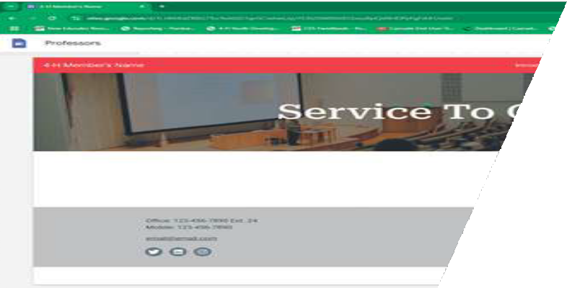
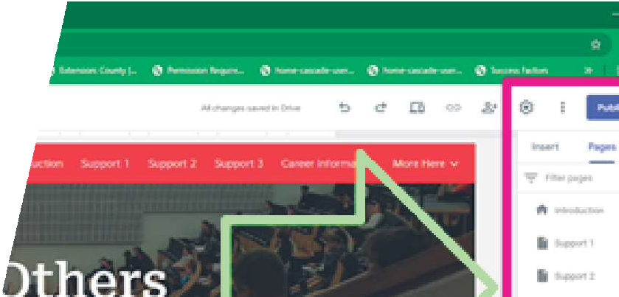
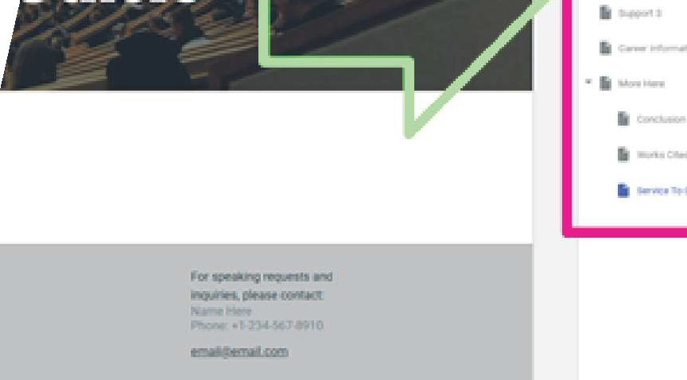




Where To Go From Here?
Use Your Basic Slides Skills To:
- Change/Add Images
- Change/Add Text
0 (Hint: Try The "Insert" Tab To The Right)
Have Fun!

