

SCORING RUBRIC

Total Possible Points=l00 | Good | Excellent
Logical Flow of Information  15 points | The presentation mostly follows the 5-paragraph essay style, with an introduction, at least three supporting areas, and a conclusion. | The presentation follows the 5 paragraph essay-style in a logical order throughout its entirety.
Research  20 points | Research is primarily accurate and current. However, topics may lack sufficient supporting research material.  I | Research is accurate and current. Sources are cited in some appropriate form. Topics are well supported.
Subject Coverage  20points | Presentation covers subject in some detail; however, it may not be complete. | Presentation covers subject in detail and the audience understanding and awareness of the subject is increased.
Presentation Delivery  15 points | Some eye contact with audience, shows basic interest in the topic, some variation in voice volume and can be heard by the audience, notes are not used to excess. | Consistent use of direct eye contact with occasional return to notes, enthusiasm for the topic is apparent, varies voice volume and inflection to maintain audience interest.
Visual Aids  15 points | Visual aids are generally readable and contribute to the overall presentation. | Visual aids are easy to see, relate directly to supporting research, are used to enhance the presentation, and have been cited in some way.
Time  10 points | Presentation time within  one-minute of presentation goals. | 2-4 minutes, Grade 3  4-6 minutes, Grades 4 and above
Appearance  5 points | Presenter appears dean and neat and it appears that an effort has been made. | Presenter is clean, neat, and well groomed,wearing business-appropriate attire. The attire may, or may-not, be related to the subject presented.



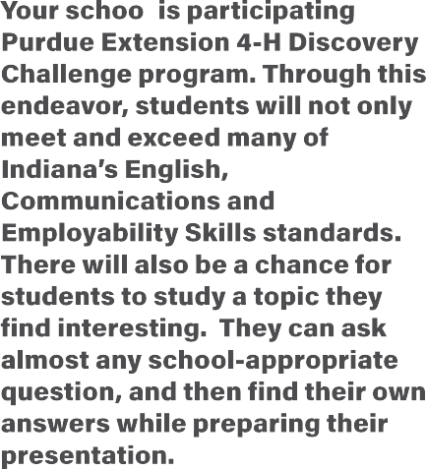











Helpful Hints For Presenters:

□ NEVER READ YOUR PRESENTATION FROM YOUR SLIDES OR NOTE CARDS!
□ Speak loud enough so that everyone can hear you!
□ Don’t use many quotes, use your own words instead!
□ Know your topic/do your own research!
□ Show enthusiasm for your topic!
□ Make eye contact with the audience! Don't talk to the floor or the ceiling. Let them see your face, not the back of your head.
□ Check the scorecard for your grade level and make sure that your presentation has included information for all scoring areas.
□ Notes work best on note cards or index cards. Number the cards and connect them together with a ring.
□ Practice your presentation and adjust your time as needed.
□ Point to your slides with your hand or a pointer.
□ Practice projecting your slides in your classroom, days before your presentation.
□ Remember, everyone wants to see you succeed!



Purdue University is an equal opportunity/equal access/affirmative action institution

Purdue University is an equal opportunity/equal access/affirmative action institution.

