IT IS ON THE INTERNET
SO, IT MUST BE TRUE!

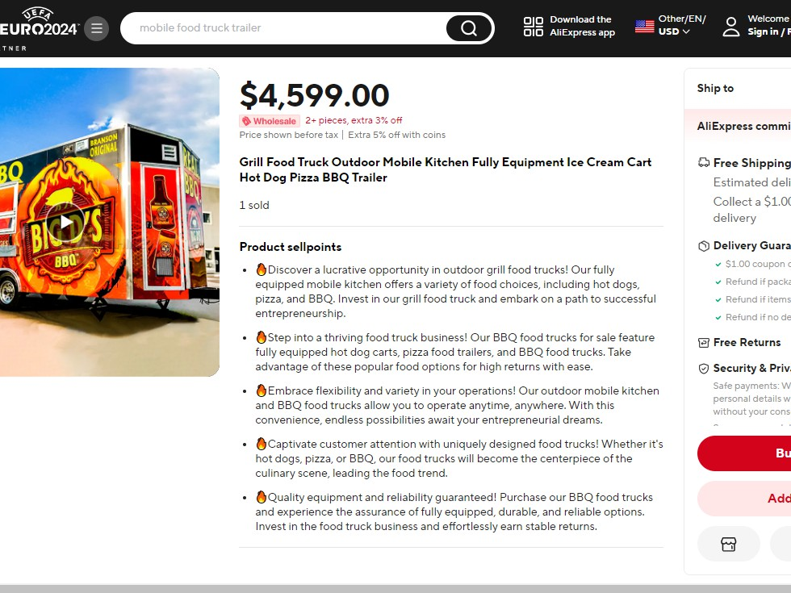
A NEW MOBILE KITCHEN ONLY $4,599!

2
Title, Franklin Gothic Italic 40


….Some Questions That Need To Be Asked
What Site Did I Find This On?
- AliExpress, China
- It Does More Sales Than Amazon!
- Anyone Can Sell On Site!
- AliExpress Does Not Background Check

3


Is This Too Good To Be True?
- The average mobile food kitchen costs between
$50,000 and $180,000
  - This Offer: $4,599
- The average cost to ship a 20-foot container from China to the US is $2,000.
  - This Offer: Free Shipping
- The average time for a container to arrive from China, 30-40 days.
  - This Offer: Delivery in 9 Days

4




OK…I’m Starting To Worry!
- Let’s Use Google “Find Image Source” To See If This Appears Anyplace Else On The Internet.
Wow! Same Trailer, ONLY
$2,399, from another dealer on AliExpress

5

HEY, Wait a Minute!

- There is a company in Virginia who claims to make custom mobile restaurants…and here is a picture of one they made a few years ago.


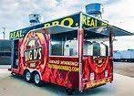

6


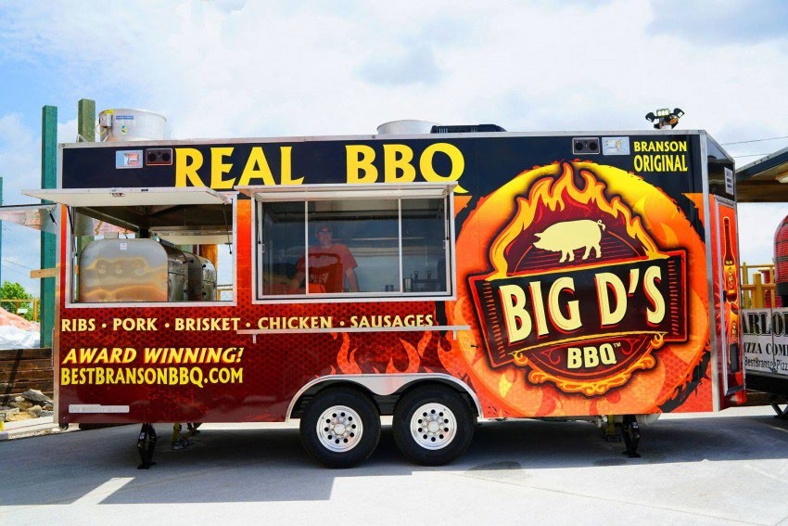
Here is that Same Trailer
Being used by the owner, who had the company in Virginia make it custom. “Custom” would seem to mean, only one exists.

7


So…What do You Think?
- I should buy the Chinese mobile kitchen for
$4,599.
- I should buy the Chinese mobile kitchen for the better price of $2,399
- I should get as far away from this deal as possible…it is a rip-off!

8

Thank You

