CAT BREEDS
COAT COLORS/EYE COLORS

ACTIVE/LAZY BREEDS

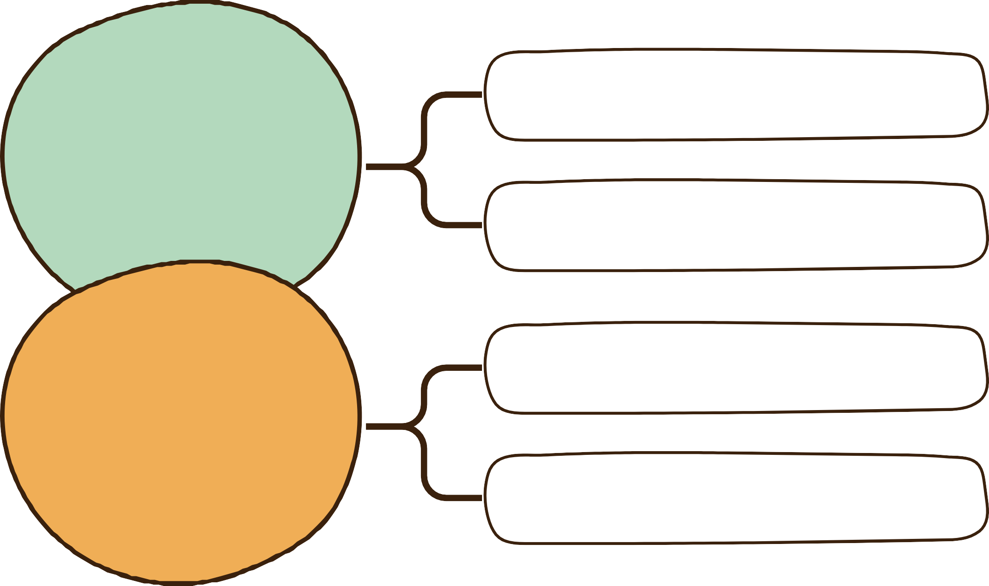

CATS

CAT CARE

CAT BEHAVIOURS
DIET/EXERCISE COAT AND NAIL CARE
KITTEN/ADULT BEHAVIOURS

BAD/GOOD BEHAVIOURS

