Apollo Egg Drop Lesson Plan

How to use a caliper:
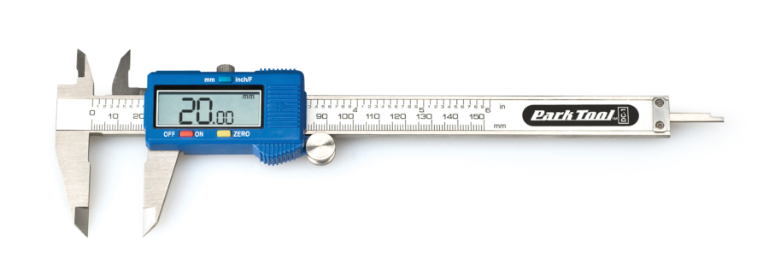
      - Use a digital Caliper on a tube or pipe
Depth Measurement
External Measurement Measurement
Internal Measurement

Can measure objects to the exact millimeter. Perfect for getting exact measurements.
Addition to base curriculum:

Lesson 2:
Youth will be given a series of tasks to complete using only the supplies given to them.
Background – After NASA Astronauts leave earth, they only have the supplies that they are given. They try to have a contingency for anything that may happen, but you can’t plan for everything. That means they need to use what they have to come up with solutions. In this lesson, you will be given a series of tasks that will need to be completed using only the supplies you have in front of you.
One item you are given is a 3-D Printing Pen, supplied by 3DDoodler. Astronauts are given 3-D printers to help them build any tools or supplies with pre-made 3-D designs. If they do not have a certain size wrench for a task they can input the info and print what they need. Your pen will be used similarly. You can use your pen to help attach supplies, add gripping or create your own tool! Use your ingenuity and imagination to use your team’s pen to its max potential!

Supply List:
Grid Paper – for designing
Dal rods
Pop sticks – Large and Small
Straws
Paper Clips
Brass Brads
Rubber bands
3DDoodler 3-D Printing Pen
3-D Pen Filament
3-D Pen pattern

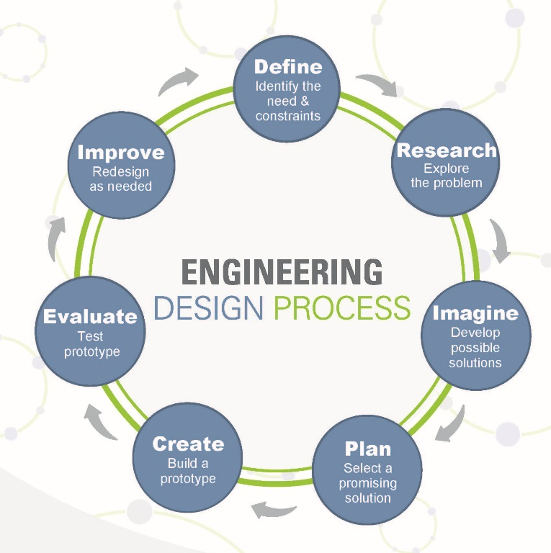
Egg Drop
Mission: Your team is tasked with creating a device that needs to house an egg. This device must be able to fall from a minimum height of 6 feet high. The device should be able to hold the egg during the drop and keep it from breaking when it lands. Your facilitator can help you with the drop by standing on a chair.
Facilitator: The engineering design process is a series of steps that engineers follow to find a solution to a problem. The steps include problem solving processes such as, for example, determining your objectives and constraints, prototyping, testing and evaluation.
While the design process is iterative it follows a predetermined set of steps, some of these may need to be repeated before moving to the next one. This will vary depending on the project itself, but allows lessons to be learnt from failures and improvements to be made.
Encourage participants to follow these steps to make sure their ideas reach their fullest potential!
Encourage youth and inform them that it is ok to fail! Just because they finish first or quickly doesn’t mean it will be successful! Follow the Engineering Design Process to encourage this. Encourage them to keep trying!

Step 1: Define the problem.
- Encourage teams to utilize their notebooks to each come up with thoughts on possible problems based on their mission.
Step 2: Research
- What challenges could you encounter while accomplishing this task?
Step 3: Imagine.
- Encourage each member of the team to come up with designs to solve the mission and overcome the written challenges.
- Each member draw up a design on the grip paper.
Step 4: Plan.
- Choose one (or two) designs to work on.
Step 5: Create!
- Build your first prototype!
Step 6: Evaluate.
- Time to test. Encourage teams to not just build and drop immediately.
- Take notes during testing and jot down any problems with their design.
Step 7: Improve!
- Work out the problems and improve your build!
- Once teams are confident run a drop with the egg and see how it holds up.

