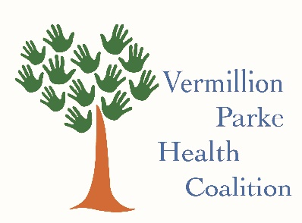

Vermillion Parke Health Coalition
July 7, 2022

Vision: Encourage healthy communities in Parke and Vermillion Counties.
Mission: To bring communities together to help everyone lead healthier lives in Parke and Vermillion Counties.
Goals:
*Education
*Advocacy
*Collaboration

Welcome and Introductions
Review notes from May 5th meeting – additions or corrections
Guest Speaker – Elizabeth McGrevy, Indiana 211
Elizabeth.mcgrevy@fssa.in.gov
317-698-0702
211 service can be reached by calling 866-211-9966 and speak to a live navigator. You can also access online and they have a texting feature.
Interpreters are available but they do not have an interpreting service (for printed materials)
Have begun using Determinants of Health screening questions to help find the best/relevant resources for each individual case.
Coalition Working Group Updates
Food Insecurity
Trauma Informed Trainings are now available to all food pantries- The Nutrition Pantry Program from Leah’s Pantry will help pantries to provided services in ways that encourage dignity and respect for neighbors needing food assistance. Contact your Community Wellness Coordinator for more information. Two pantries in Parke County are currently going through this program.
Vermillion—Allison Finzel afinzel@purdue.edu
Parke—Mindy Duckett duckett@purdue.edu
Farmers Markets have opened for this season in two locations – Dana and Eugene Station. They are accepting FMNP vouchers as well.
Connecting Health Care
Matt Smith will help Larry Addison. More information will be shared this fall. A Qualtrics will be available soon.
Resource Manual
The focus of this committee will be bolstering 211 and ensuring all members information is included and up to date.
Poverty
See next 2 points
Report from Bridges Out of Poverty
Bridges Out of Poverty event was very successful and a big thanks to Lori for all she did to make it happen! 44 participants were registered!
Poverty Simulation – September 9th
Poverty Simulation is set for September 9, 1:00-4:00 pm and will be a free event. Need 60 registered participants. There is also a need for 12-15 volunteers (don’t register). Reach out to Lori if you are interested in volunteering.
Connections IN Health Regional Roadshow in Vermillion County – November 17
Cayuga Christian Church 10:00-noon
Coalition meeting will follow with lunch provided
Suggested Coalition Meeting Speakers
Vermillion Trail Alliance and Parke Trail Alliance--September
Roadshow--November
District 7 Health Coalition—January(??)
Organization Updates and Sharing
Will Center-Danny Beemer—Transportation Planning Meeting—looking for volunteers to build a team
Community Impact--Kris Aninger—Substance use and recovery in Vermillion County
A story map of Connections in Health’s work in Vermillion County was shared with everyone
Health Coalition Web Presence: https://extension.purdue.edu/vermillion/article/37773
Please continue to forward to Lori email addresses of new coalition members
Next Meeting – September 1, 10:00 AM

