Mini 4-H

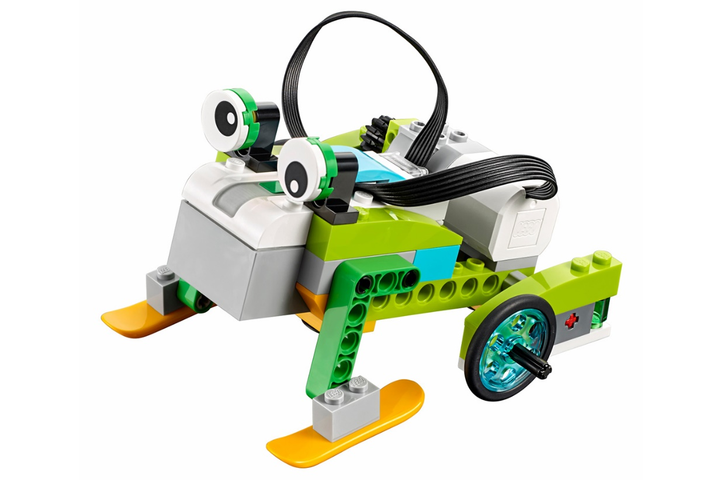

Robotics
Purdue University is an equal opportunity/equal access/affirmative action institution.

Mini 4-H Robotics

Working with robotics can be fun. It lets you use your hands to create something useful, or something for pleasure. It gives you a good feeling to know that something you have made is useful.

Mini 4-H lets you learn some robotics skills as you put together a project from a kit.

There are some activities in the manual for the grade you are in.

- Kindergarten: "Robot Friends" and "Connect the Dots"
- First Grade: "Build a Robot" and "Eco Friendly Robot"
- Second Grade: "All-About-Me Robot" and "Construct a Robot"

4-H Show Exhibit

For this project you will need to purchase your own kit.

Read and follow instructions carefully. Exhibit your Robot at the 4-H Show.

All projects are to have a name label on them.

When making your Robotics project you will use a kit. Ask a grown-up to help you and always use safety habits.

Kits

Kits may be purchased at a store or off of any website. There will be a it for each grade level.

Suggestions are:

Kindergarten – Tin Can Robot
1st Grade – Solar Robot
2nd Grade – Motorized Robot

Read the instructions with the kit so you know how to put it together properly.

Bring your finished project to the 4-H Show.

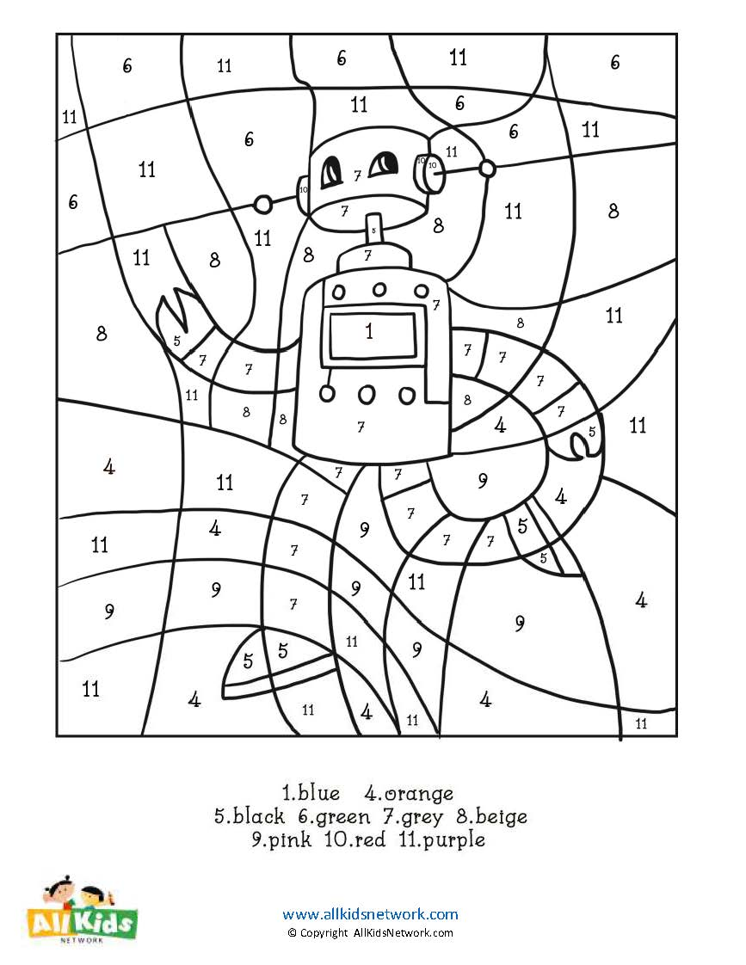
Kindergarten Activity: Robot Friends

•, • '\. ••

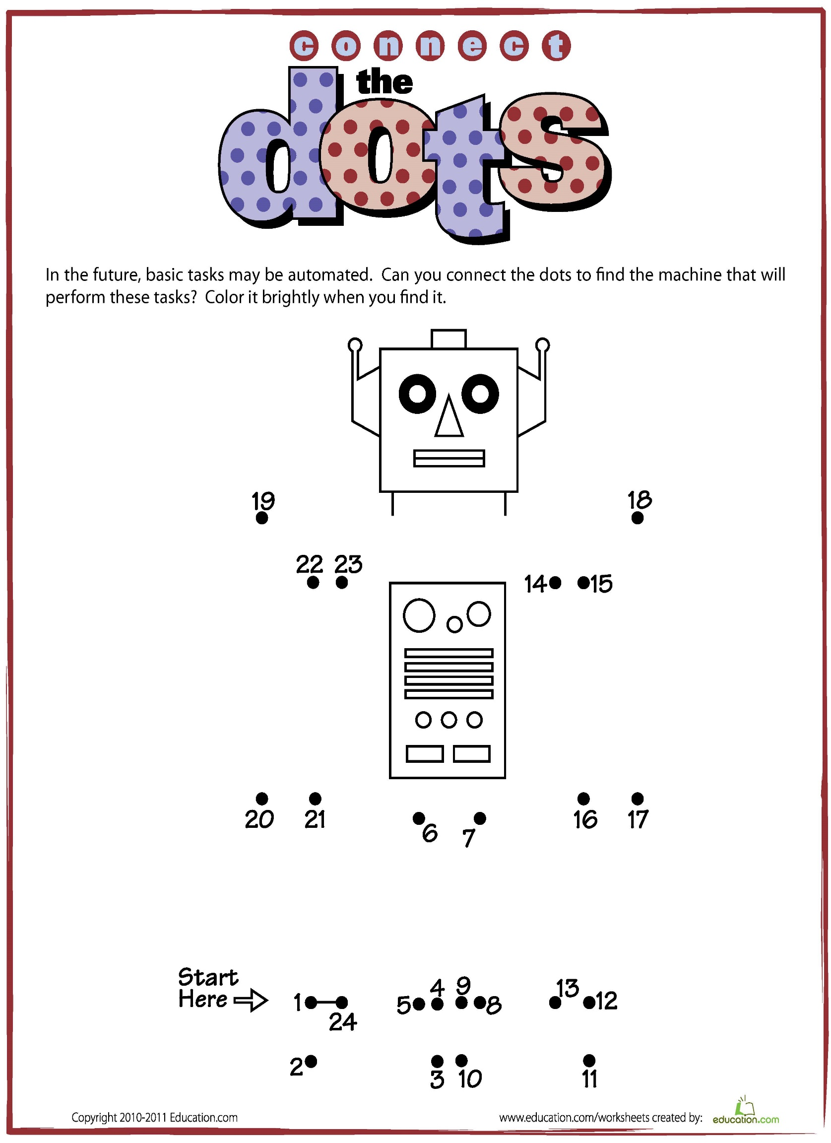

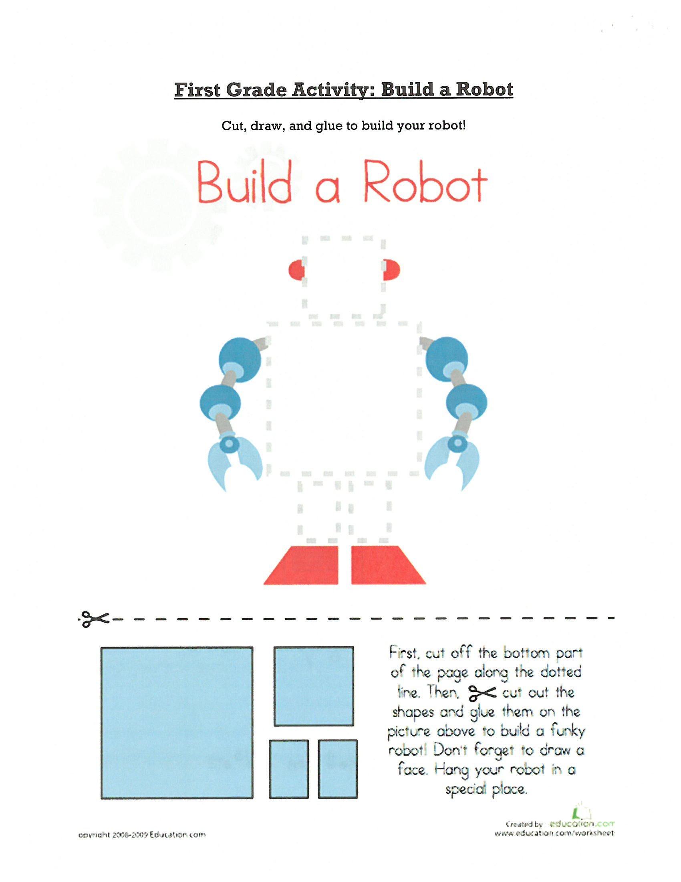

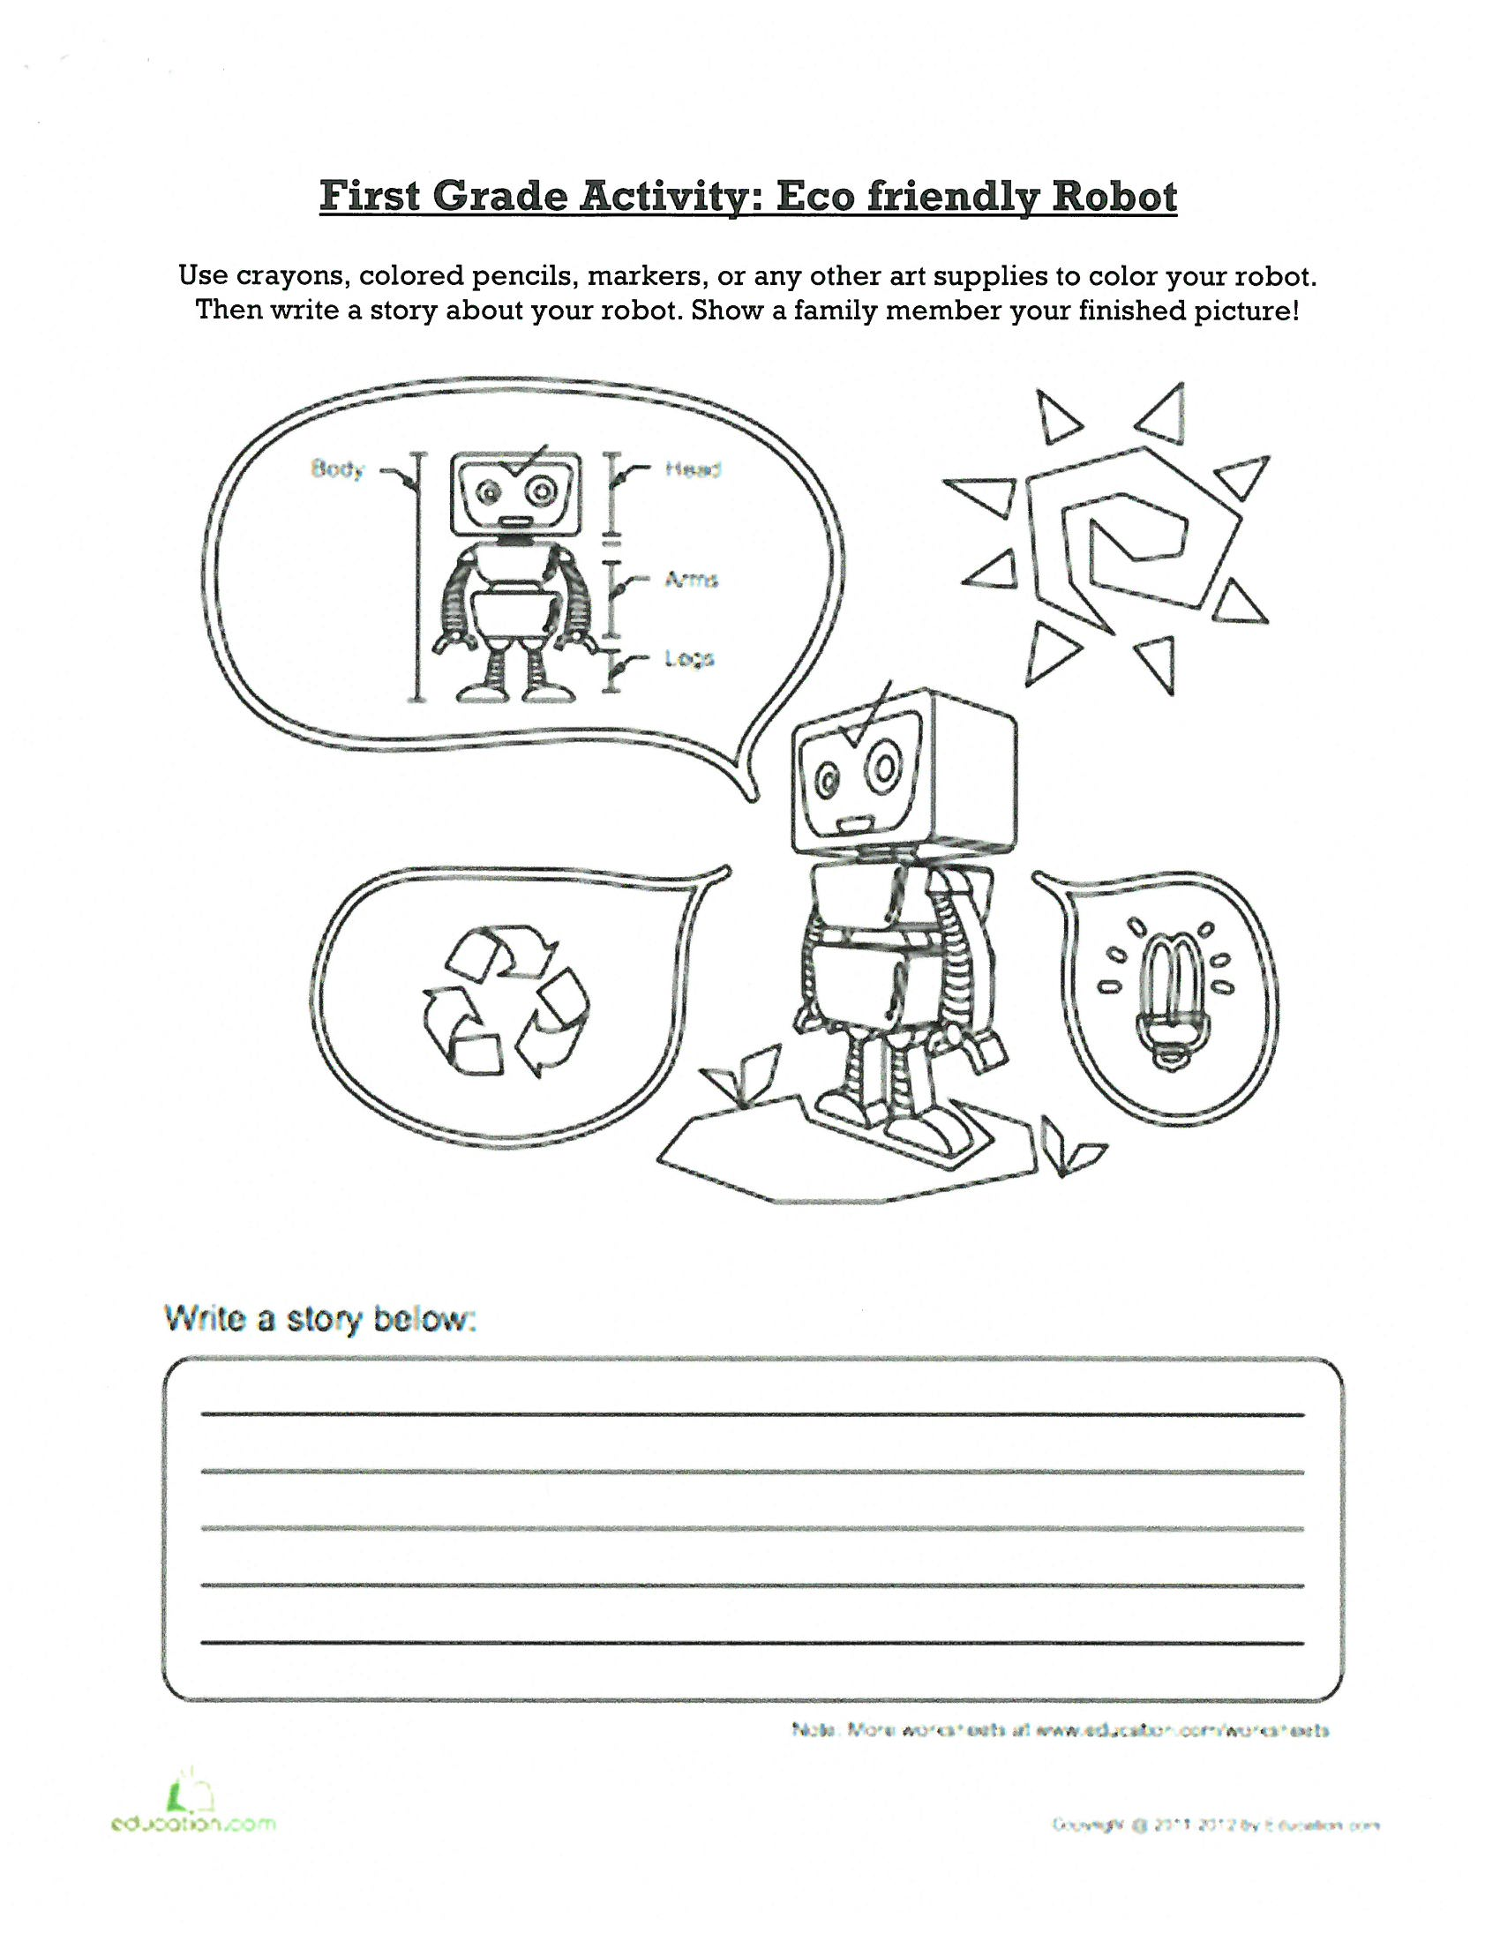

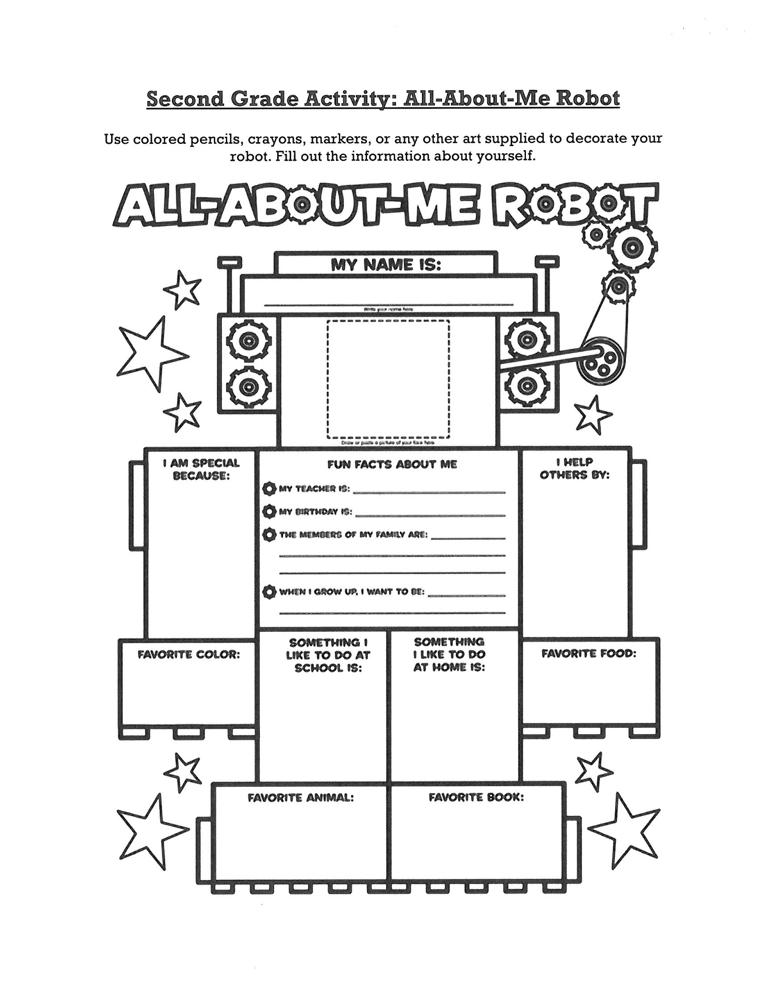

My Teacher is: ______________________

My Birthday is: ______________________

Members of My Family Are: ___________
______________________________________
______________________________________

When I Grow Up, I want to be: __________
__________________________________________________________________________________________________________________

