What is this study about?
4-H Volunteer Impact Study
Exploring the personal, organizational and public value of being a 4-H volunteer

The North Central Region 4-H Volunteer Impact Study was conducted with volunteers in the 4-H Youth Development program
across 12 states.

The purpose of the study was to better understand the value of being a 4-H volunteer. 1,000 randomly selected volunteers from each state were asked to reply to an electronic survey. This report focuses on Indiana findings.

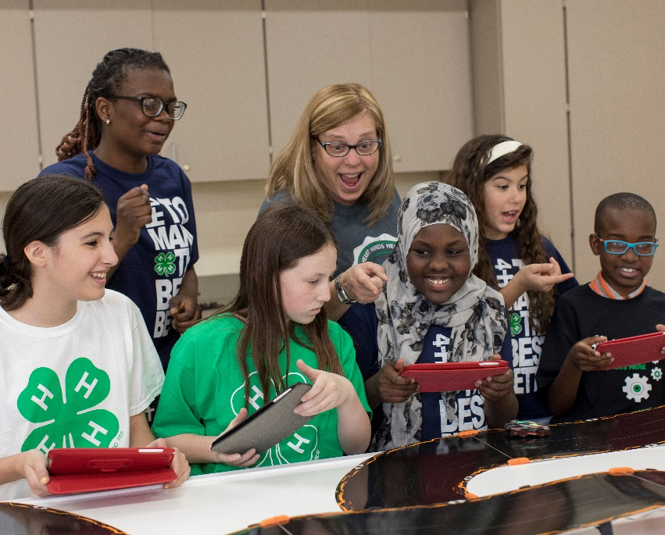

Who completed the study?
255 Indiana Volunteers Responded
Top reasons for volunteering

#1 Help others

#2 Make a difference

#3 Support child in 4-H

Volunteer years of service
5%
one year
or less
25%
2-5 years
47%
11+ years
23%
6-10 years
Childhood participation in 4-H
66%
in 4-H as a child

66% of volunteers were part of 4-H as a child
34% were not part of 4-H as a child

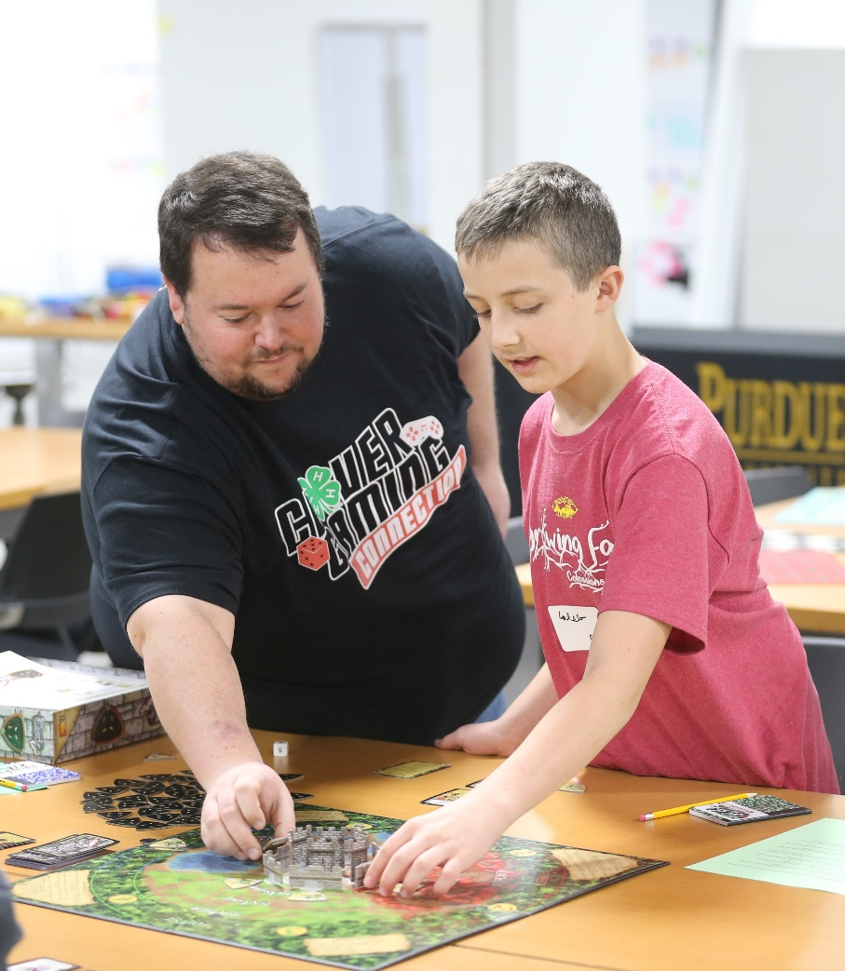

How does the individual benefit?
Volunteers personally benefit from their 4-H involvement.
Volunteers come into the 4-H program hoping to support youth and make a difference. In the process, they gain skills in teaching, leadership
and communication. These skills transfer to other environments in which volunteers work and live.

90%
built new relationships with youth

“Impacting the youth’s experience and assisting them with preparation for the future. I genuinely enjoy just having the opportunity to meet these young individuals and get to know them while seeing their growth over time.”

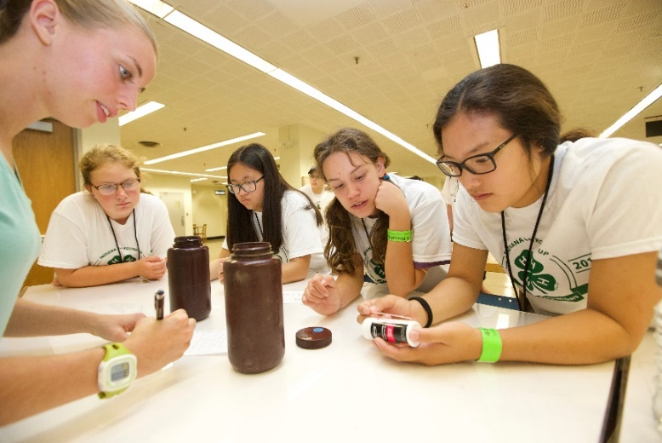

87%
“I’ve used some of the activities I’ve taught in club meetings in an after school mentoring program I volunteer with in one of our city’s most troubled neighborhoods. Tried and true activities that have worked for my 4-H kids have been well received with these less fortunate students.

gained skills that are useful in other settings

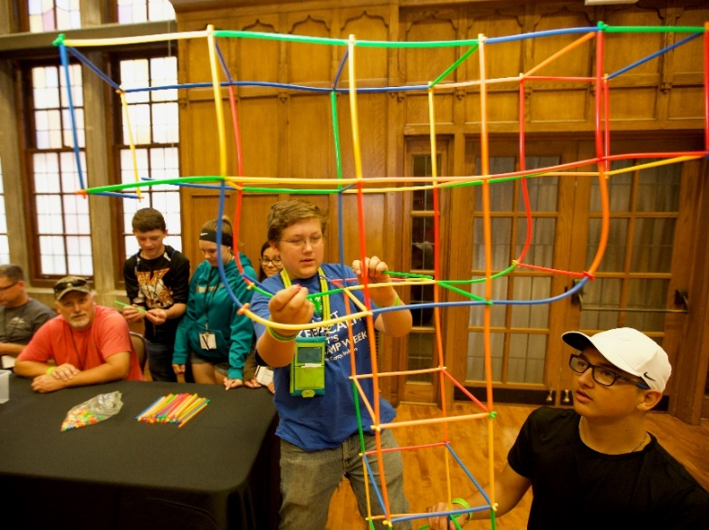

79%
“Working with students with special needs. These students have unique personalities and want to be treated like other students or 4-H’ers. They just need more help in accomplishing tasks.”
learned to think from different perspectives

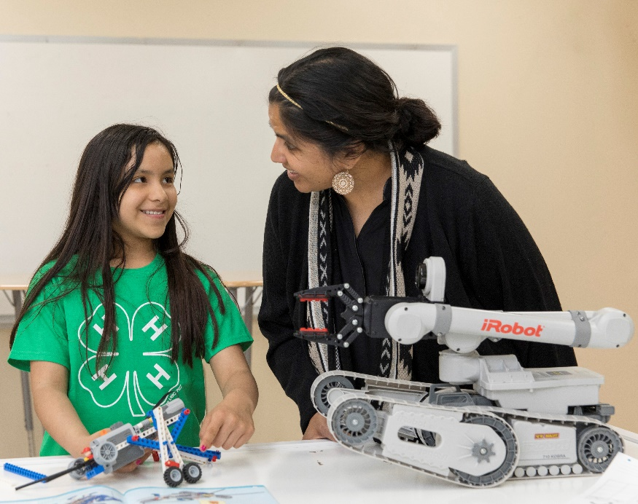

How does our organization benefit?

4-H Youth Development benefits from volunteers.
Volunteers give their time, talents and energy to the 4-H program. On average volunteers give 8.3 hours per month, an annual contribution valued at $2,421*. In addition to time, 93% of volunteers contributed supplies and 85% of volunteers contributed financially.

Volunteers serve as primary ambassadors for
4-H. They tell others about the importance of youth development, recruit new youth and volunteers, and expand community partnerships.

95%
taught youth new skills

“Getting kids involved in not only doing the projects but holding an office in our clubs helps them learn leadership skills which they carry into their school careers, into college, and then into life in our communities to help build a stronger, better world for all of us to live in.”

85%

planned learning experiences for youth.
“Young adults will become the future of our communities. Basics such as integrity, truth, honesty, hard work and responsibility are all attributes that are communicated through numerous 4-H activities.”

88%
“4-H crosses all economic and social lines. It gives city kids the access to animals in the rural parts of the county. It gives kids skills that will last a lifetime. Who knows what skills will be valuable in the future? 4-H gives kids the flexibility to learn skills that they may use in the future.”

recruited new youth to 4-H

84%

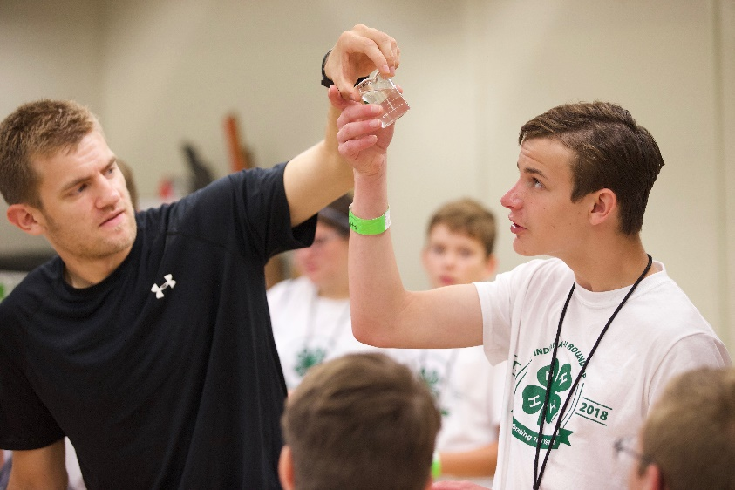
made new connections in the community on behalf of 4-H
“Since we have so many sponsors on the robotics team, we get youth internships with the sponsors thus getting them jobs after college.”

84% spoke about the value of the 4-H program
to members of the community
“I’ve seen volunteers come out of their shells after working with 4-H, myself included. I’m more likely to talk to people I don’t know personally, and I’m more likely to enter into a professional/business conversation than I was before. I’m building a community network through and beyond 4-H.”

How does the community benefit?
Communities are stronger because of 4-H Youth Development volunteers.
Volunteers have a positive impact where they live and work. They make communities stronger, connect communities to each other, improve community health and increase overall civic involvement. The value of 4-H volunteers extends far beyond the scope of youth development into every part of their community
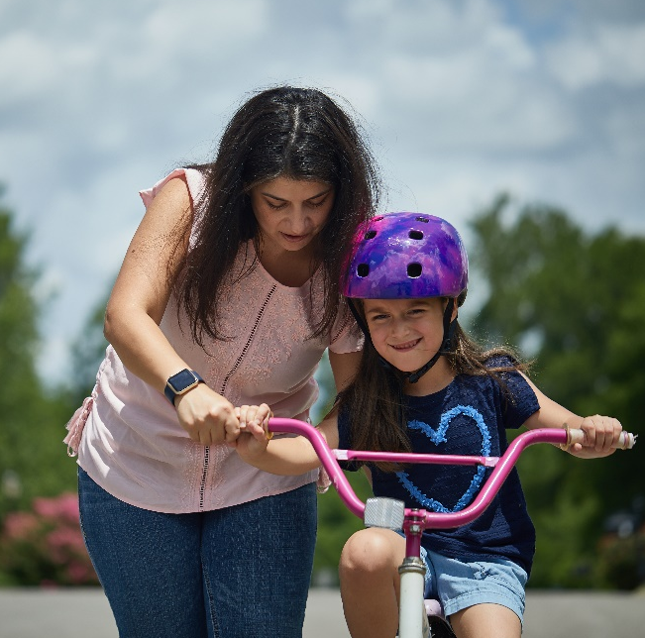
“4-H turns out skilled youth. The students I’ve met through 4-H are incredibly capable in a host of arenas. They can build a robot, fix a small engine, and decorate a cake. Skills make communities stronger. Communities need people who can do things. 4-H does that very well.”
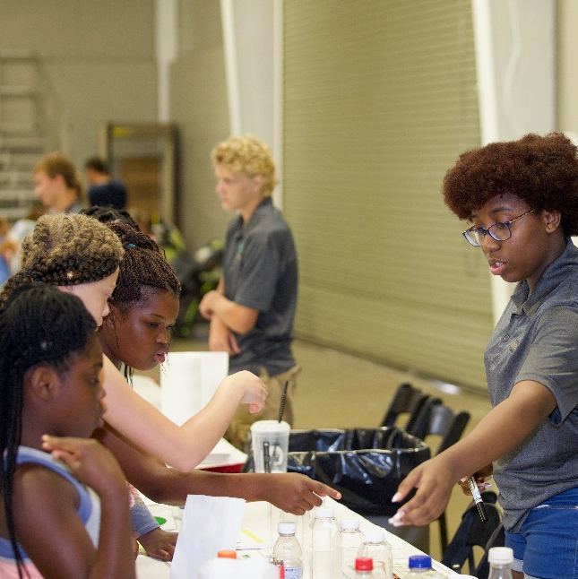
“For the very first time ever, my husband and I (both 4-H volunteers) became more vocal in the political process for our community and our state.”
73%
said volunteering with 4-H increases civic involvement
80%
said volunteering with 4-H improves the health of communities
90%
said volunteering with 4-H makes
communities stronger
88%
said volunteering with 4-H contributes to better connected communities

Volunteers matter and they make a significant impact.

The 4-H program would not be possible without volunteers. Through their service, volunteers grow personally. They enrich the 4-H program and youth. They make our communities stronger.

Learn more about 4-H in Indiana and how you can become involved at: bit.ly/in4hvol or call 765-494-8435.
Data in this report are from a 2018 evaluation project of 4-H volunteers in the North Central Region. Response rate for Indiana volunteers was 25.5%.

* Direct value of volunteer contributions based on Independent Sector hourly rate of $24.13.

Report format adapted with permission from University of Minnesota Extension.

It is the policy of the Purdue University Cooperative Extension Service that all persons have equal opportunity and access to its educational programs, services, activities, and facilities without regard to race, religion, color, sex, age, national origin or ancestry, marital status, parental status, sexual orientation, disability or status as a veteran. Purdue University is an Affirmative Action institution. This material may be available in alternative formats.

