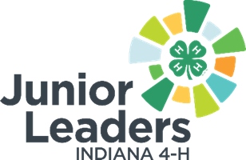

4-H Junior Leader Service Learning Officer Role Description
Qualifications:
- Desire to help the community
- Knowledge of other non-profit organizations in the community
Skills:
- Positive attitude and team player
- Organized
- Ability to lead your peers
- Creativity
Responsibilities:
- Assist the Jr. Leaders group in doing a needs assessment to determine the needs within the community.
- Assist Jr. Leaders in listing possible community service options and deciding which project to do.
- Assist Jr. Leaders in developing a plan to conduct the community service activity.
- Lead the community service project as planned.
- Monitor the activities taking place and make adjustments as needed.
- Document efforts with photos and written notes.
- Evaluate the experience with Jr. Leaders afterwards to discuss the successes and shortcomings as well as ideas for improvement or repetition.
What you will gain from this:
- Career readiness skills
- Networking abilities with local organizations in your community and beyond
- Leadership skills

