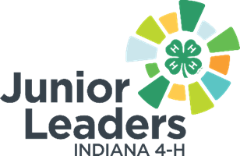

4-H Junior Leader Board Representative Officer Role Description
Qualifications:
- Have an understanding of the 4-H Council, Extension Board, and other affiliated organizations that work with 4-H Junior Leaders
- Ability to attend and actively participate in board meetings
Skills:
- Effective communications with youth and adults
- Willingness to represent and advocate for 4-H Junior Leader ideas
- Positive attitude and team player
- Be able to write and review reports for the Junior Leaders
Responsibilities:
- Find out when and where the board meets.
- Attend all board meetings.
- Report back to Junior Leaders on what’s happening with the board.
- Give brief reports to board on 4-H Junior Leader activities at the board meeting.
- Serve on countywide committees when appointed by the board.
- Participate in training when needed.
What you will gain from this:
- Career readiness skills
- An understanding of how a board runs and operates
- Working with a team dynamic
- How to summarize reports for board meetings

